Cách tính điểm toiec

* cách tính điểm toiec

Speak: >60, tầm 80 điểm là ổn

Write: 200

Listen: 495

Read: 495

Write +Lis +Read > 400 ( là mọi thứ nhẹ nhàng )

đề khảo sát vừa rồi

nên ôn

* speaking + writing => ở drive ( tham khảo )
* Listen + reading => [study 4](https://study4.com/tests/toeic/?term=2024) ( có từ vựng là làm được)
* Tin học thì [ở đây](https://drive.google.com/drive/folders/1AKh2dqd0uBJOtwleUsmBN4FswNi4dVU_?usp=drive_link)

|  | **Khảo sát** | **Toiec** |
| --- | --- | --- |
| **Part 1** | 10 | 6 |
| **Part 2** | 40 | 25 |
| **Part 3** | 25 | 39 |
| **Part 4** | 25 | 40 |
| **Part 5** | 30 | |
| **Part 6** | 16 | |
| **Part 7** | 54 | |

* cách tính điểm tin học

>5 là qua

Nói thì phần express opinion quan trọng, cbi phần đó trước, vì nó 140 điểm lận. Còn phần tranh có 60 điểm thôi nên phải luyện trước vô là nói ko cần cbi gì nhiều

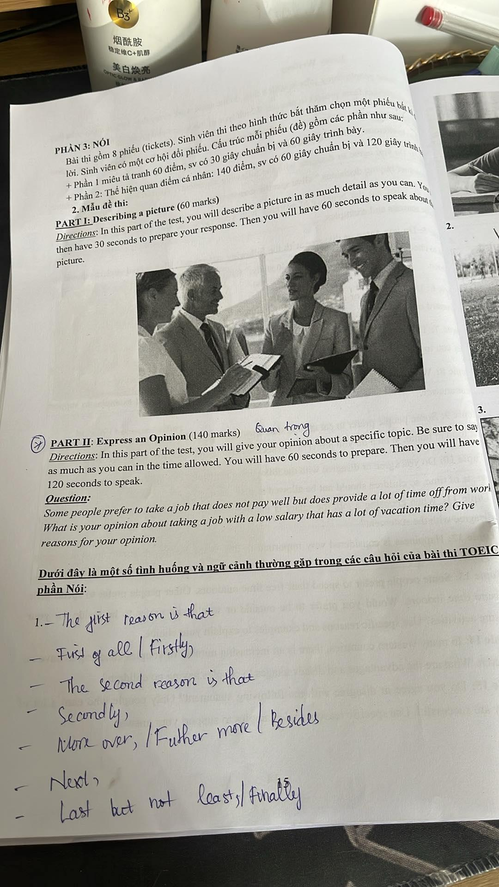

**PART II: Express an Opinion (140 marks)**

Quan trọng

Directions: In this part of the test, you will give your opinion about a specific topic. Be sure to say as much as you can in the time allowed. You will have 60 seconds to prepare. Then you will have 120 seconds to speak.

**Question: 3.**

Some people prefer to take a job that does not pay well but does provide a lot of time off from work What is your opinion about taking a job with a low salary that has a lot of vacation time? Give reasons for your opinion.

**Dưới đây là một số tình huống và ngữ cảnh thường gặp trong các câu hỏi của bài thi TOEIC phần Nói:**

1.- The first reason is that

First of all I Firstly,

The second reason is that

Secondly,

Move over, / Further

Next

more / Besides

Last but not leasts / Finally

**ví dụ**

**Alright, in my opinion, taking a job with a low salary that has a lot of vacation time can be a good option, but it depends on your life stage and priorities.**

Firstly, if you're young and seeking new experiences, this free time allows for travel, volunteering, or pursuing hobbies. These experiences can be personally enriching and even build valuable skills.

Secondly, a good work-life balance can be crucial for preventing burnout and maintaining overall well-being. Ample vacation days let you recharge and return to work feeling refreshed.

However, financially supporting oneself can be challenging on a low salary. So, this option might not be suitable for everyone, especially those with families or significant financial obligations.

**Overall, a low-paying job with generous time off can be an attractive choice for those prioritizing experiences and well-being, but careful financial planning is necessary.**

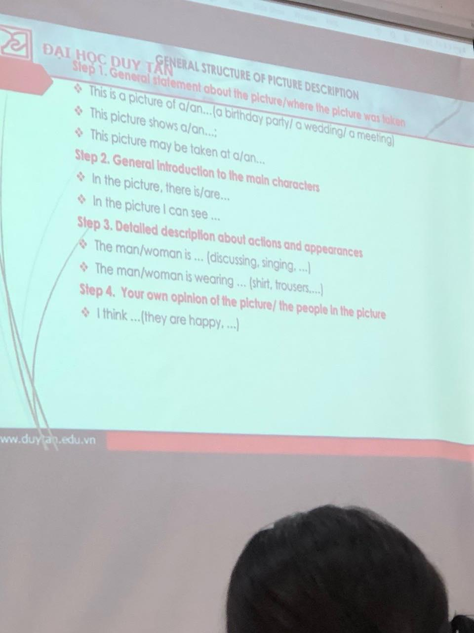

CÁCH TÍNH ĐIỂM BÀI THI TOEIC ĐẦU RA 4 KỸ NĂNG:

BÀI THI 4 KỸ NĂNG GỒM TỔ HỢP 3 KỸ NĂNG (LISTEN- READ- WRITE) + SPEAK

-BÀI THI TỔ HỢP 3 KỸ NĂNG:

LISTEN: ĐIỂM TỐI ĐA: 495

READ: ĐIỂM TỐI ĐA: 495

WRITE: ĐIỂM TỐI ĐA: 200

TỔNG ĐIỂM TỔ HỢP 3 KỸ NĂNG: LISTEN + READ + WRITE: 495 + 495 + 200 = 1.190

ĐIỂM ĐỂ PASS BÀI THI 3 KỸ NĂNG LISTEN + READ + WRITE:

TÙY THEO MỨC ĐIỂM TỪNG NGÀNH THEO QUY ĐỊNH CỦA TRƯỜNG

-SPEAK: ĐIỂM TỐI ĐA: 200

ĐIỂM TỐI THIỂU ĐỂ PASS BÀI THI SPEAK: 80/200

**3 TUẦN SAU KHI THI SẼ CÓ KẾT QUẢ THI**

Phần Speaking 2024

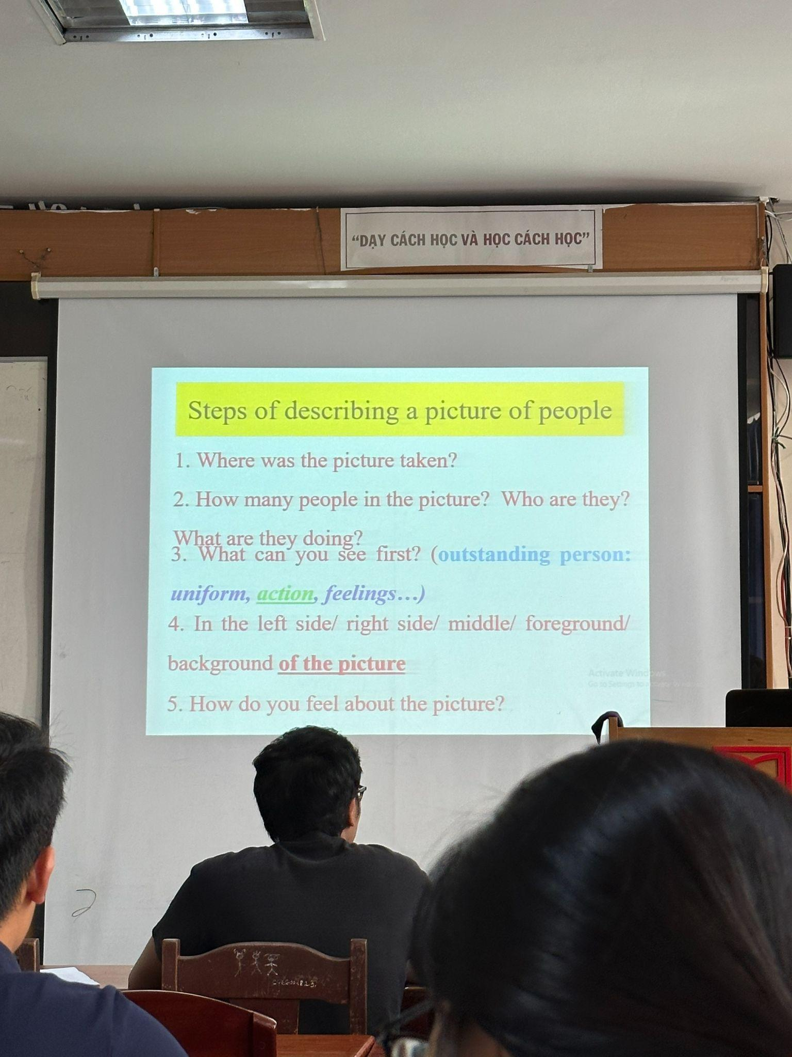

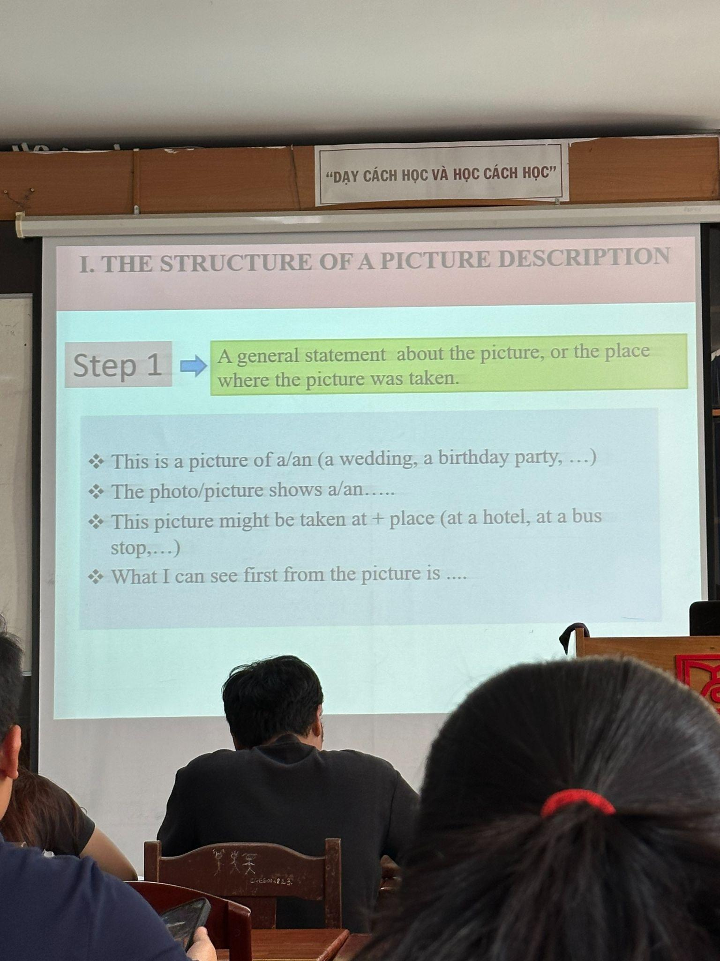

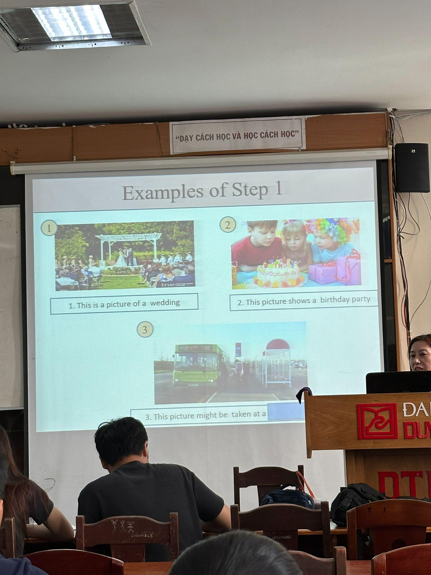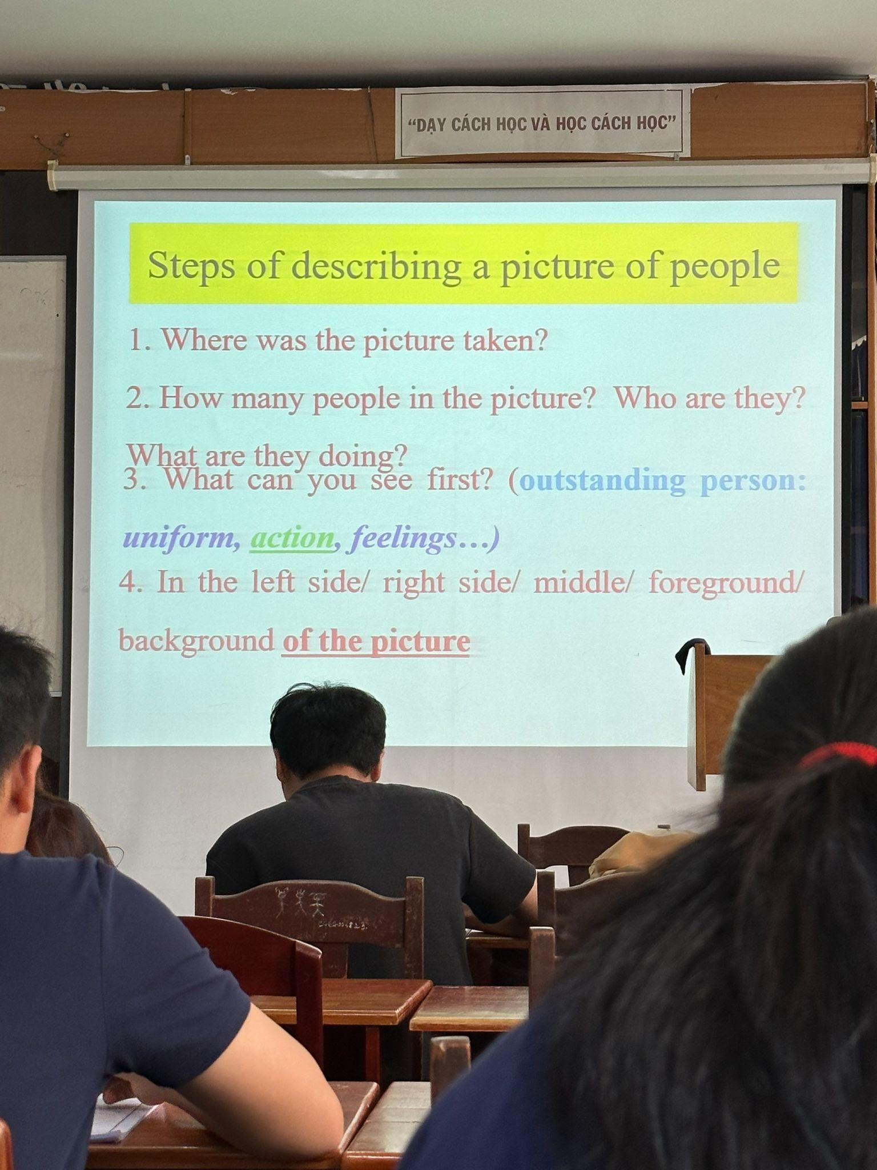

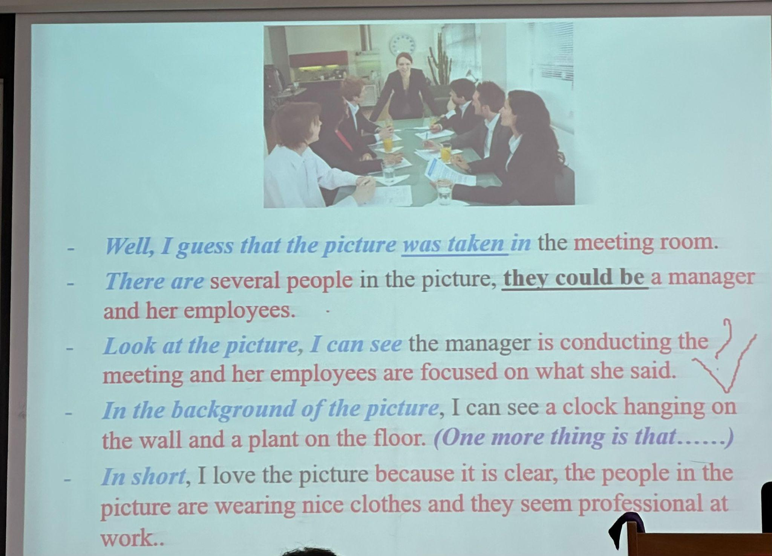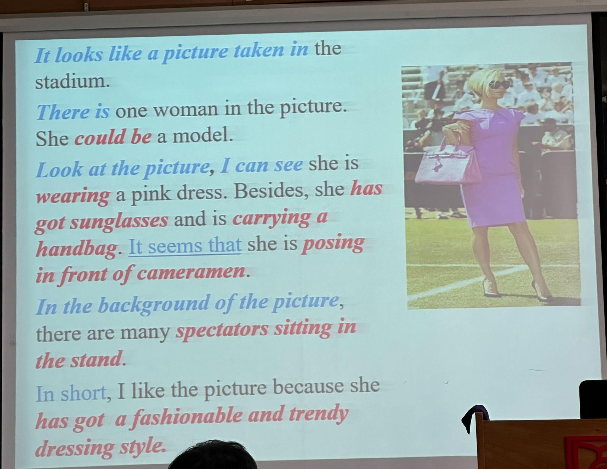

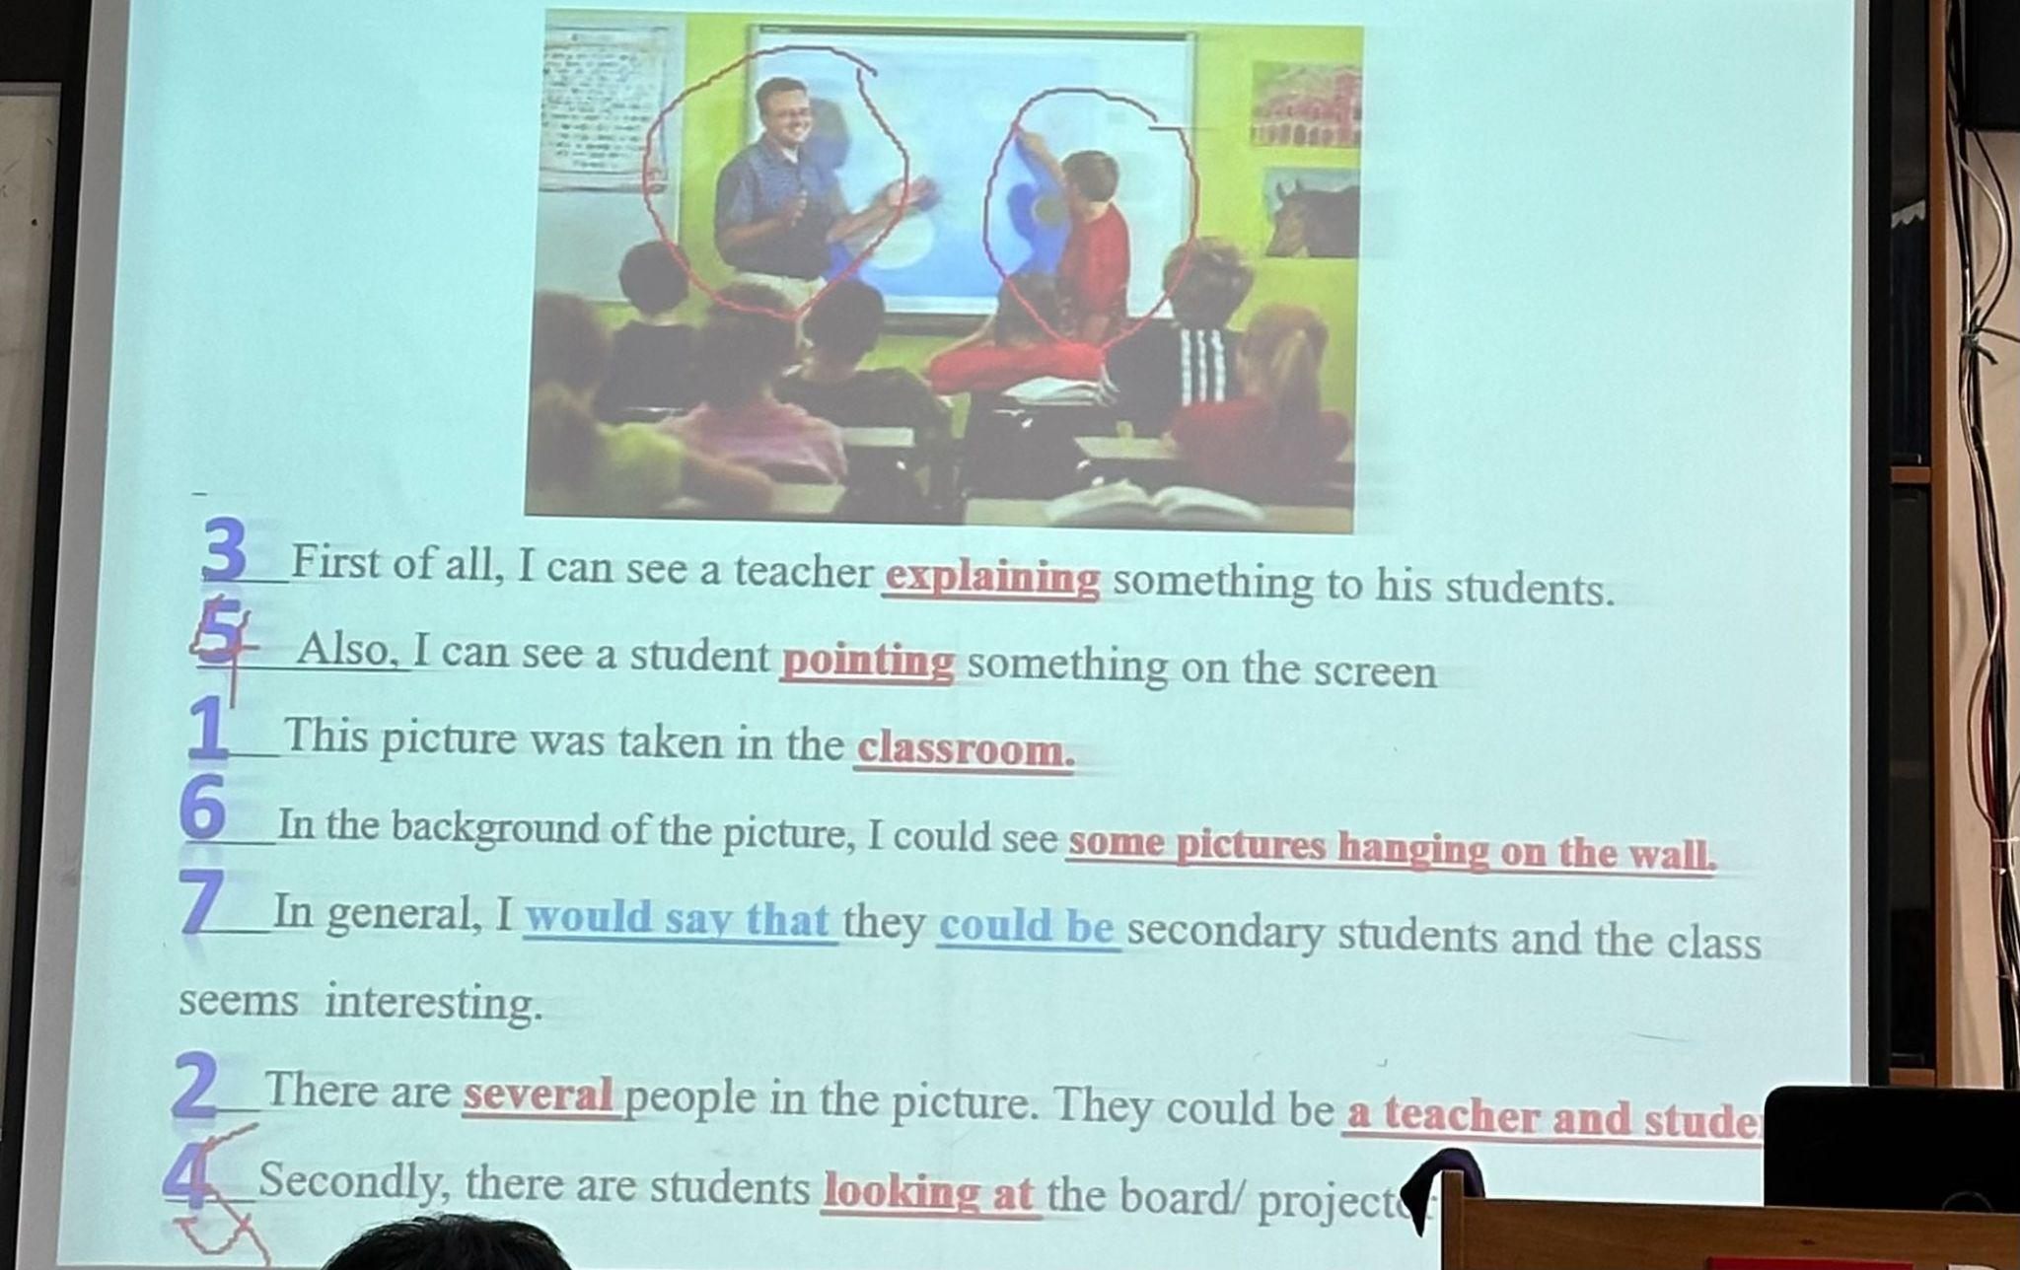

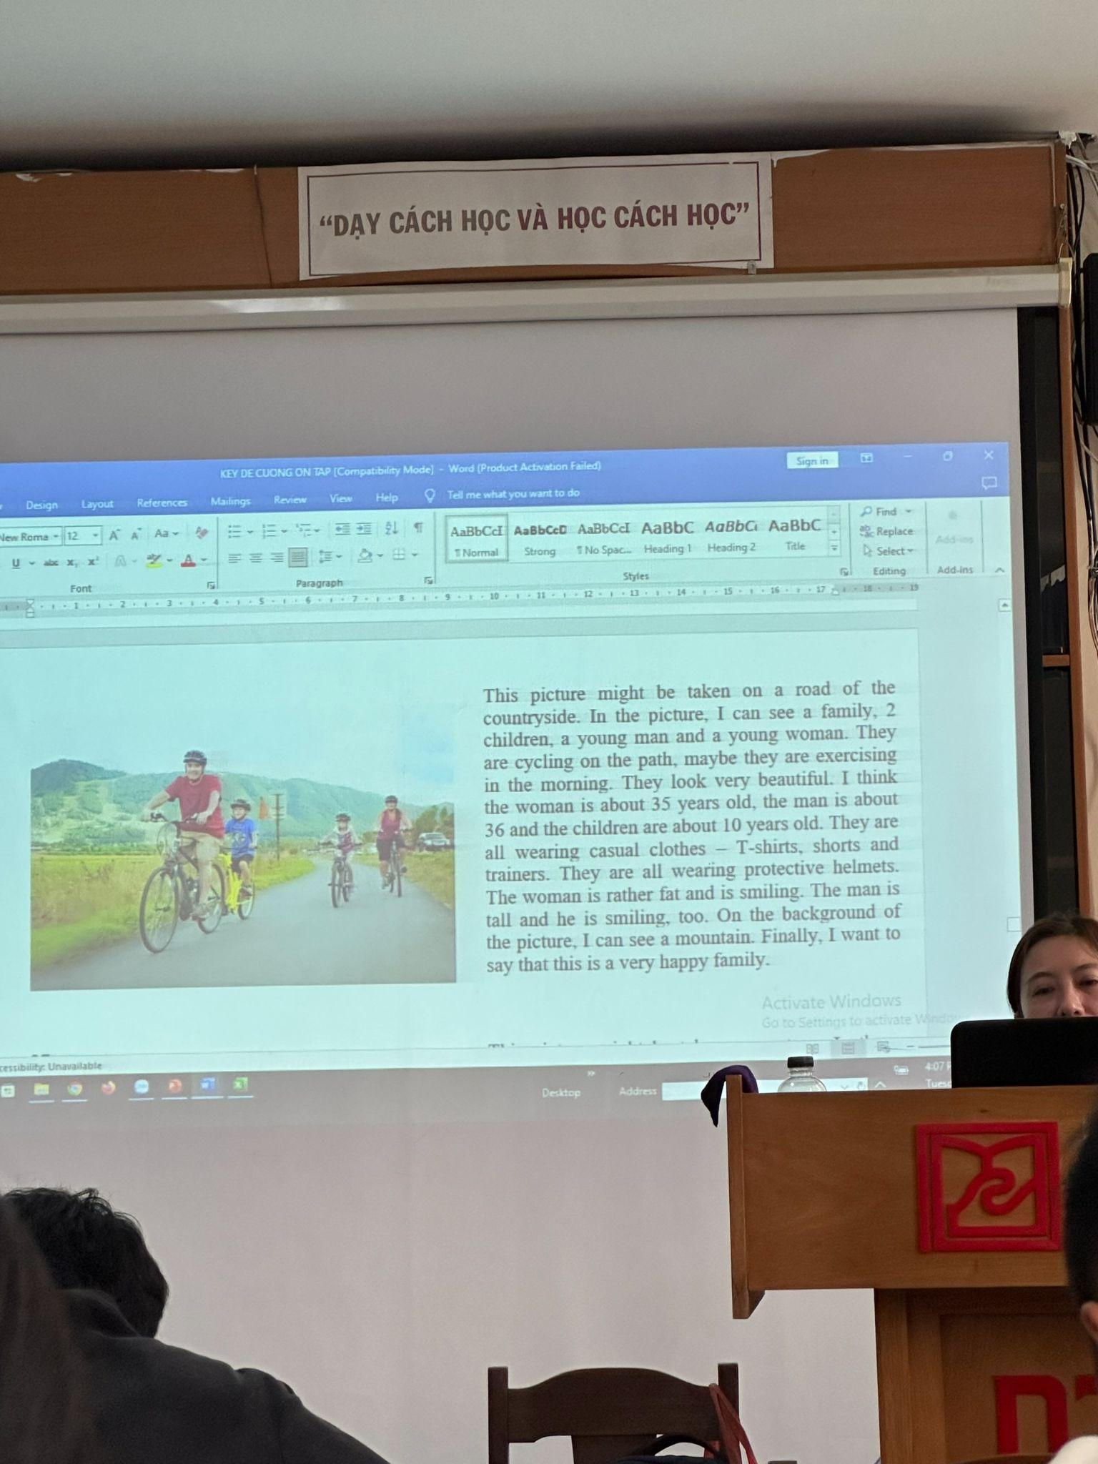

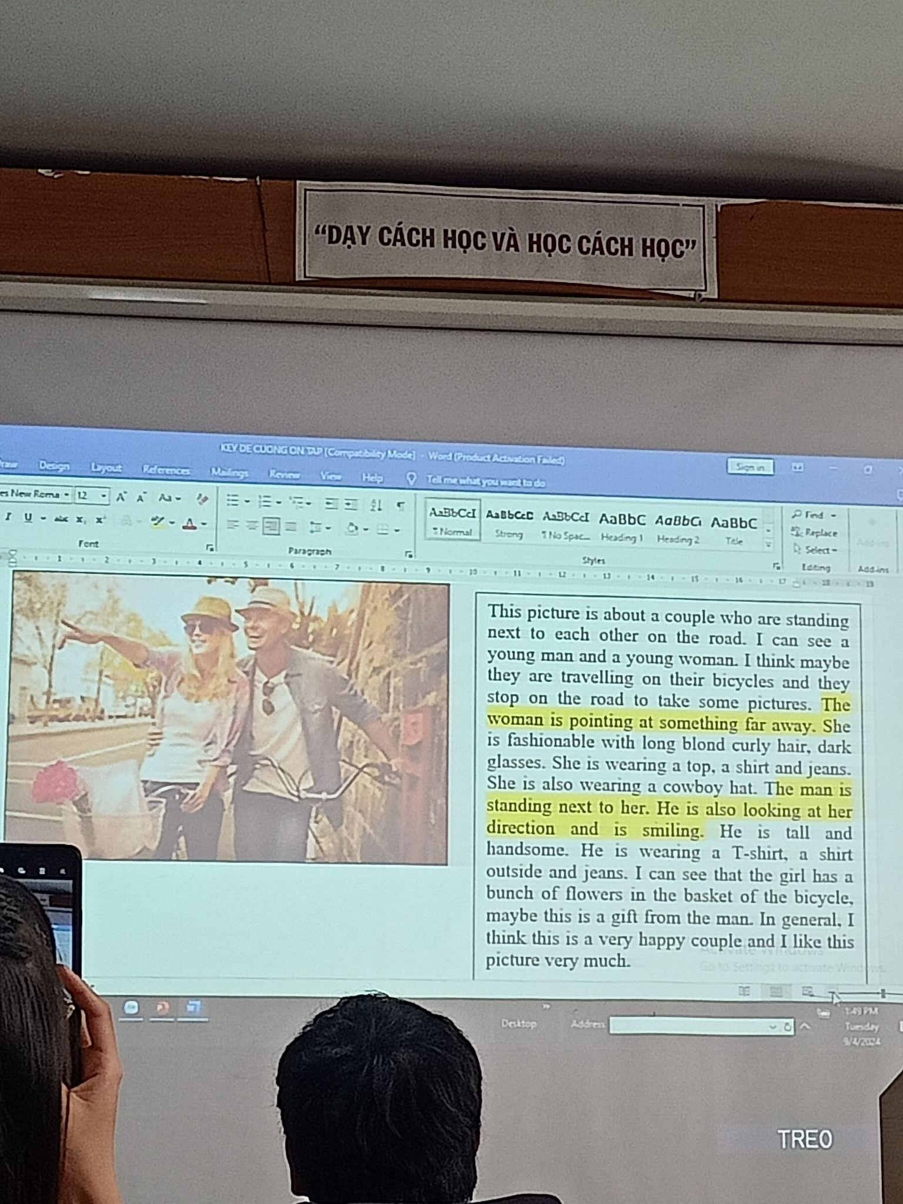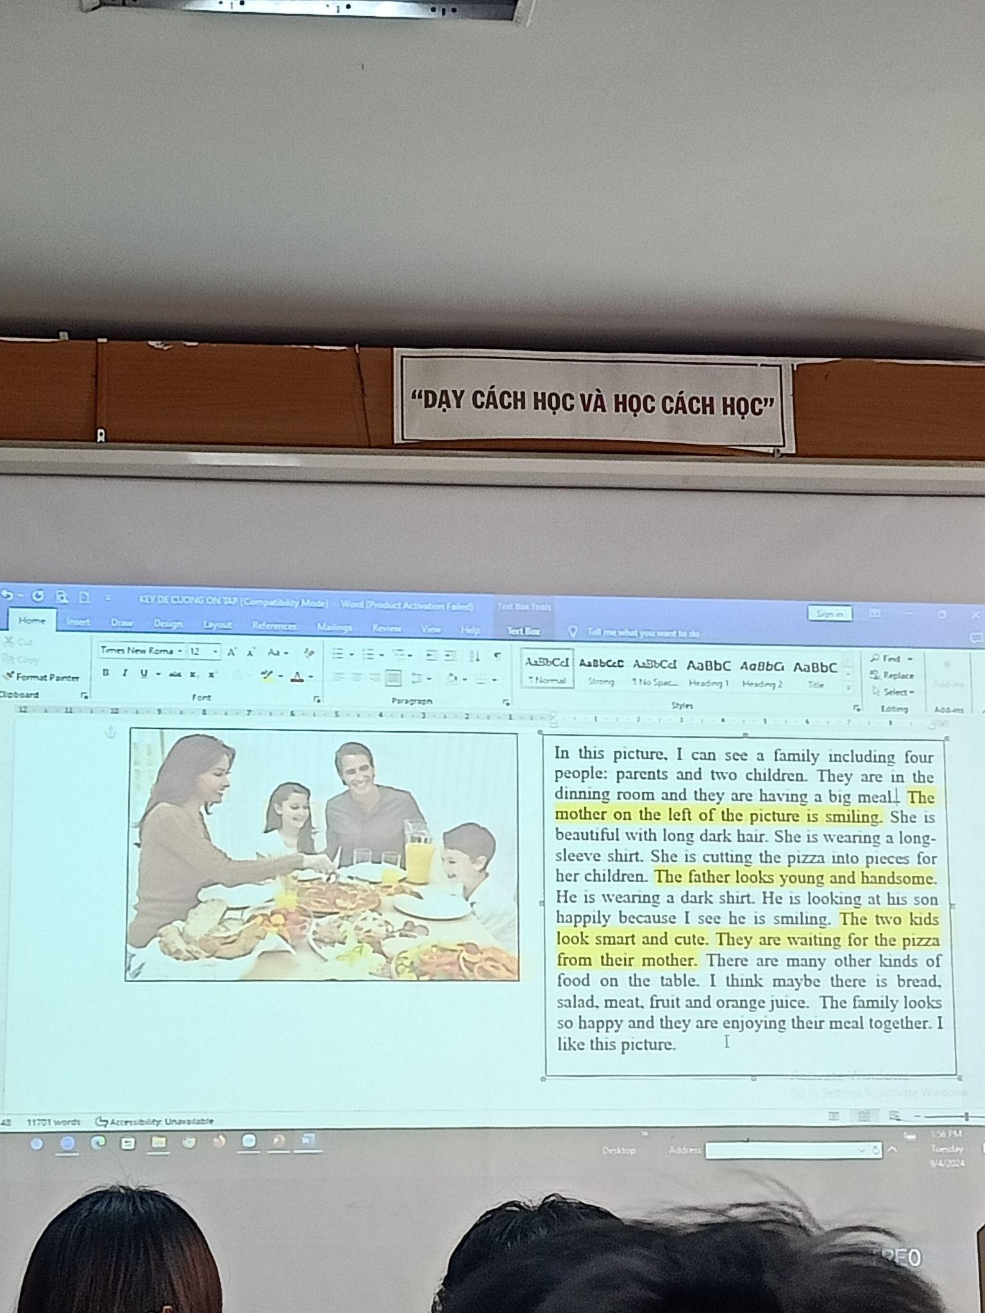

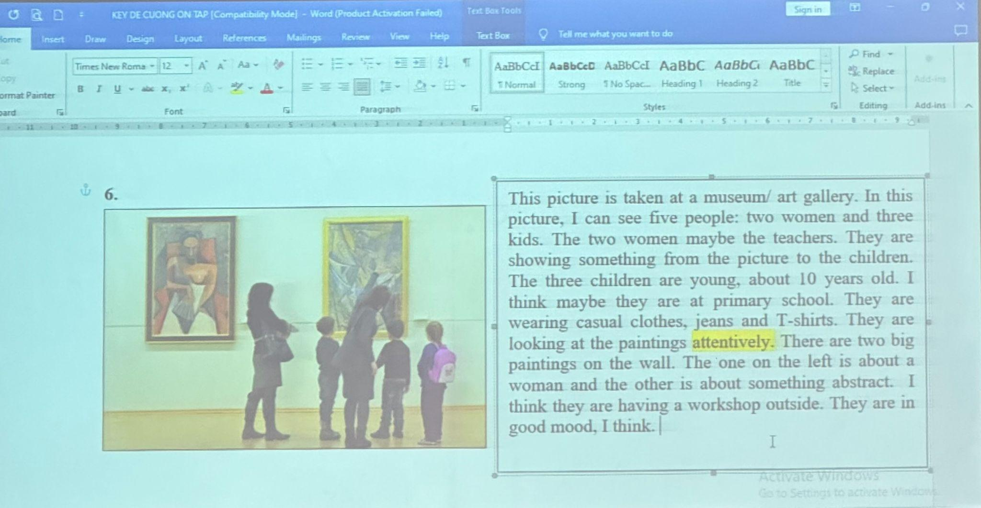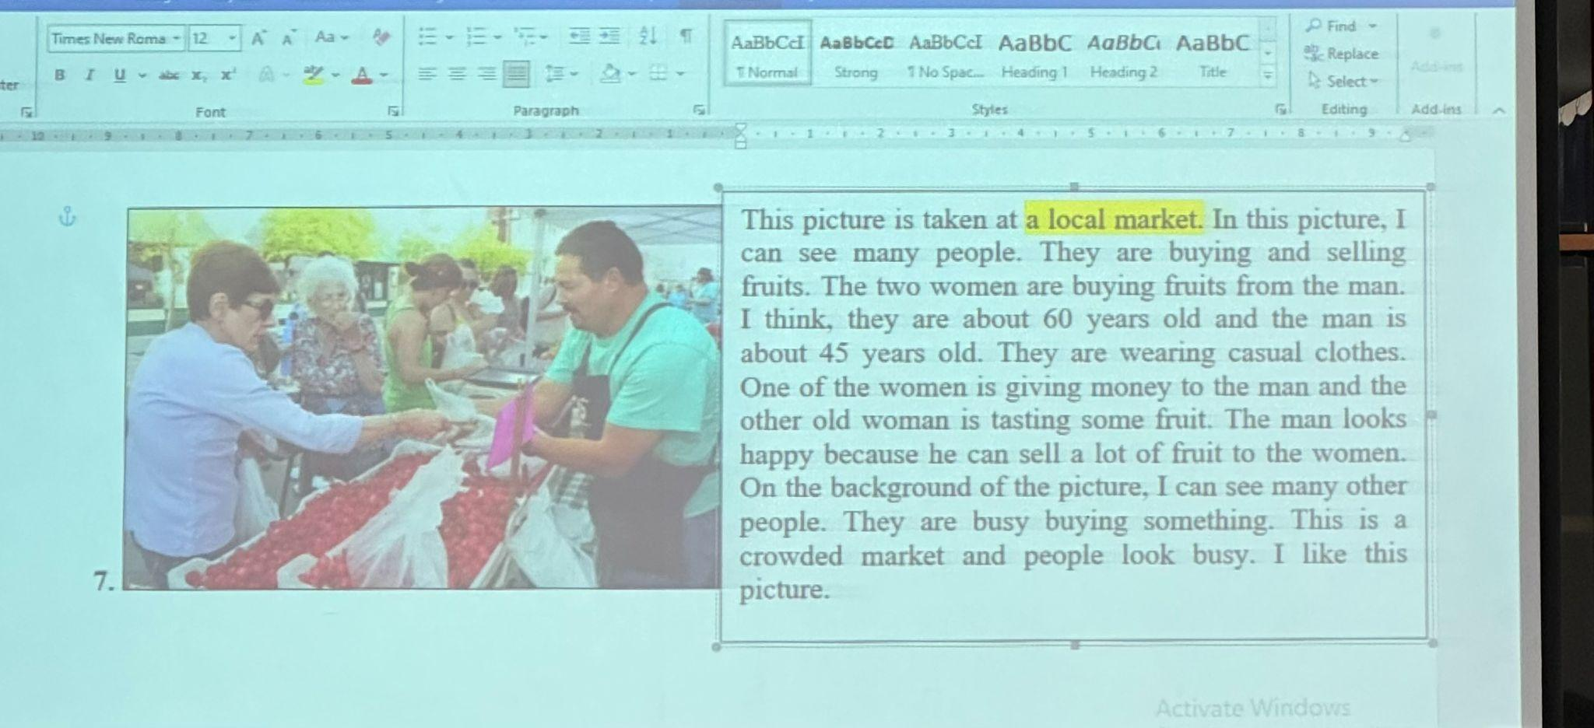

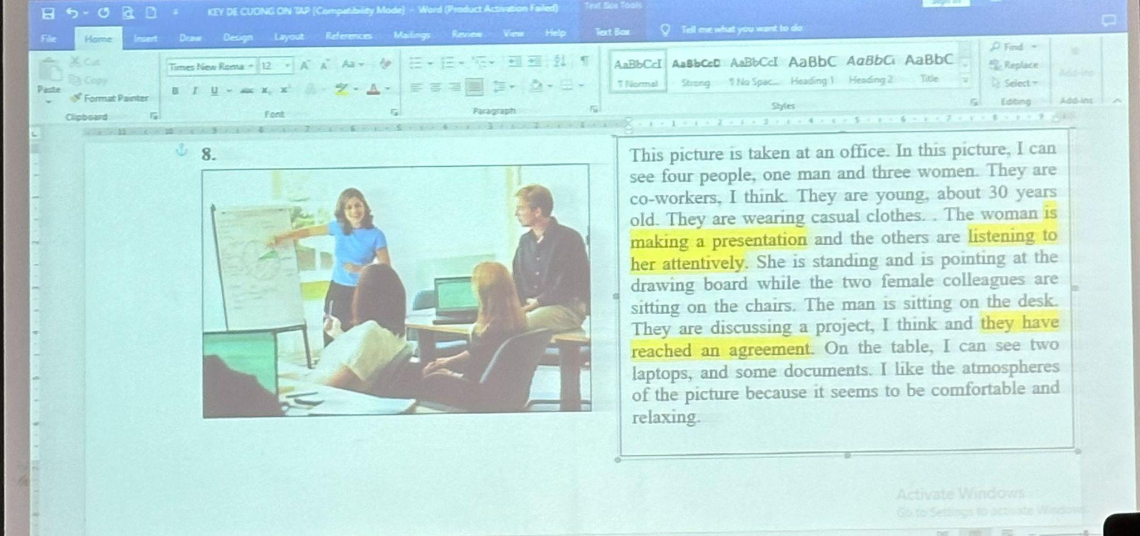

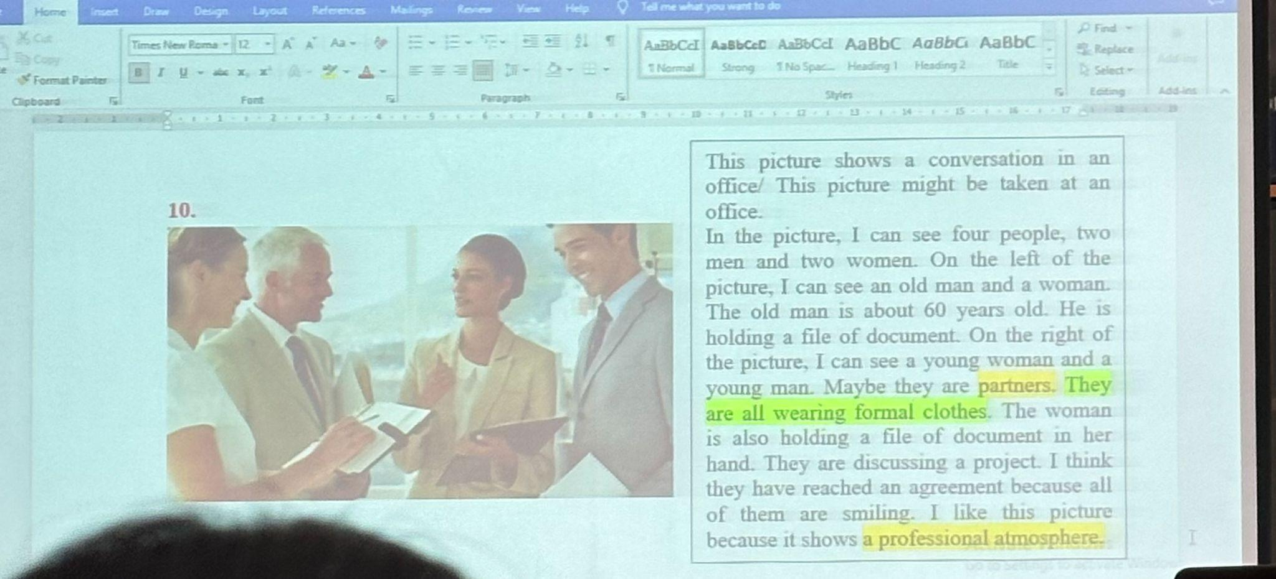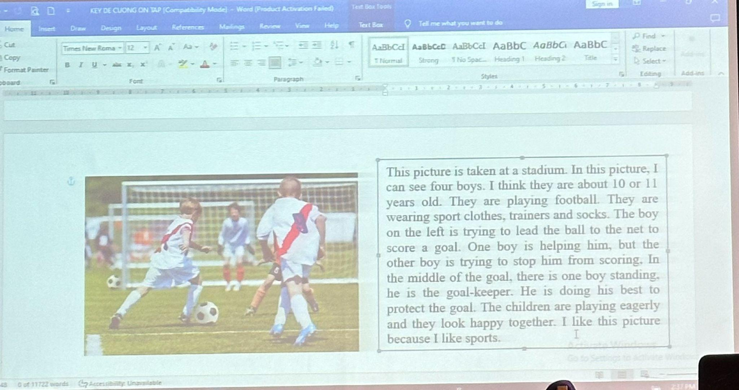

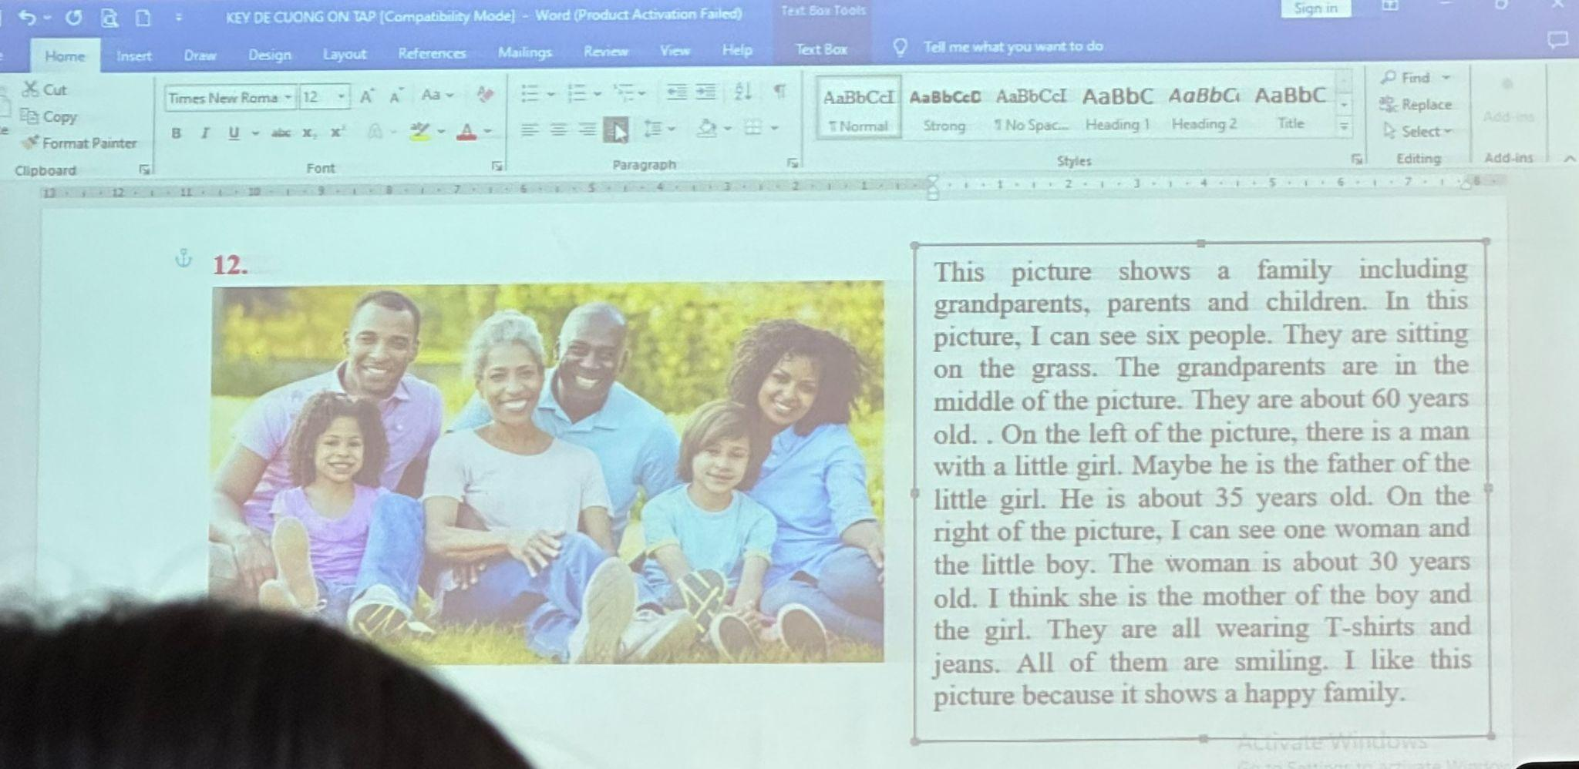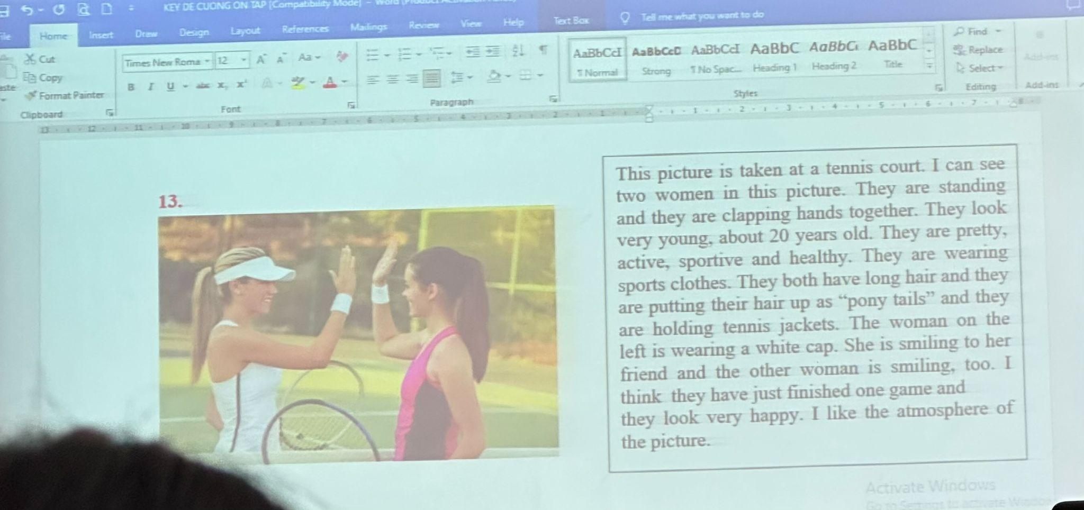

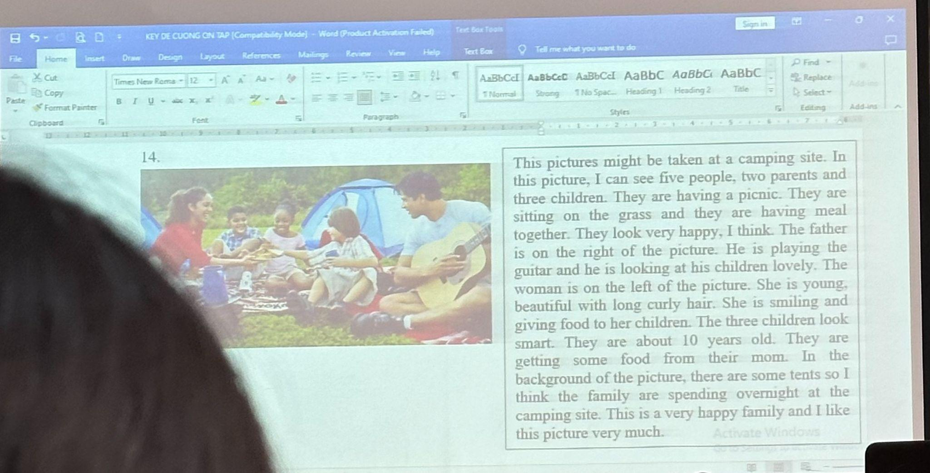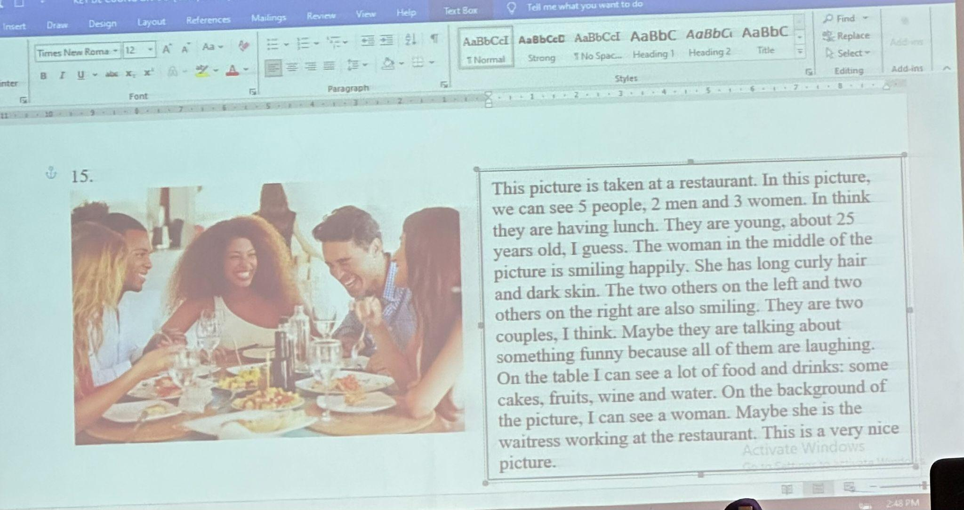

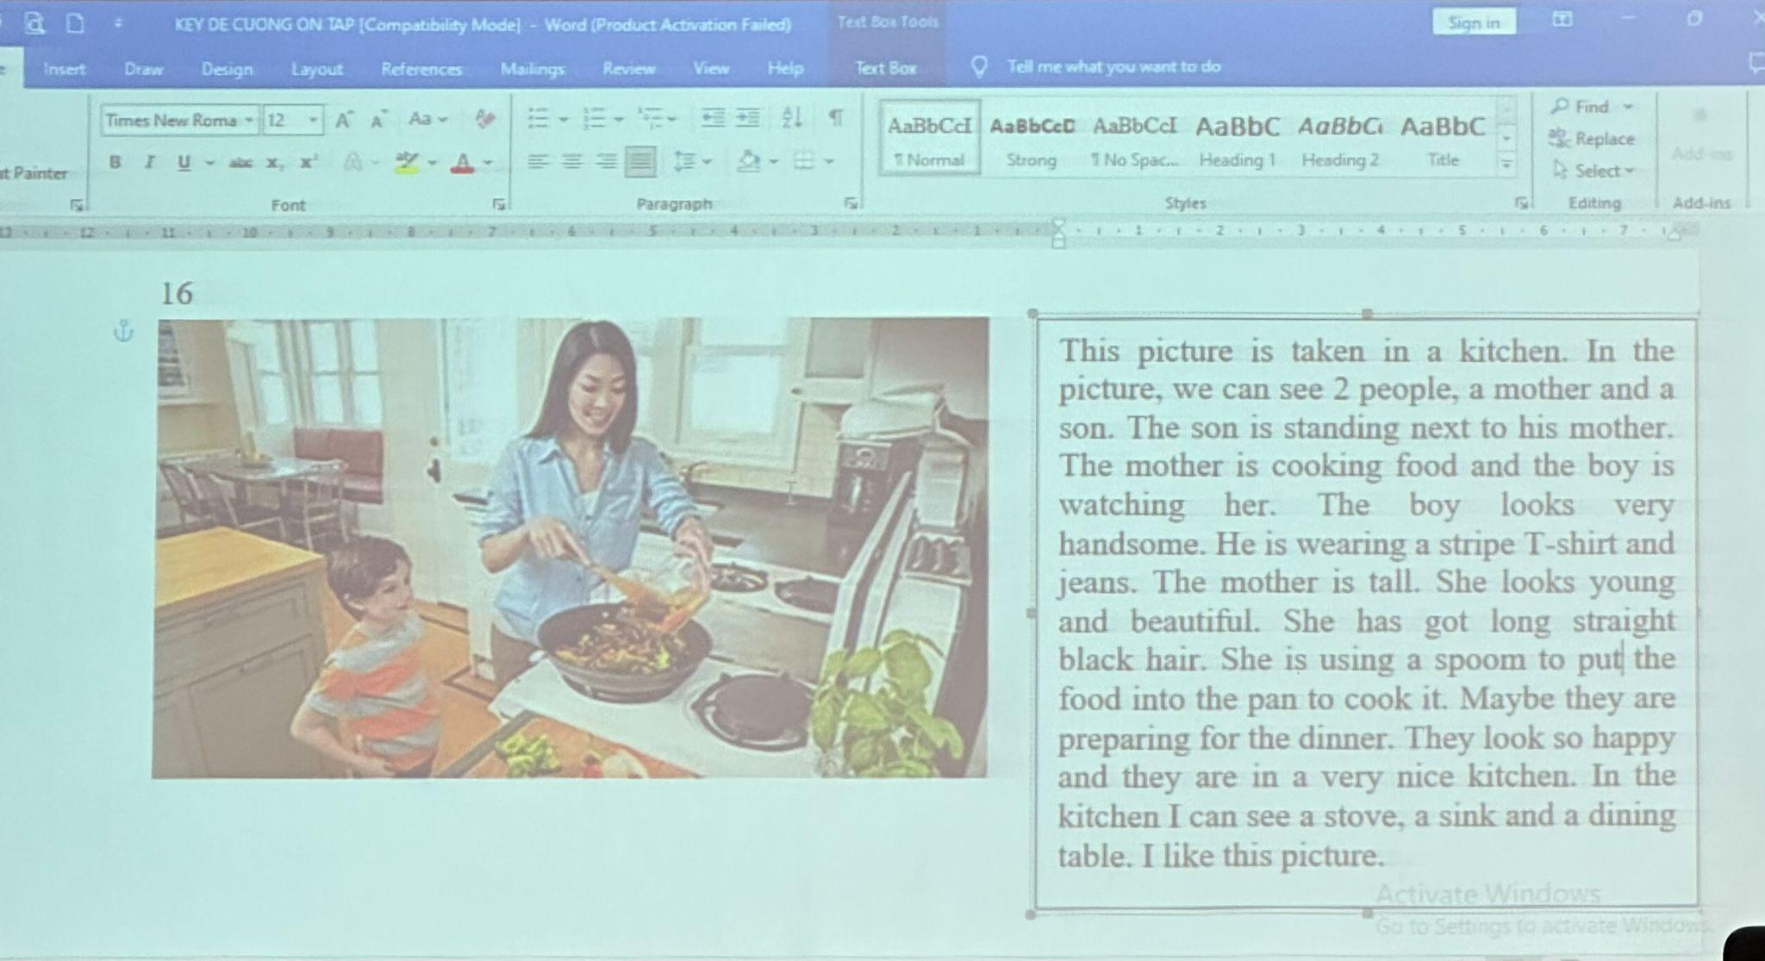

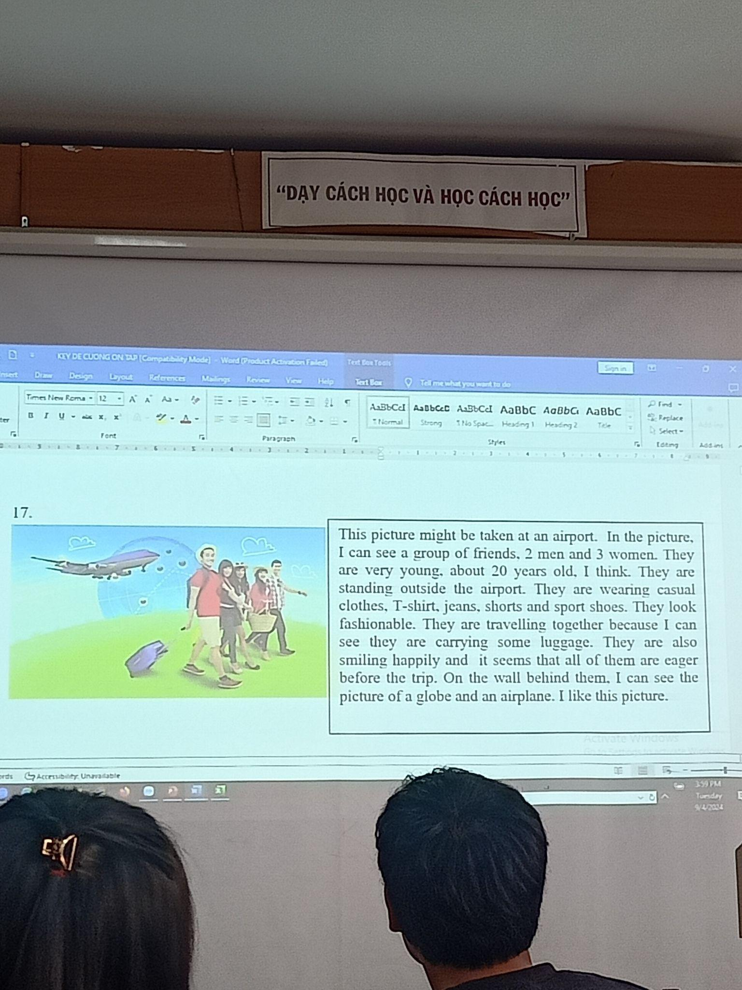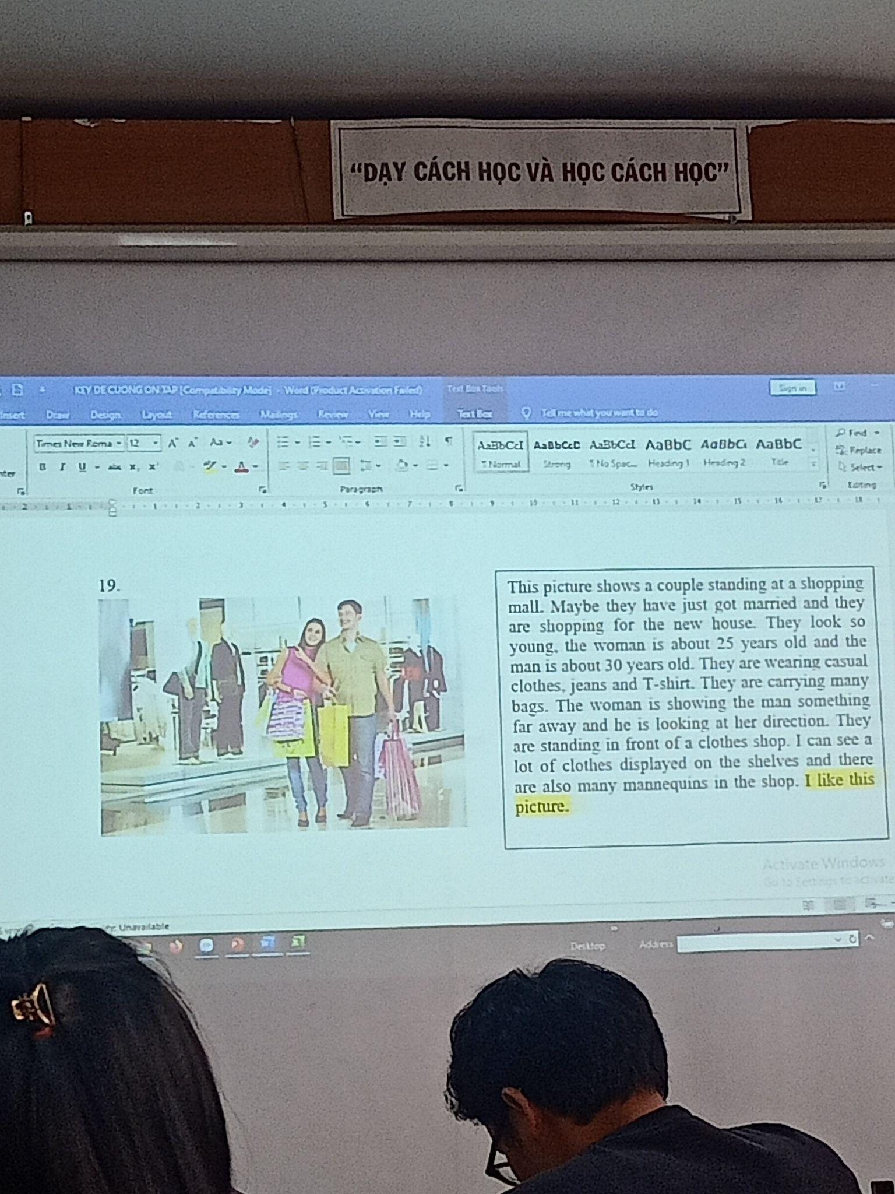

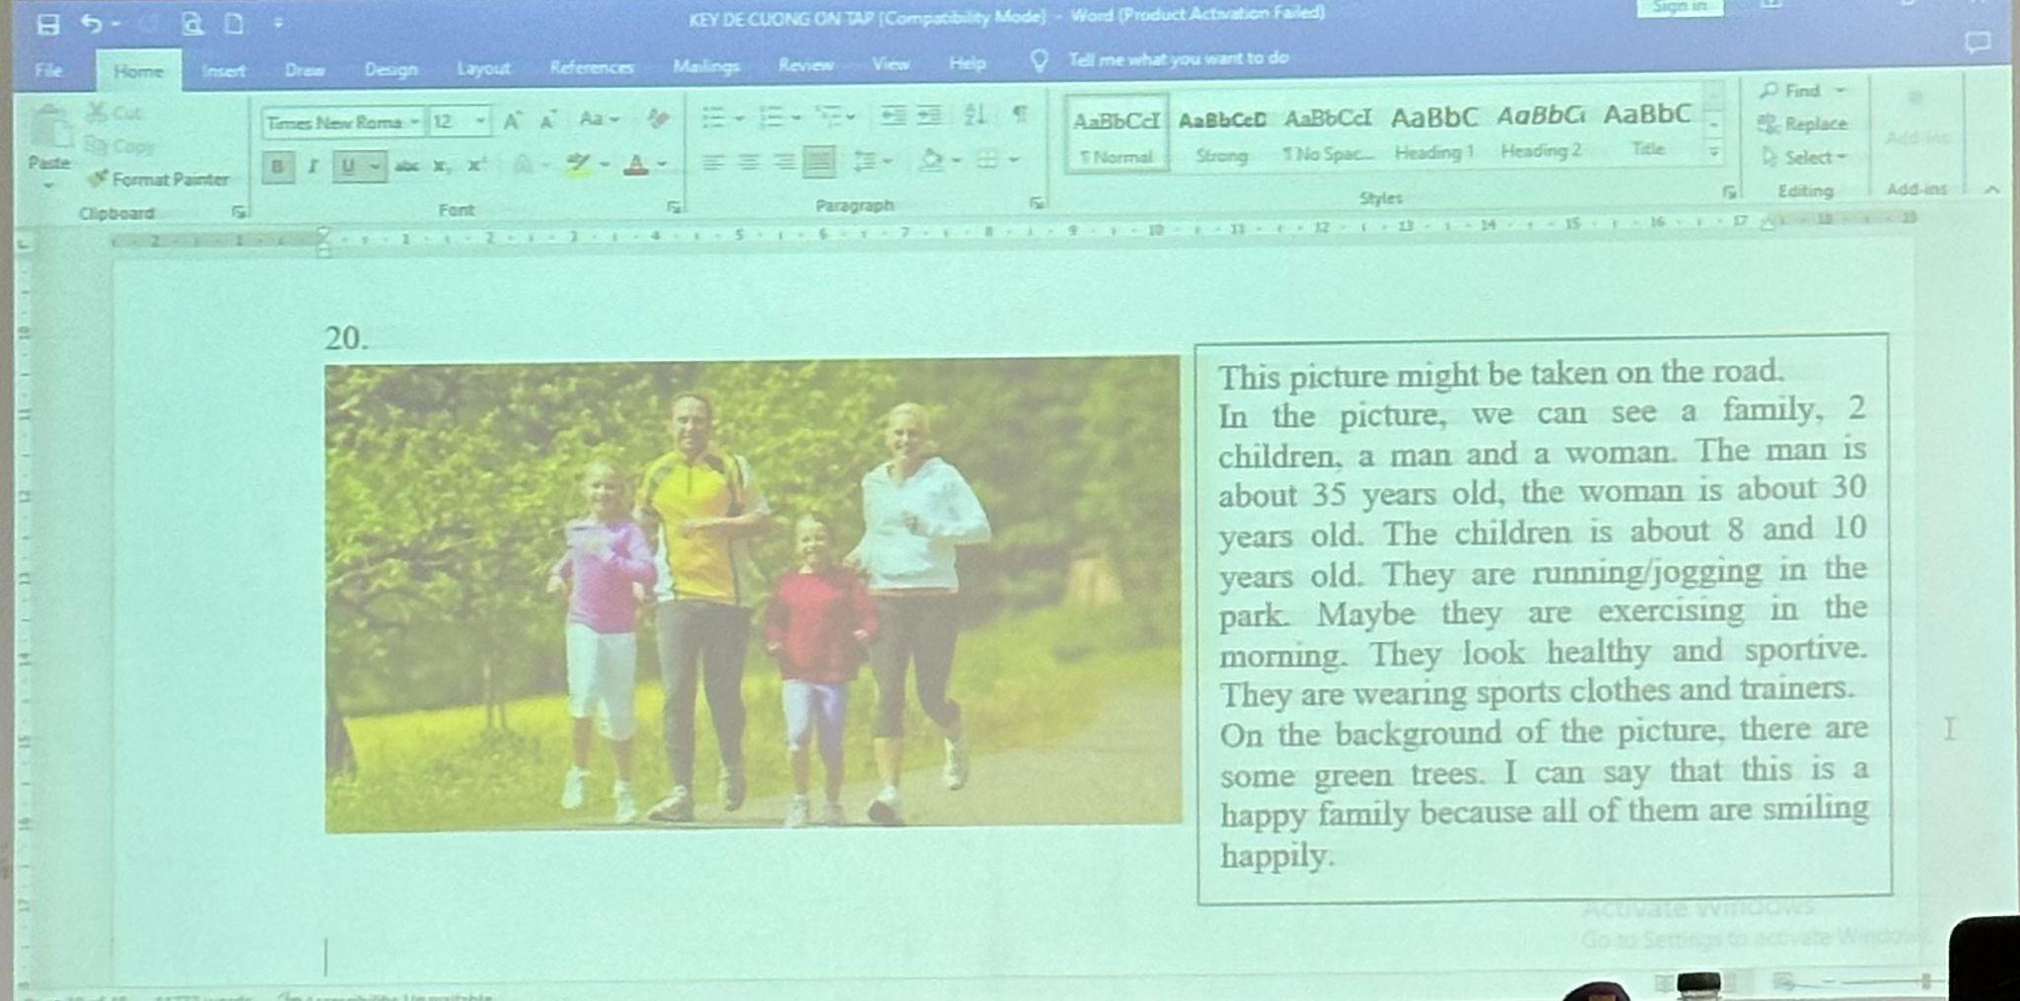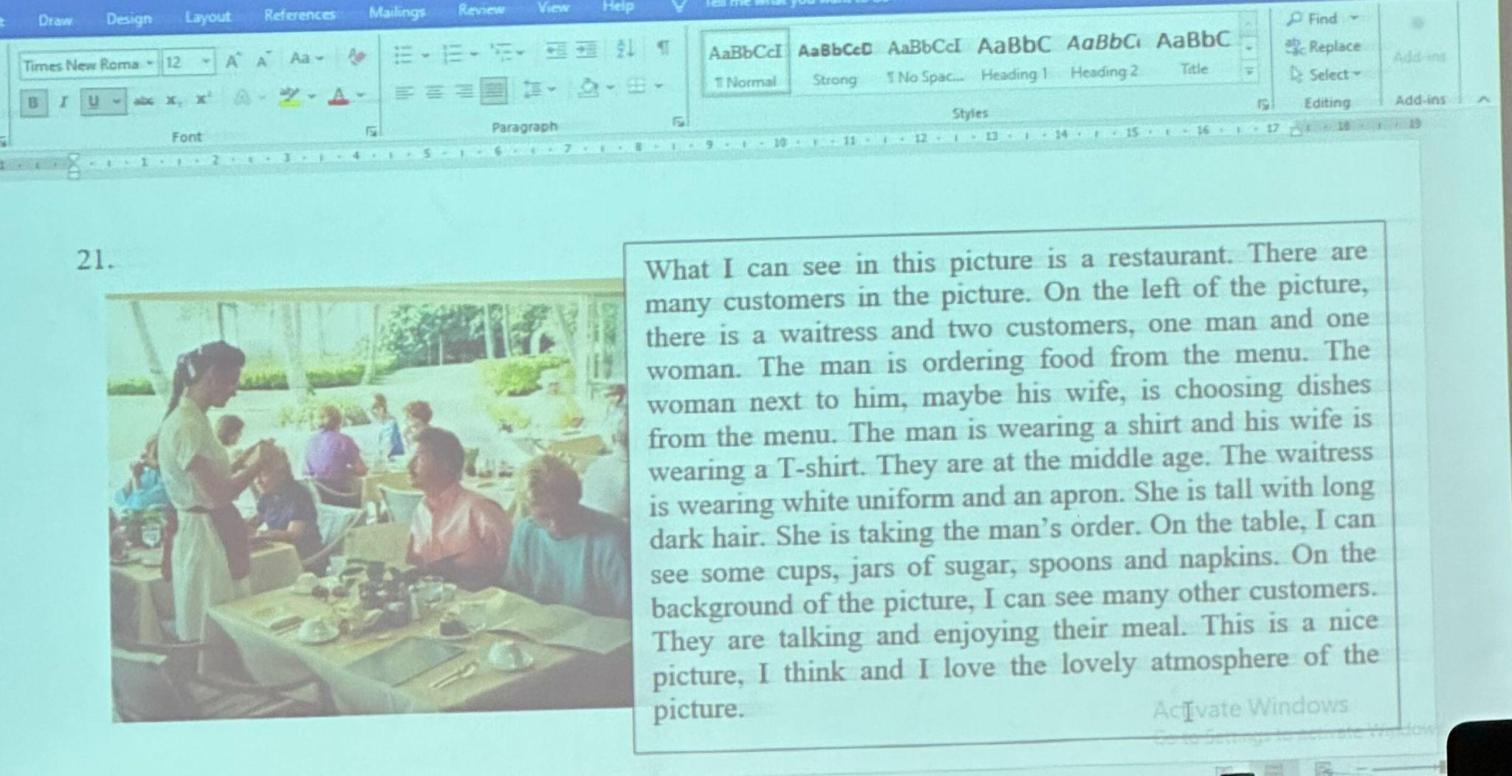

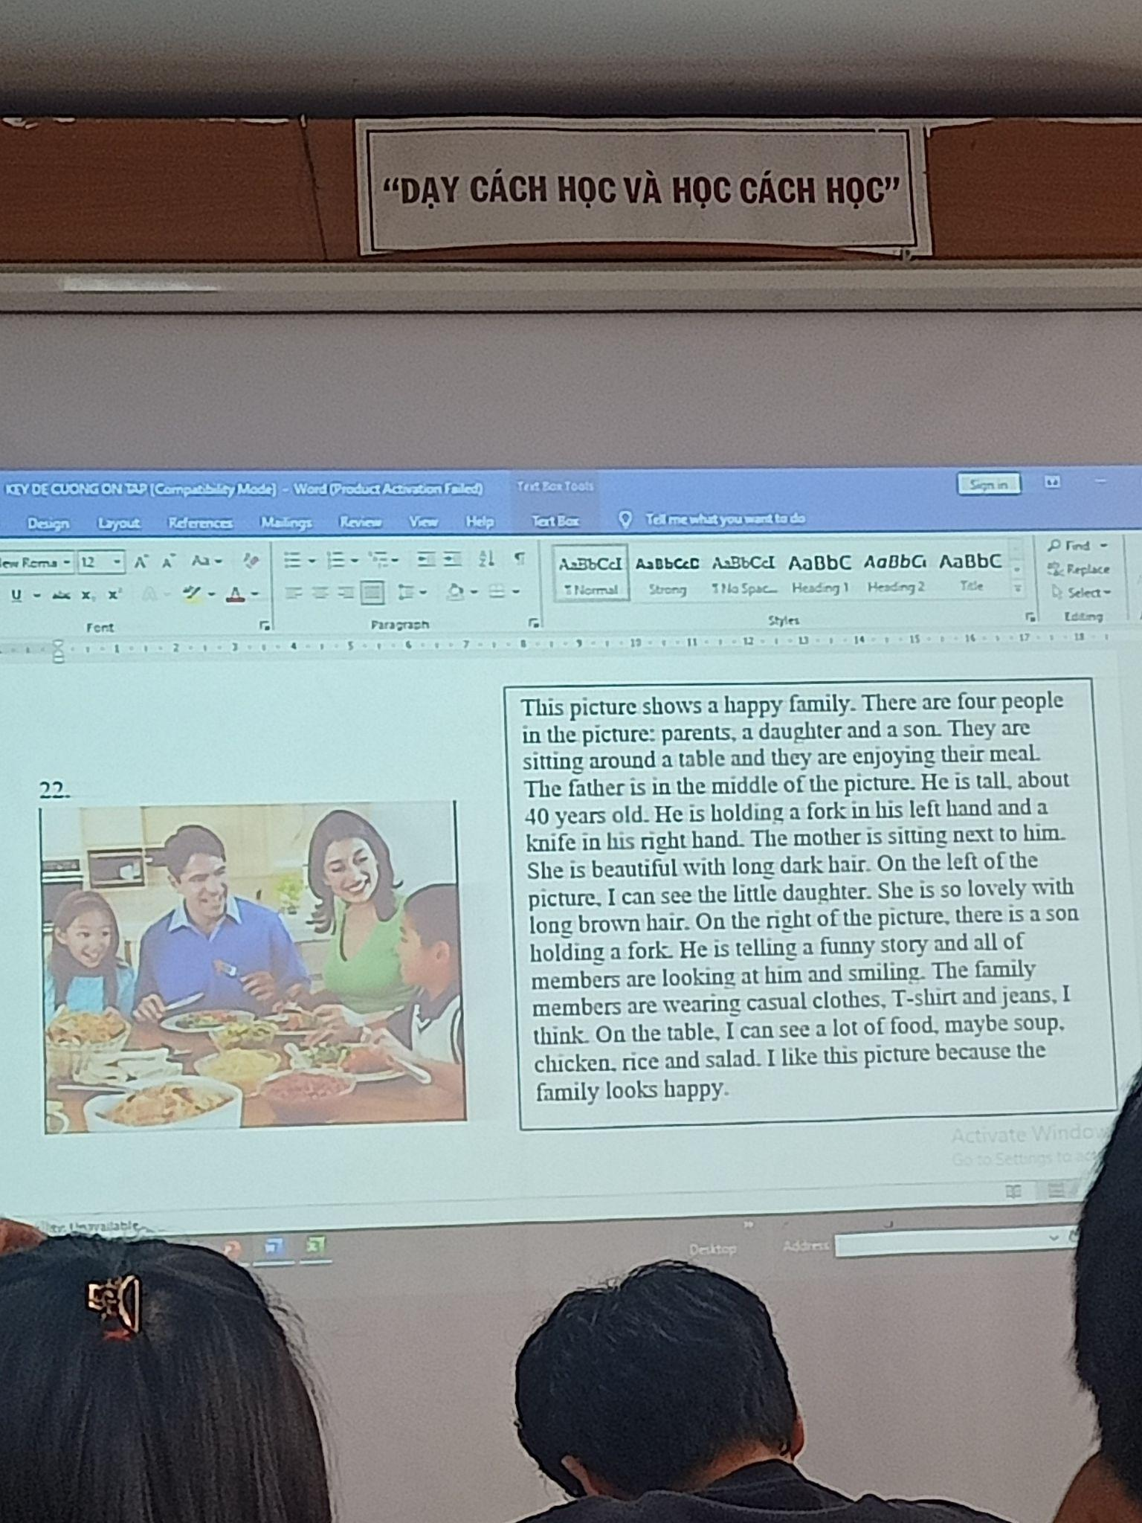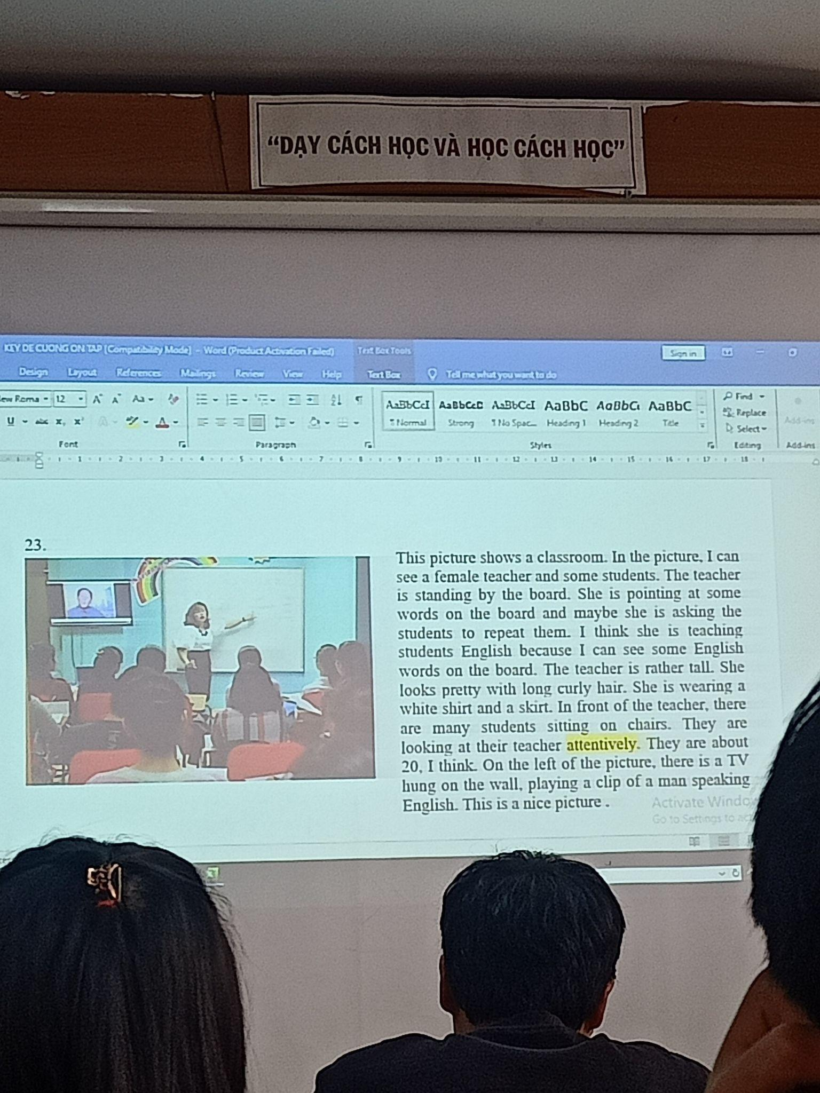

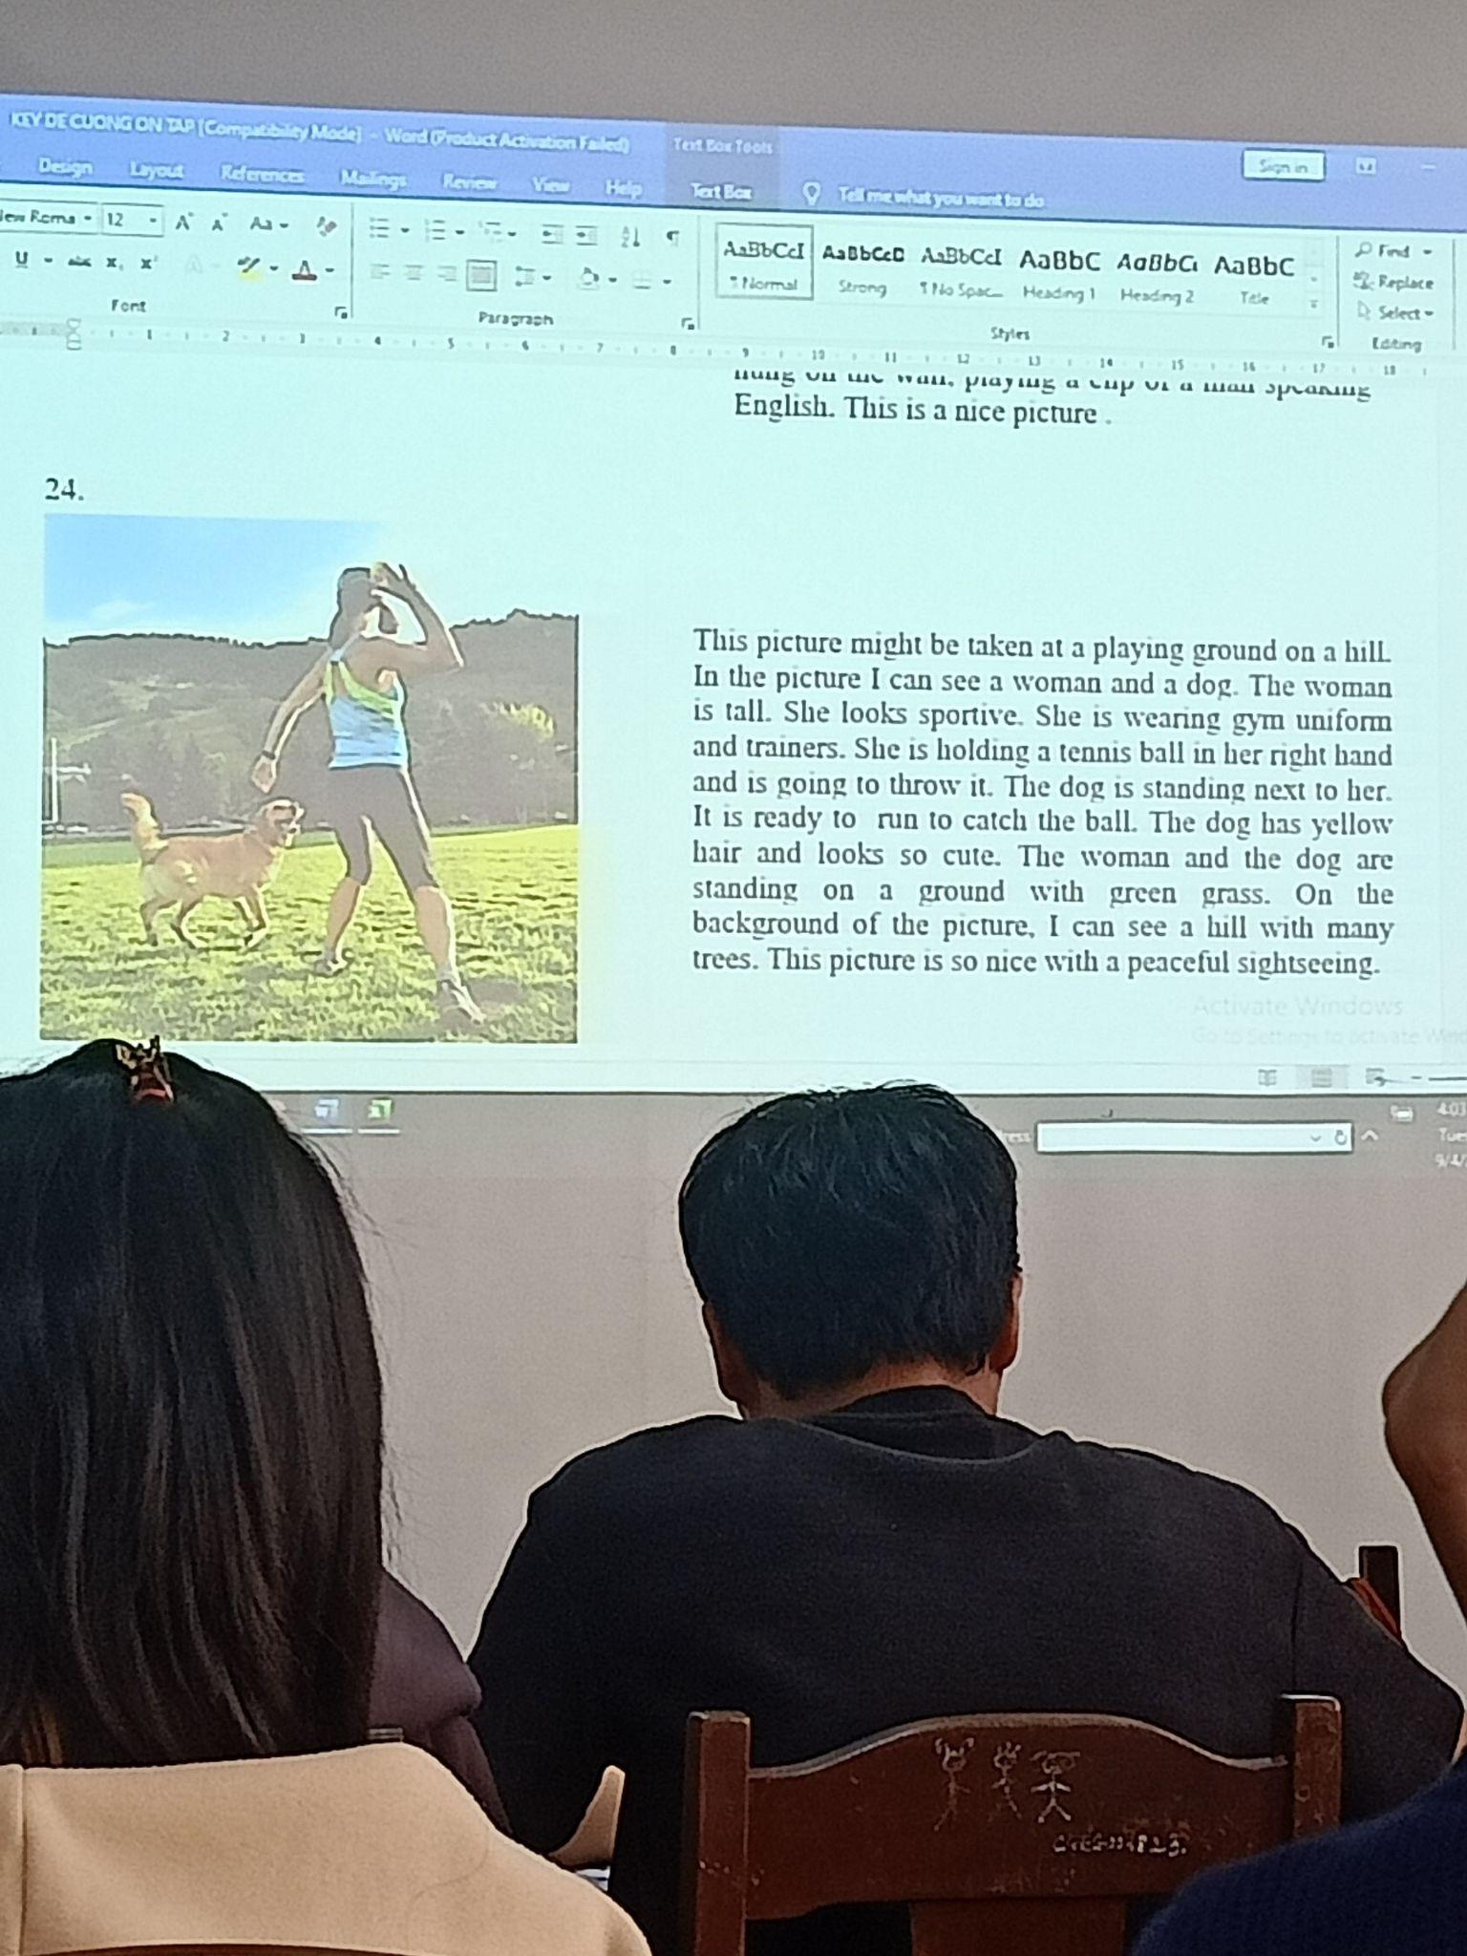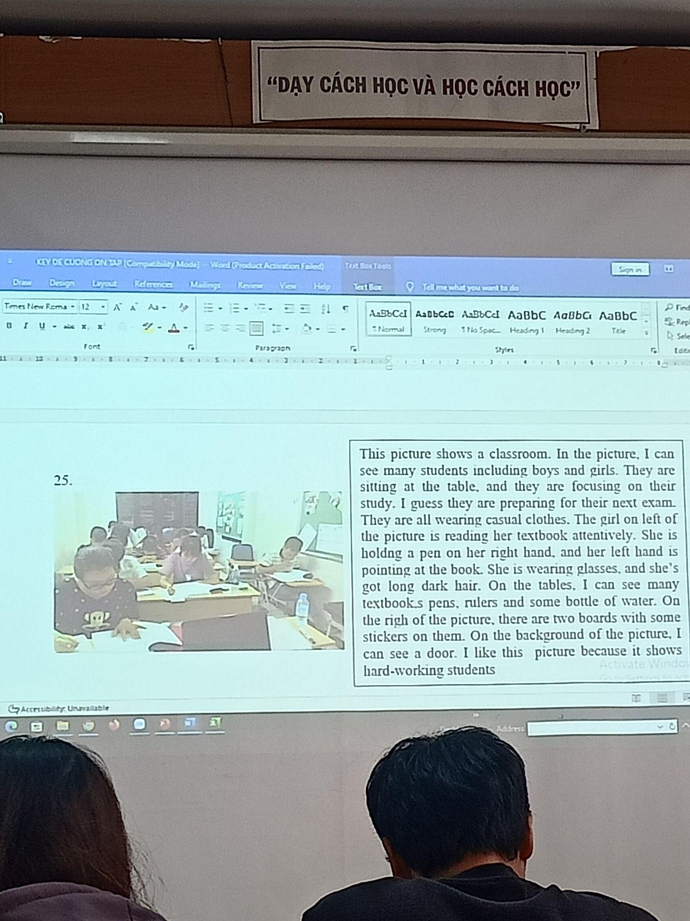

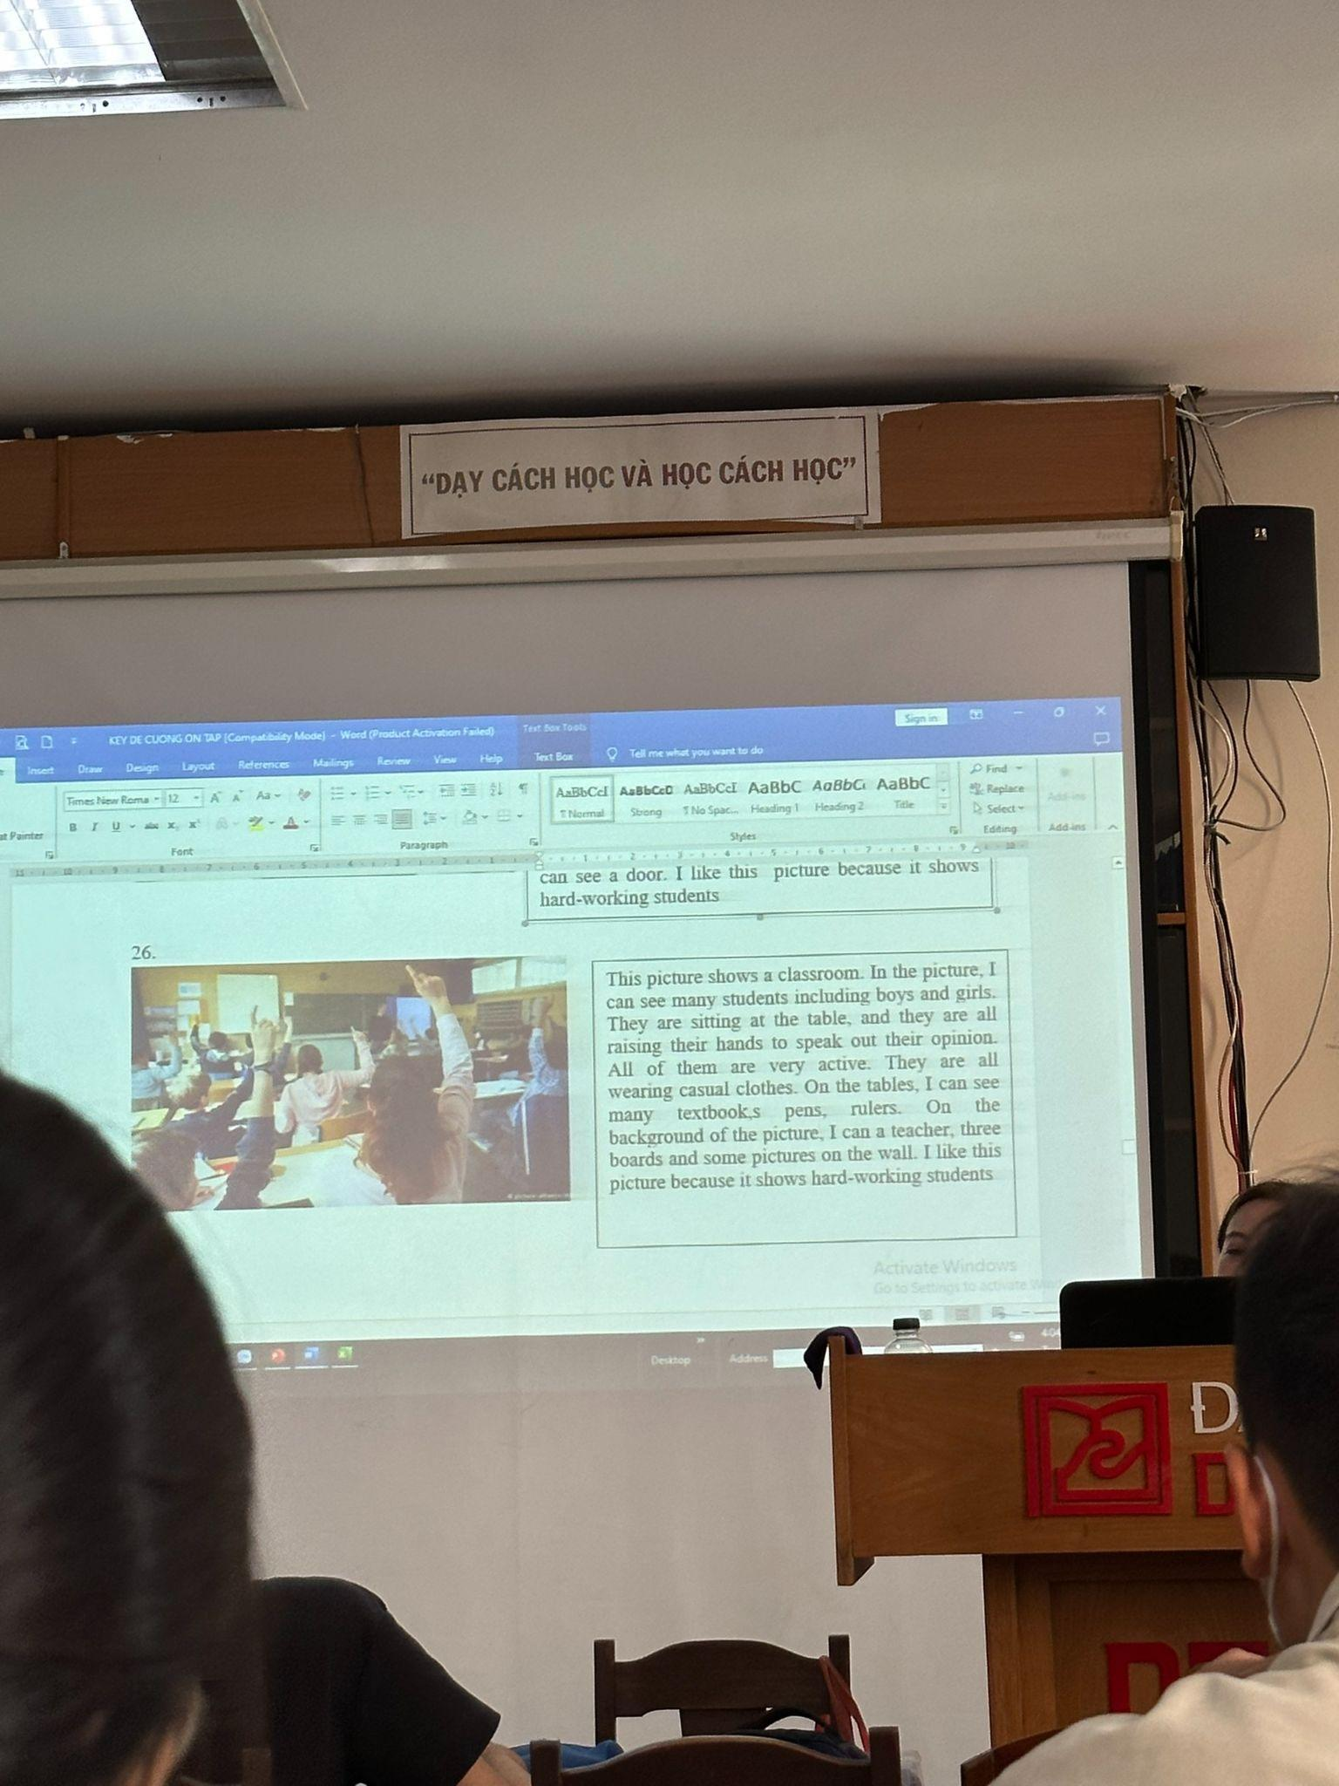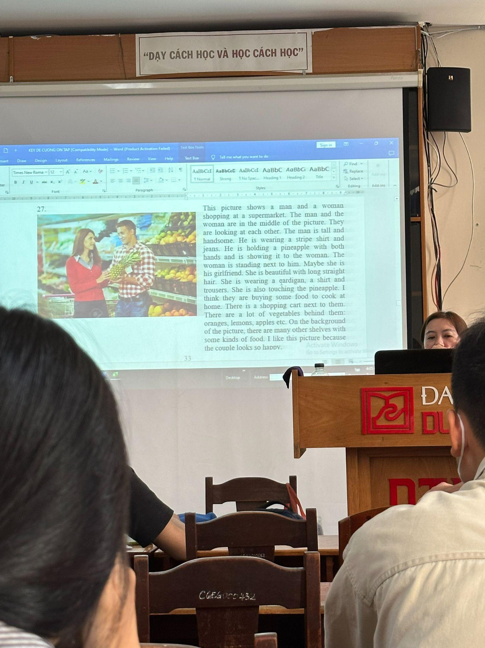

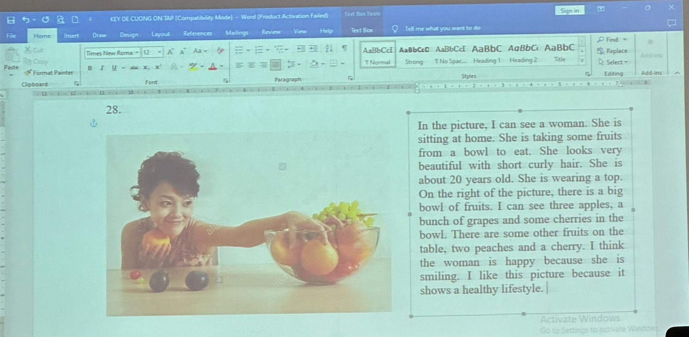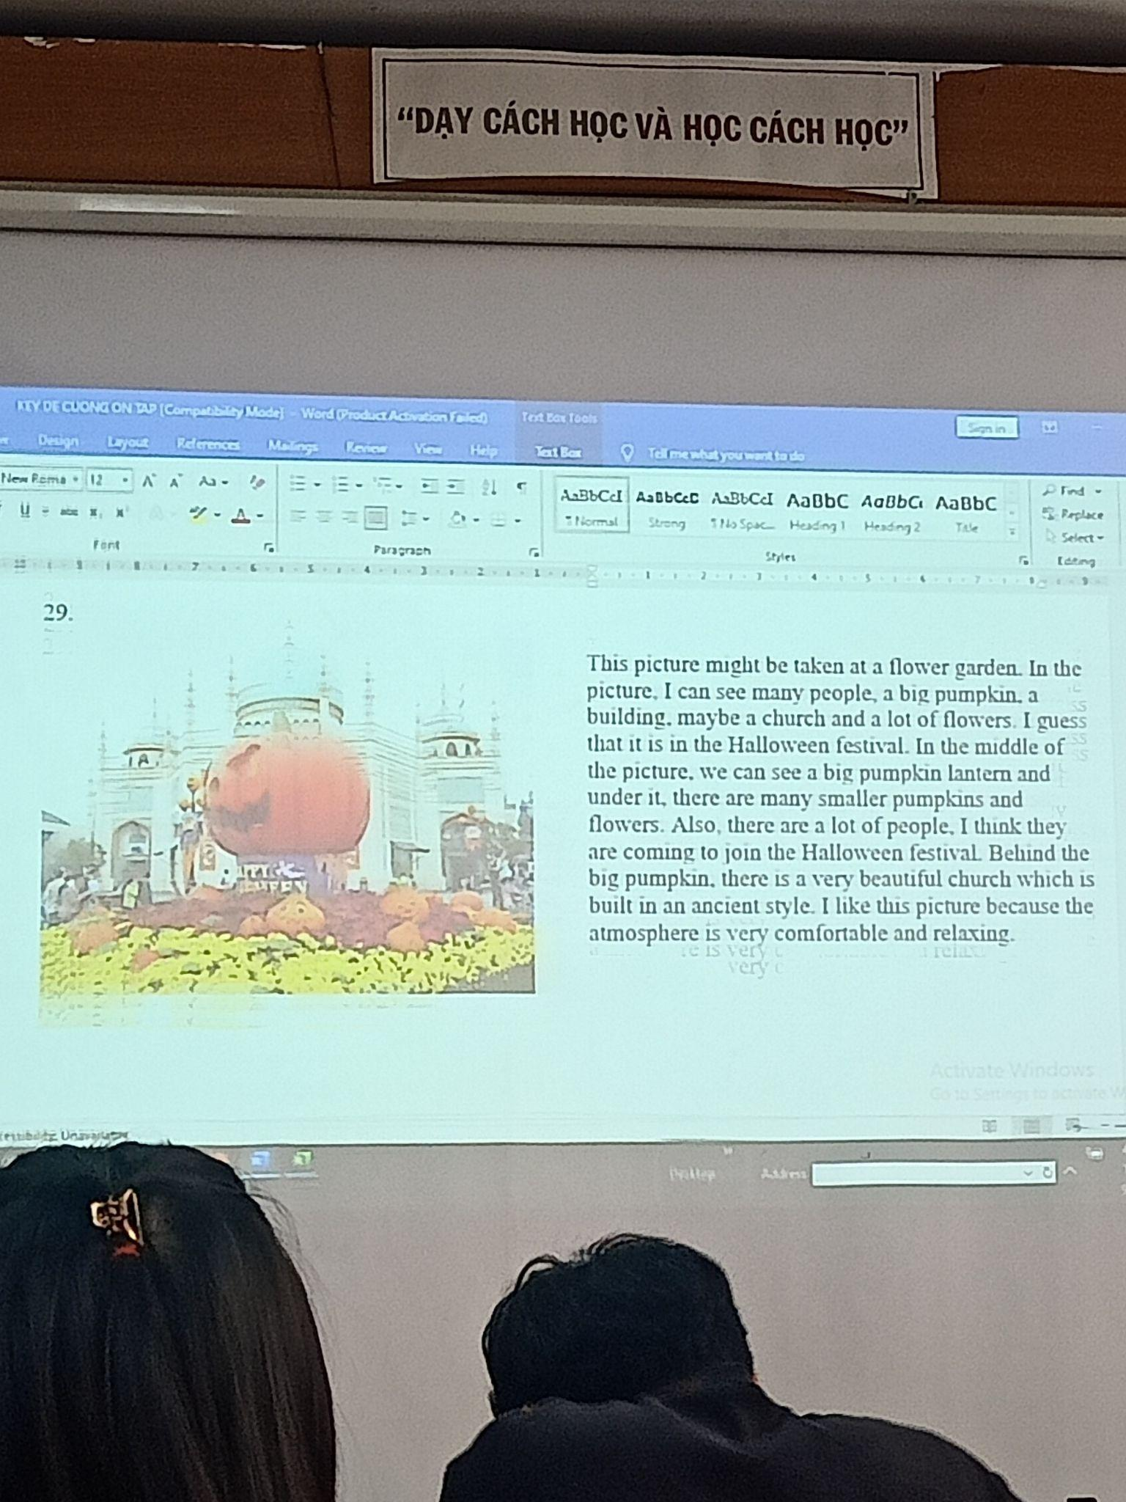

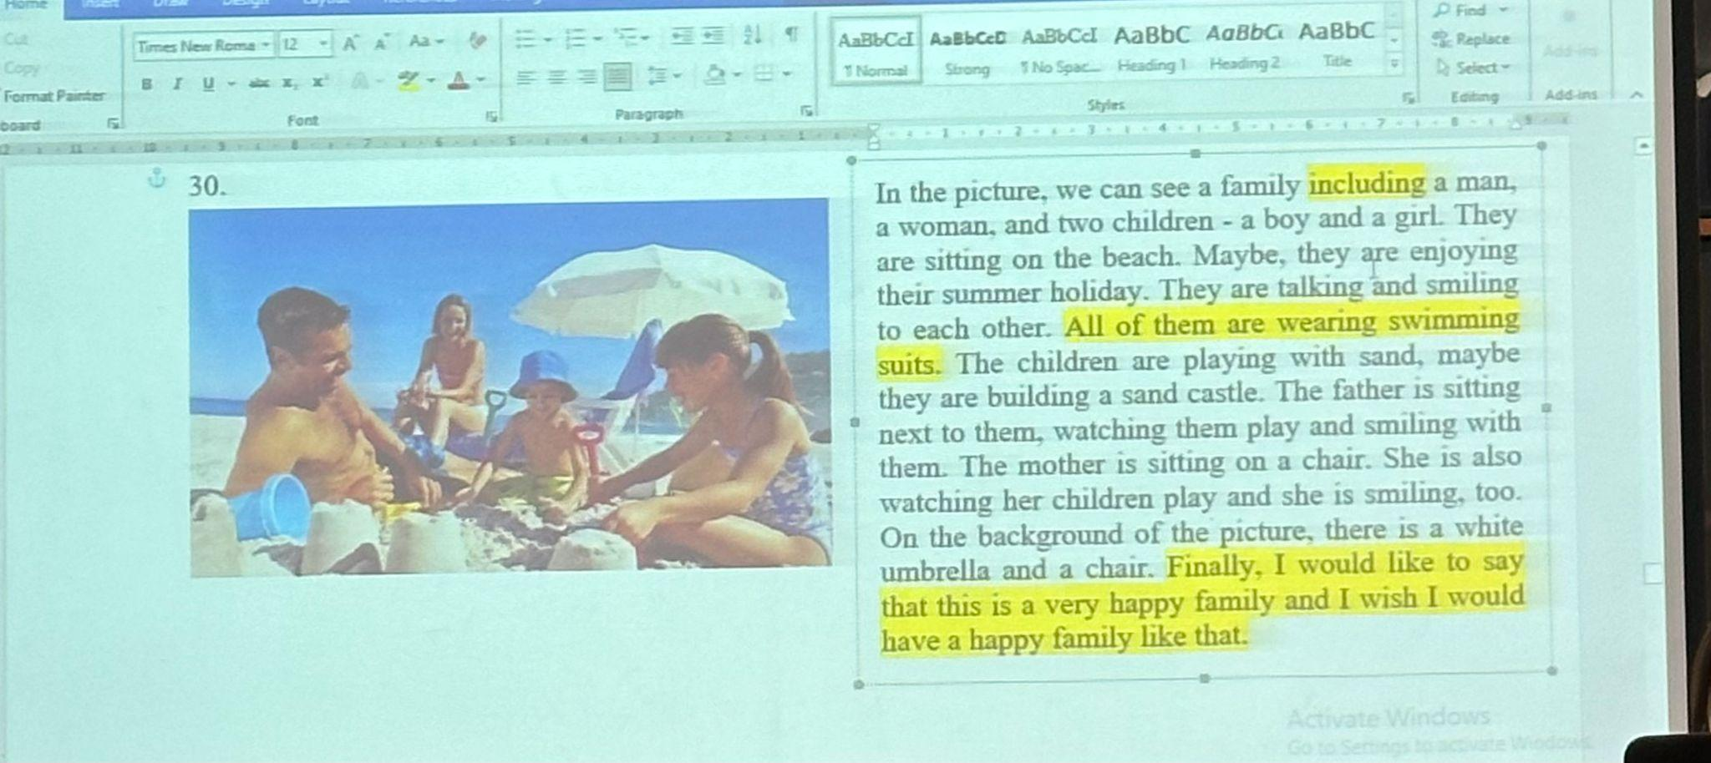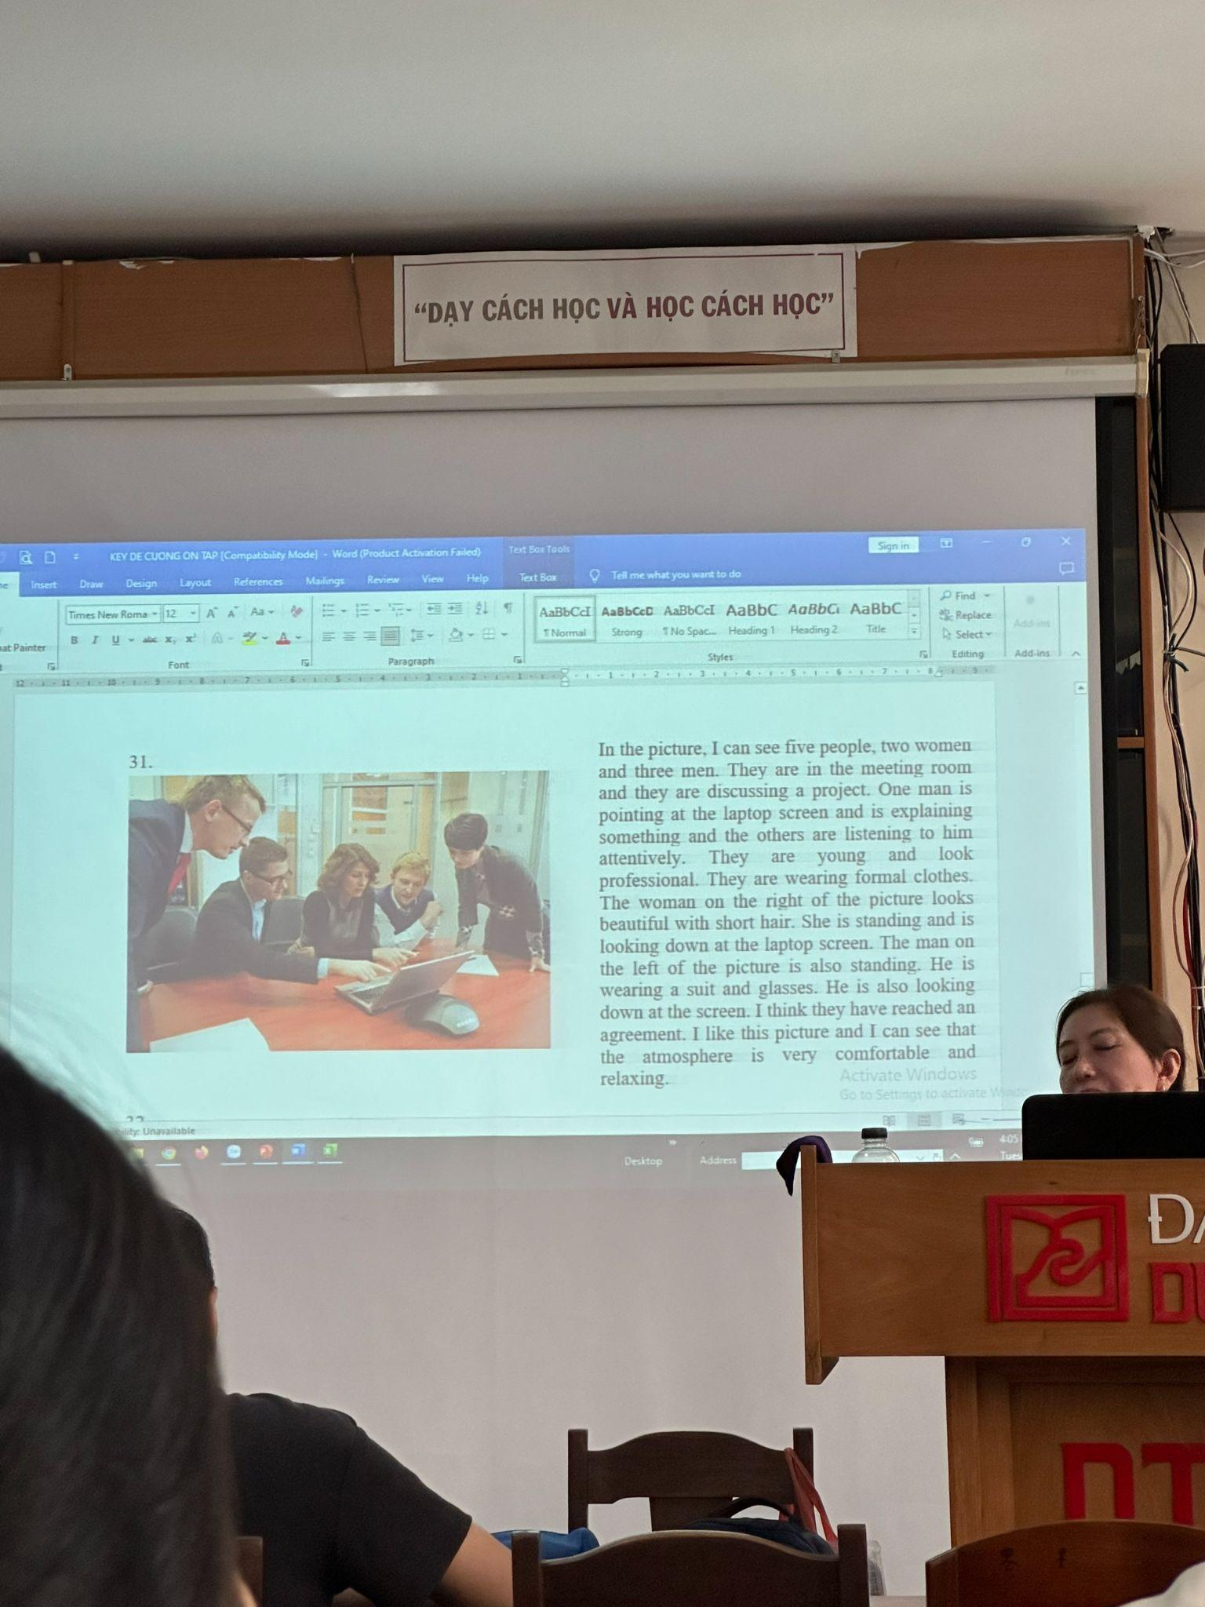

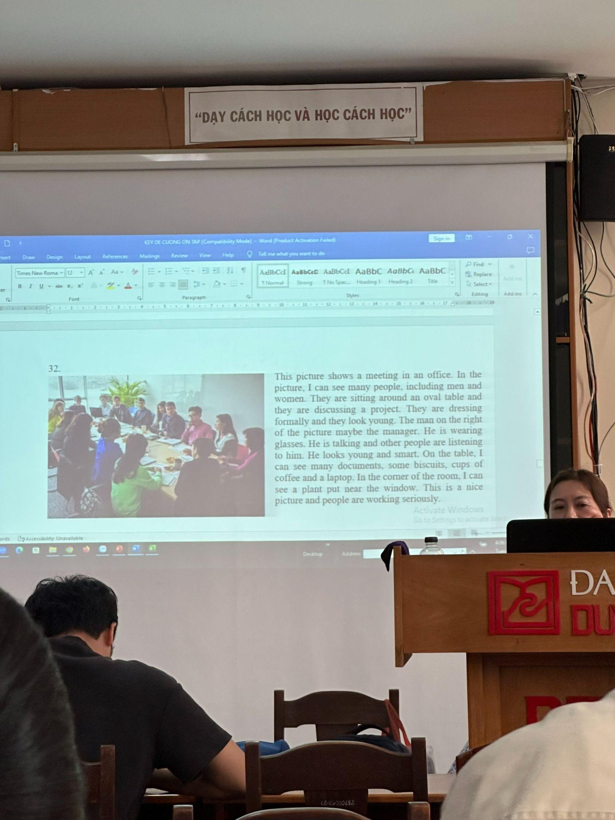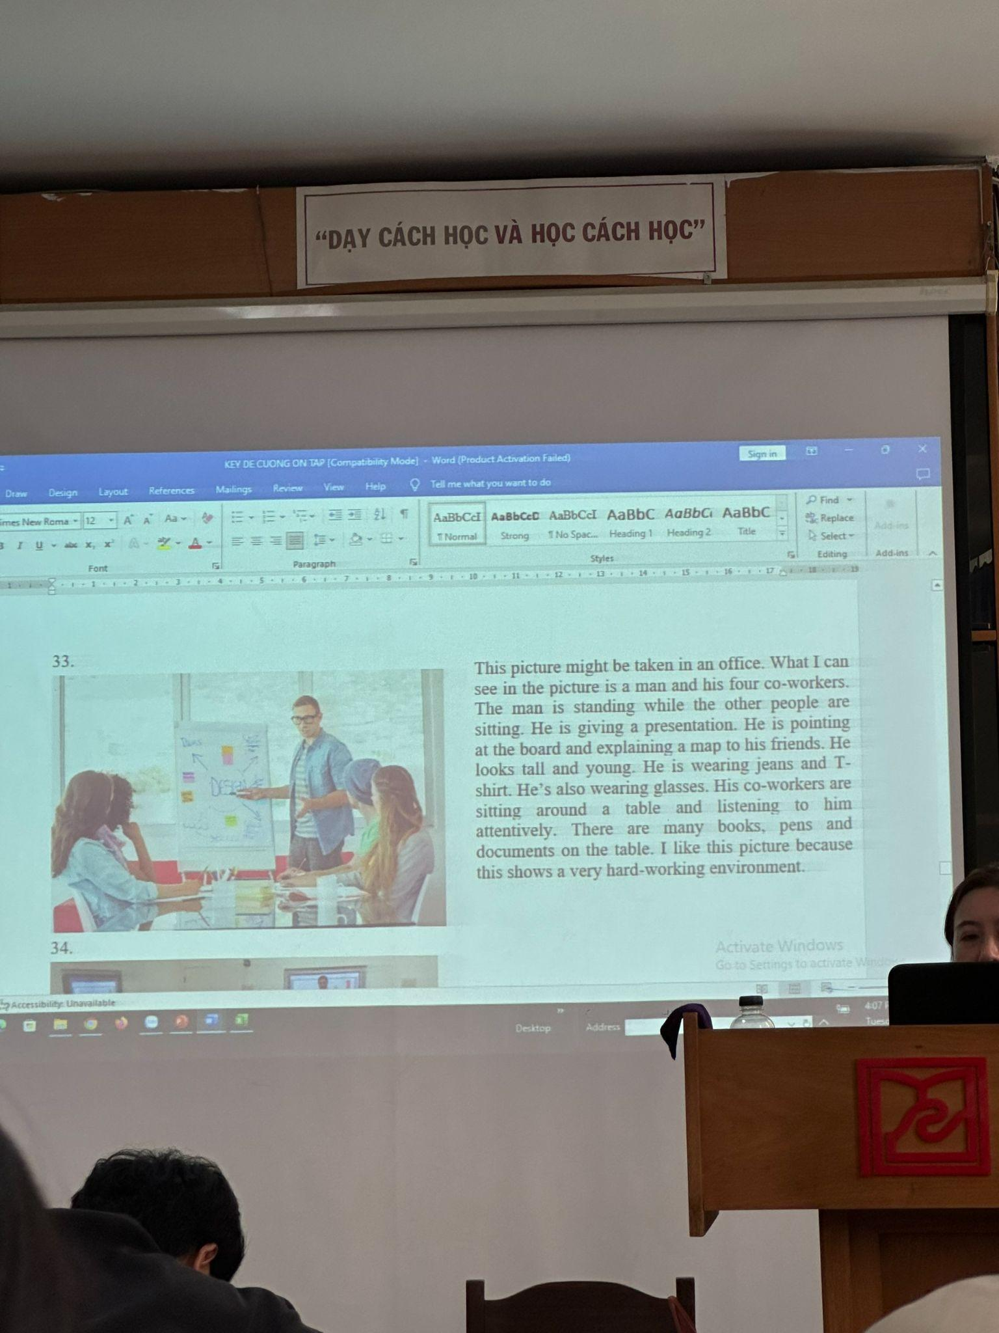

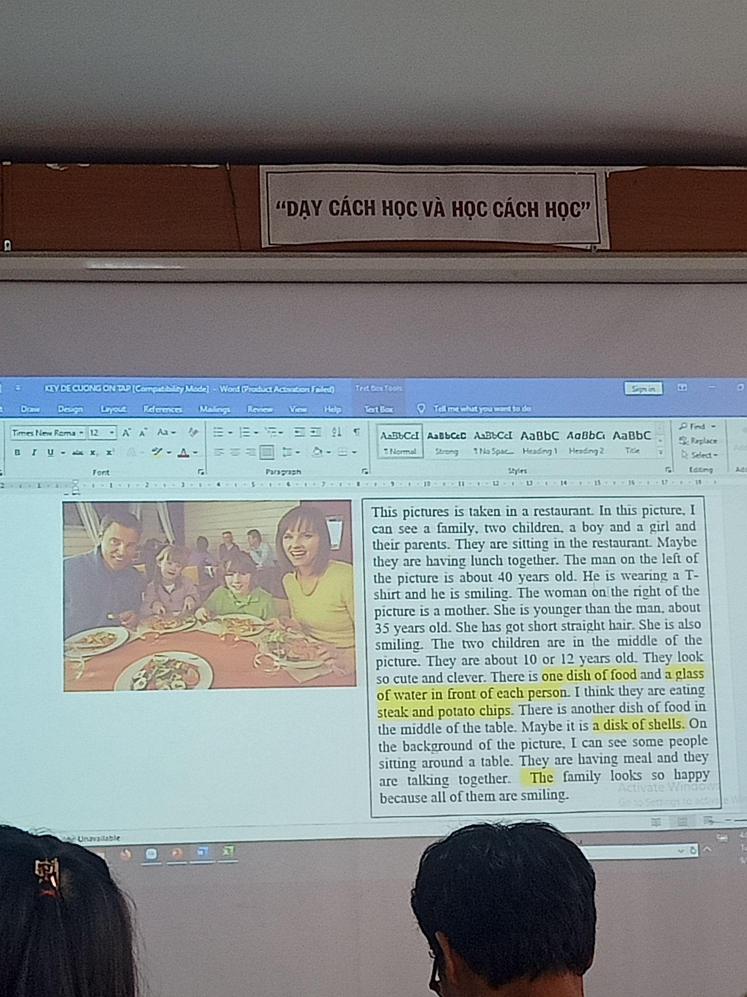

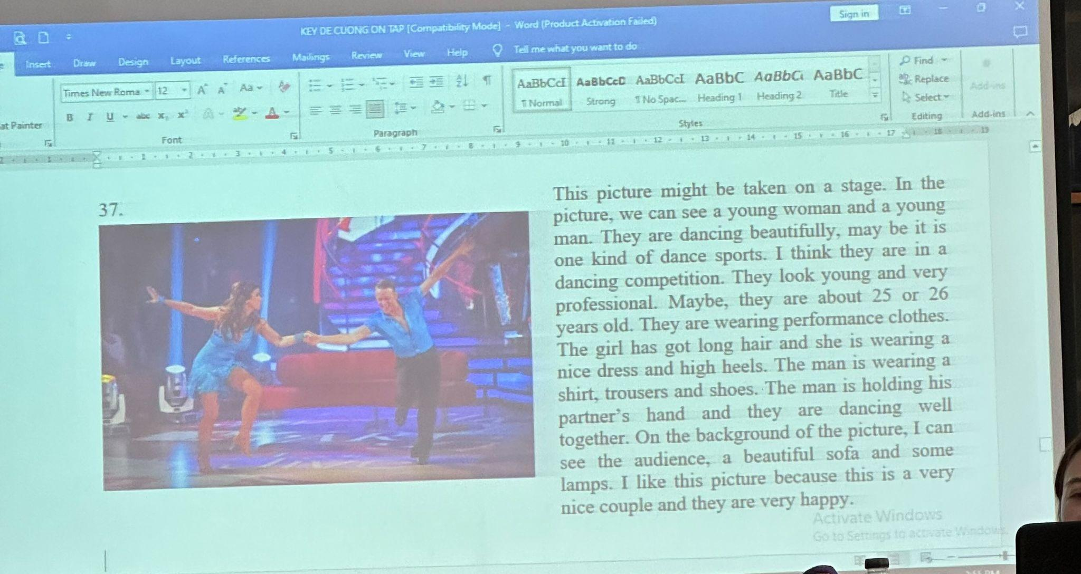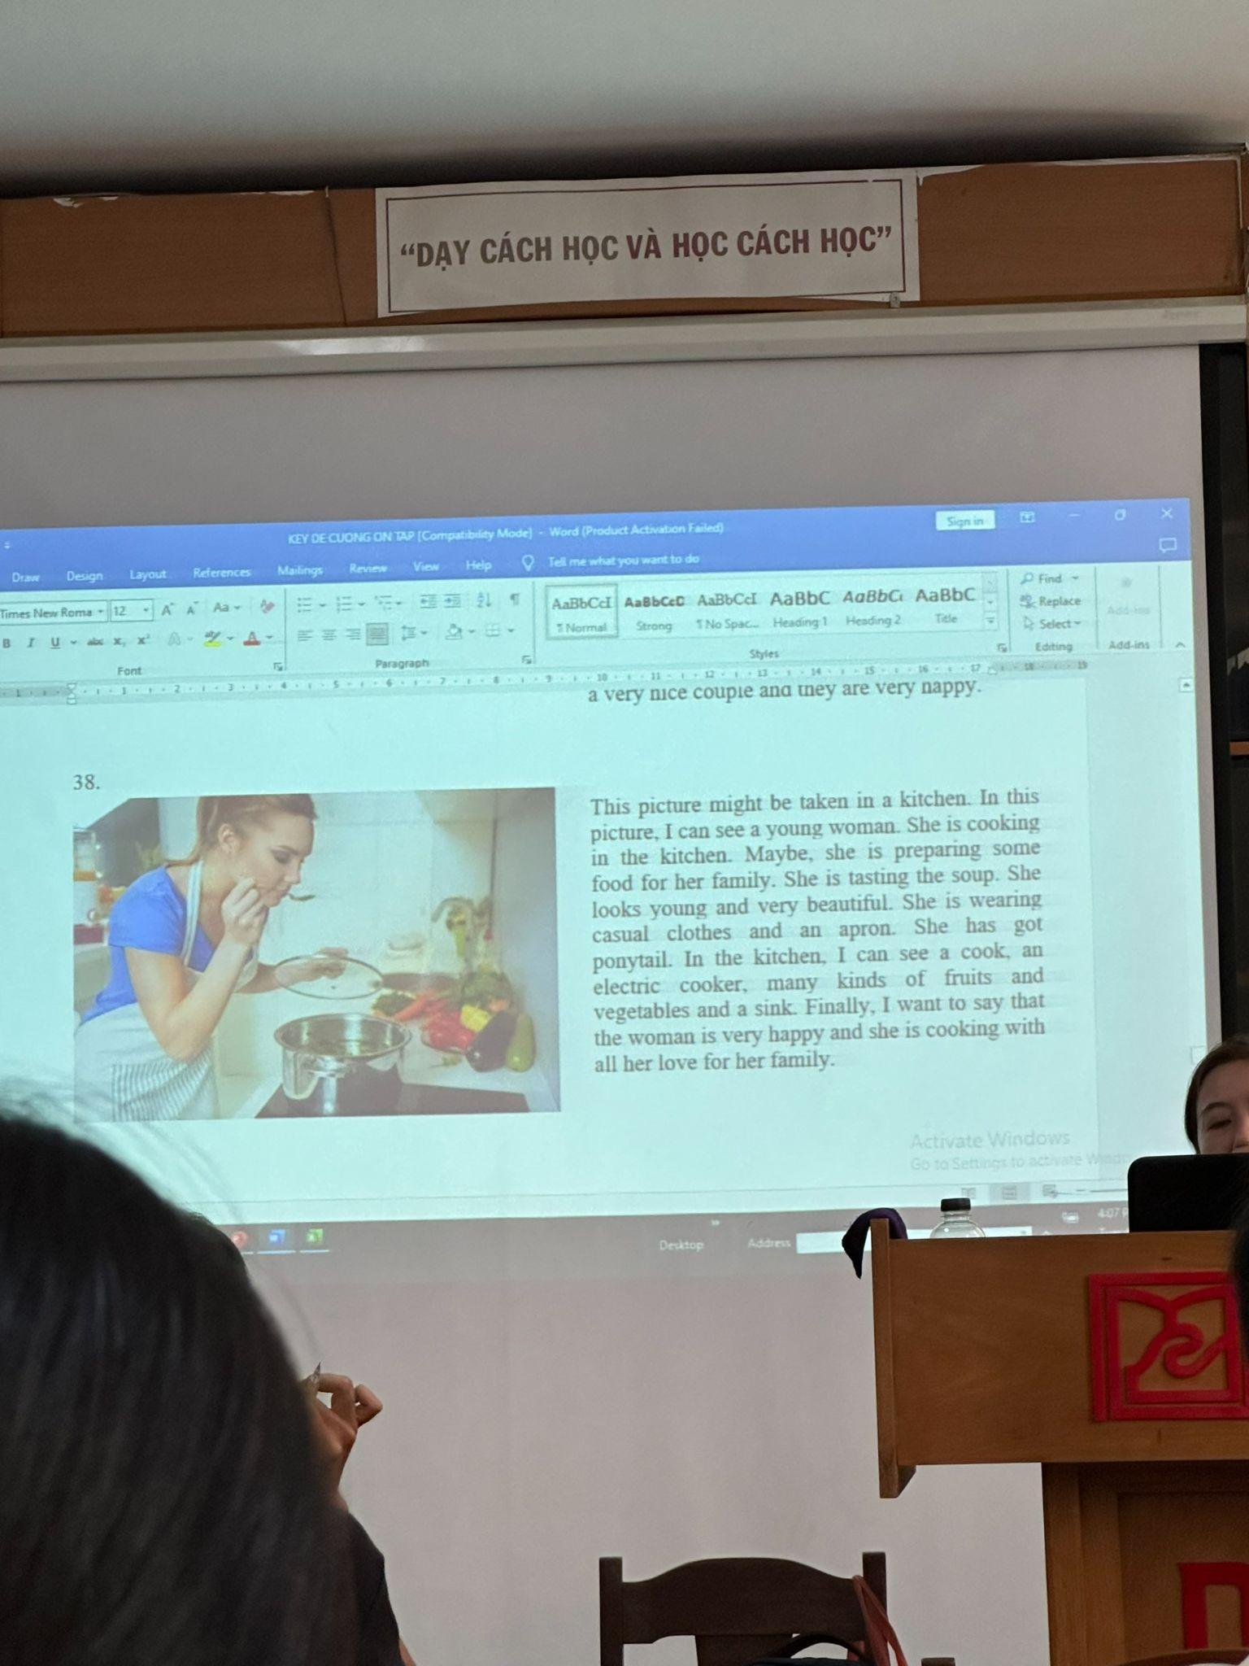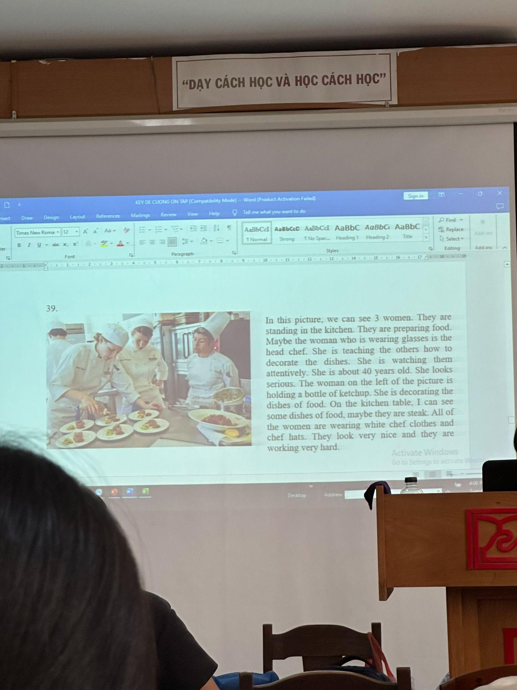

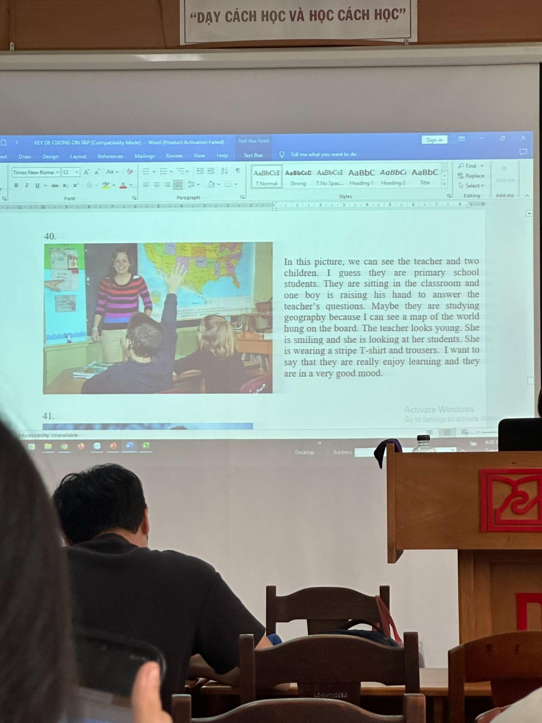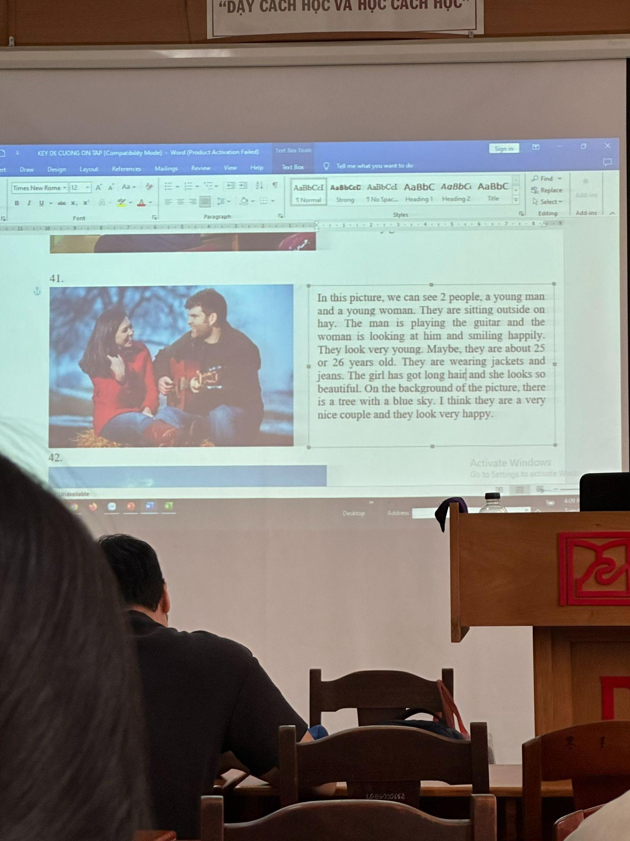

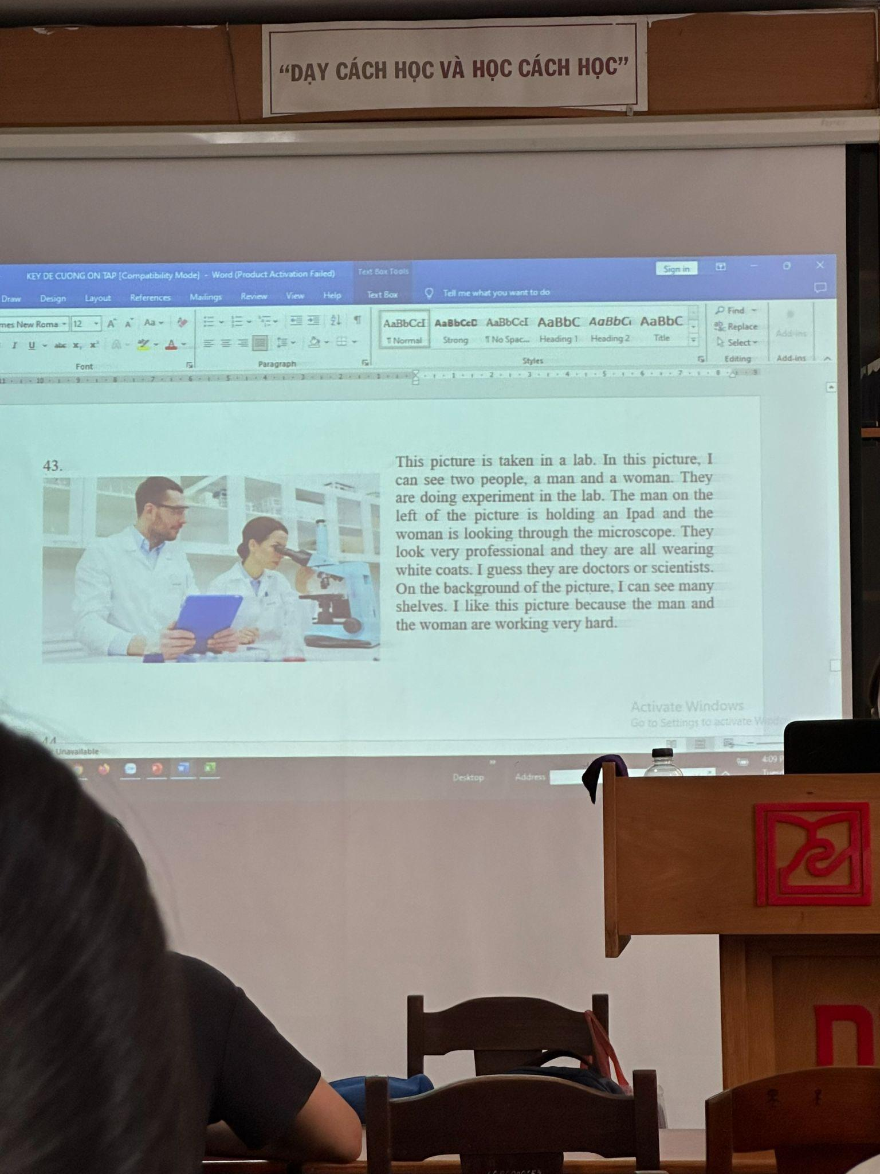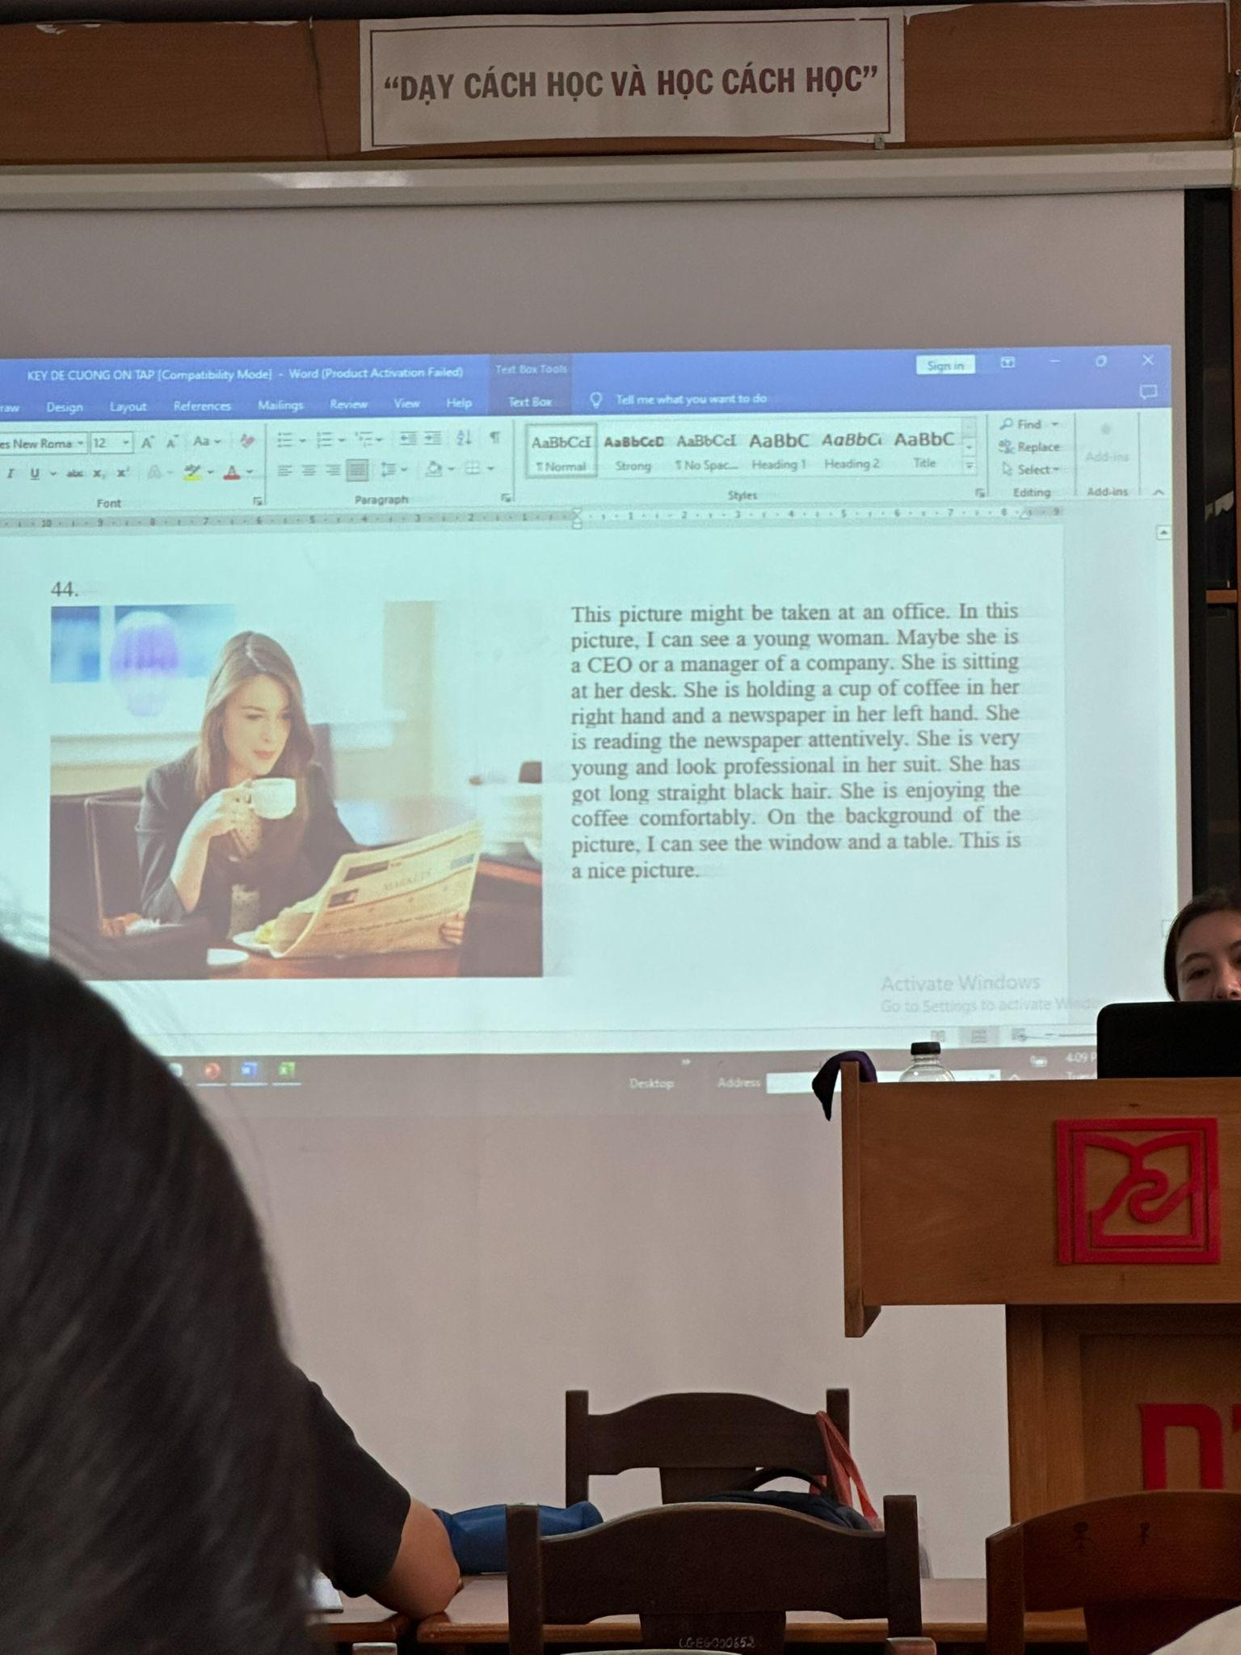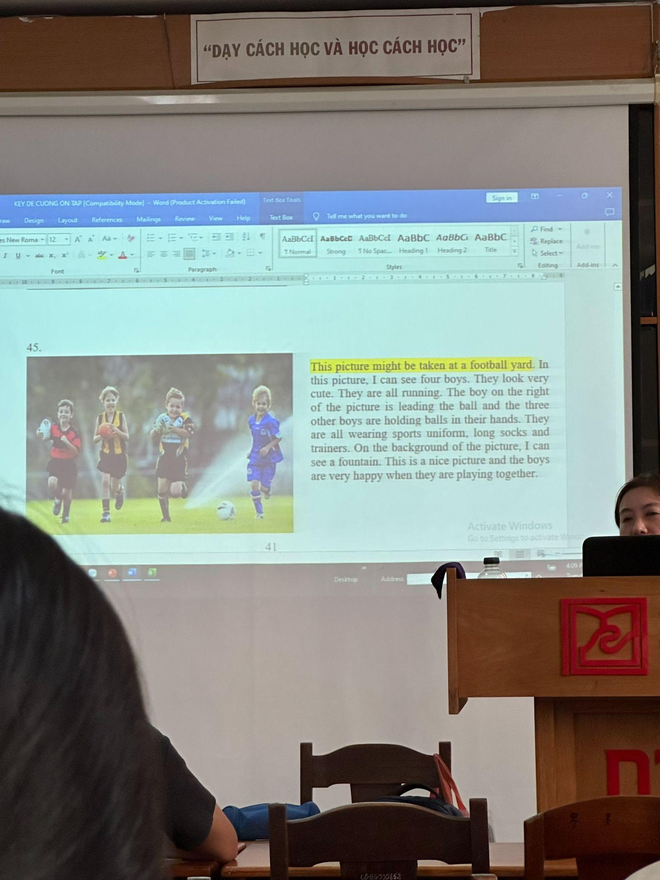

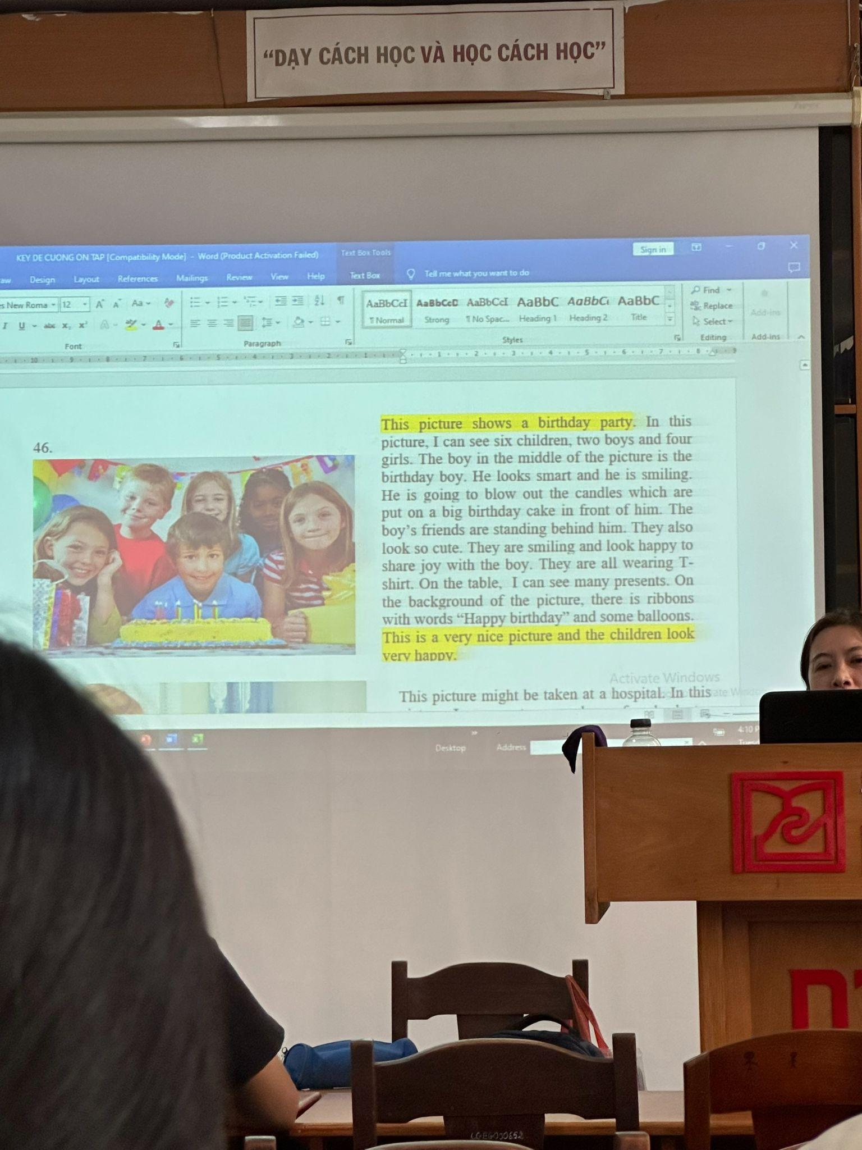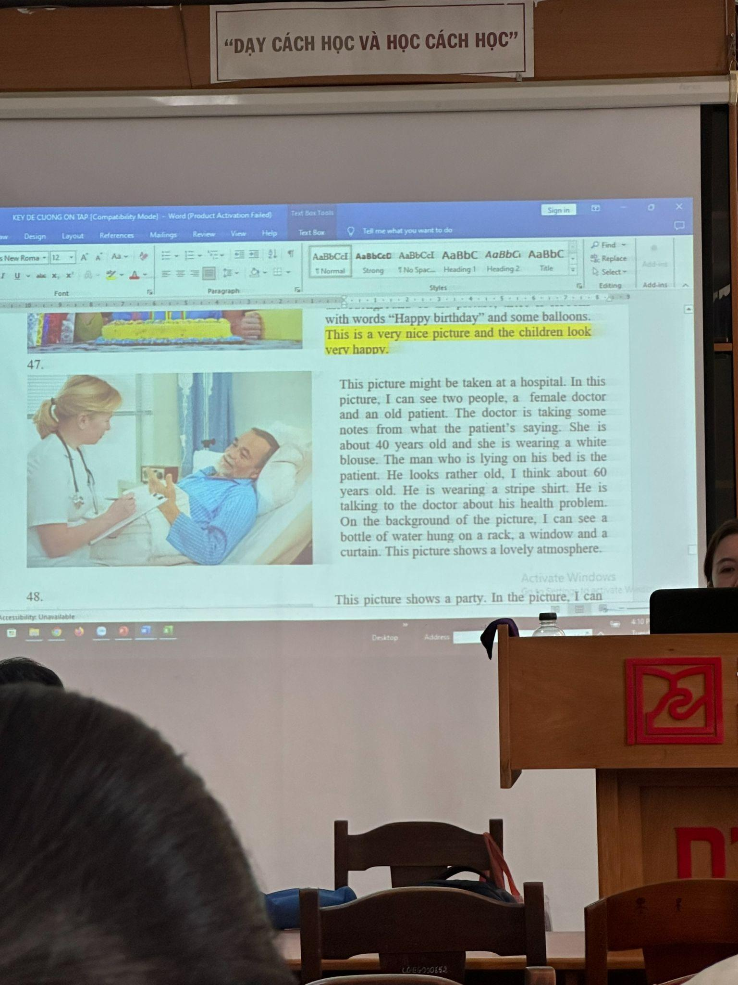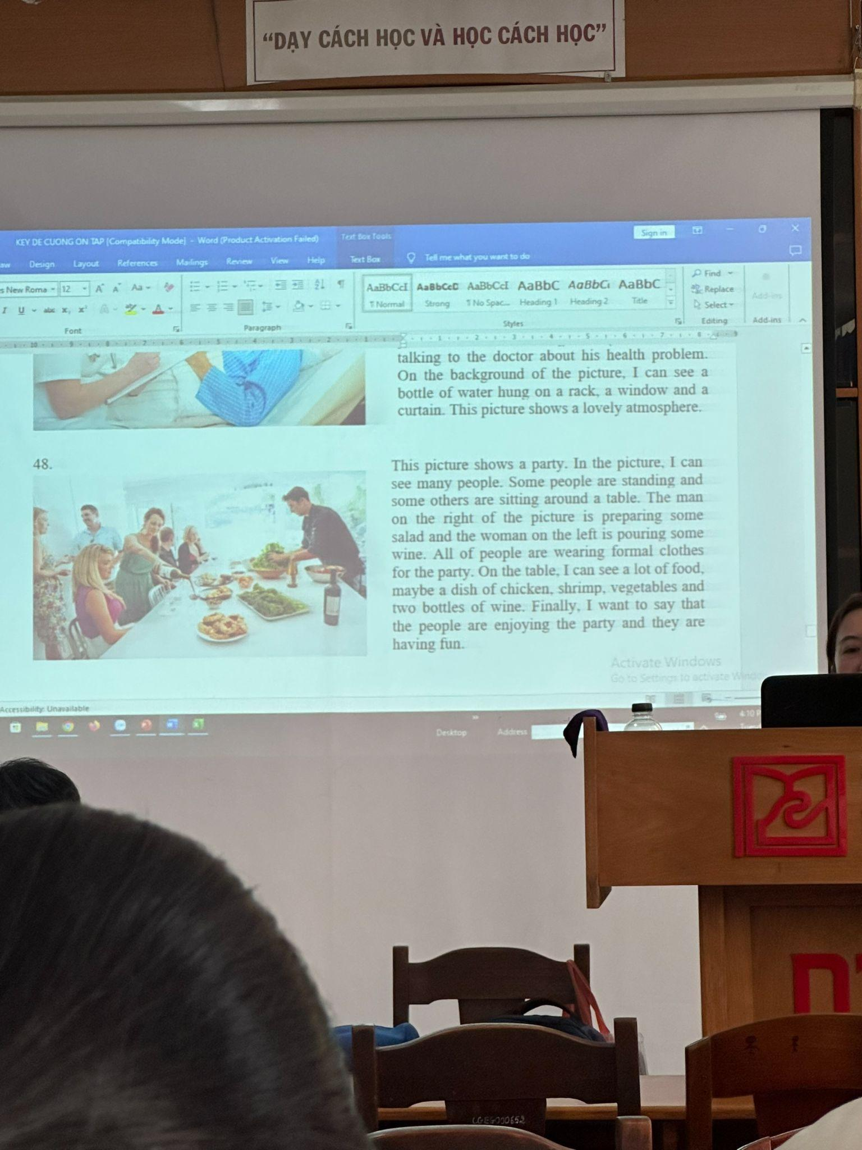

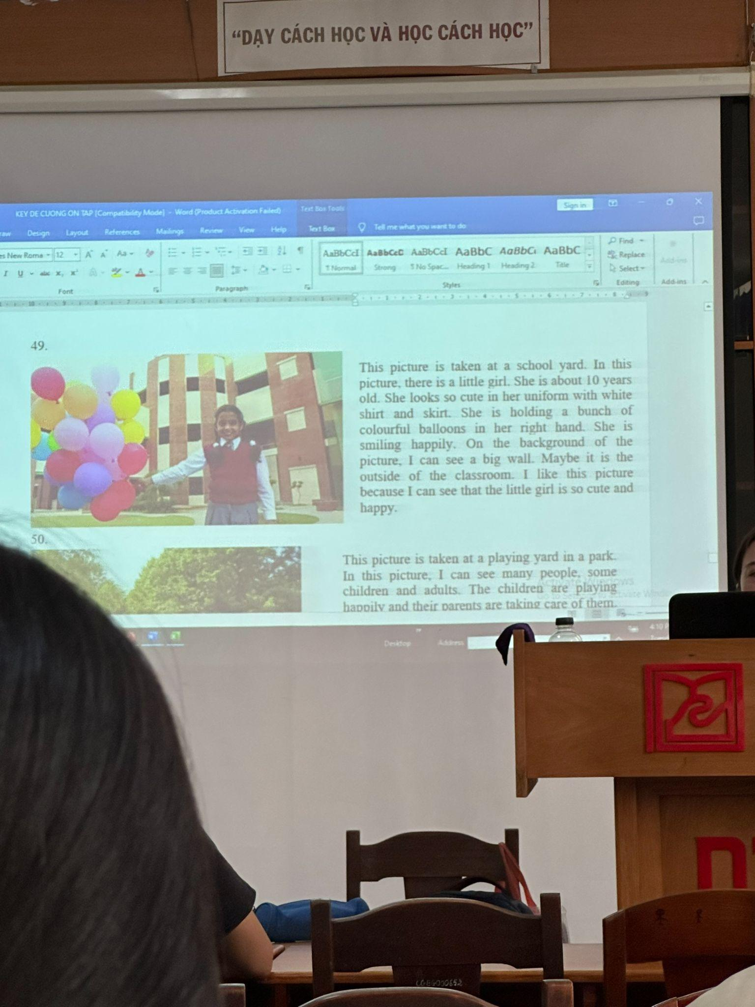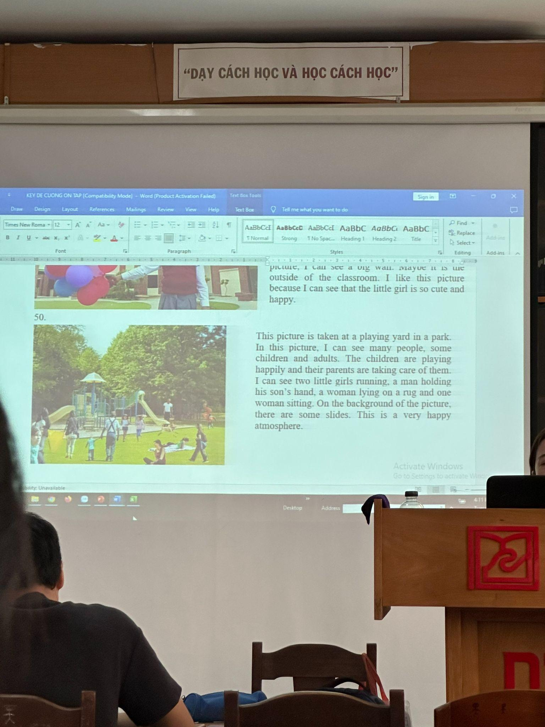

Speaking: tổng hợp

Speaking opinion

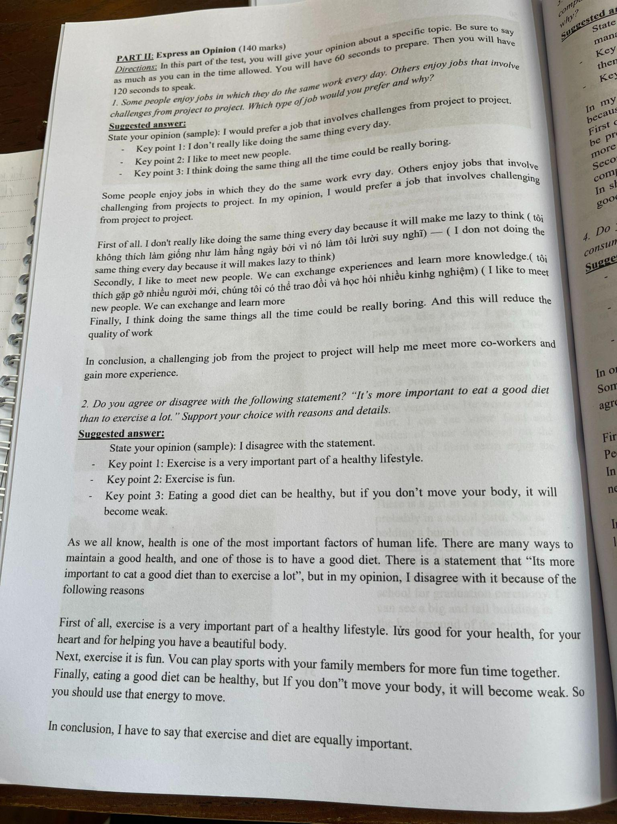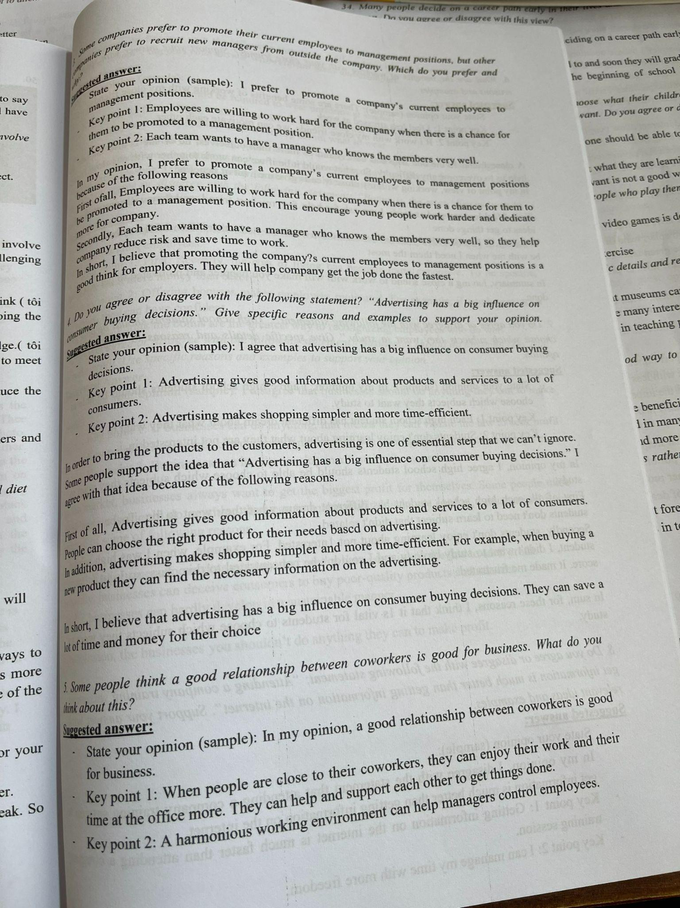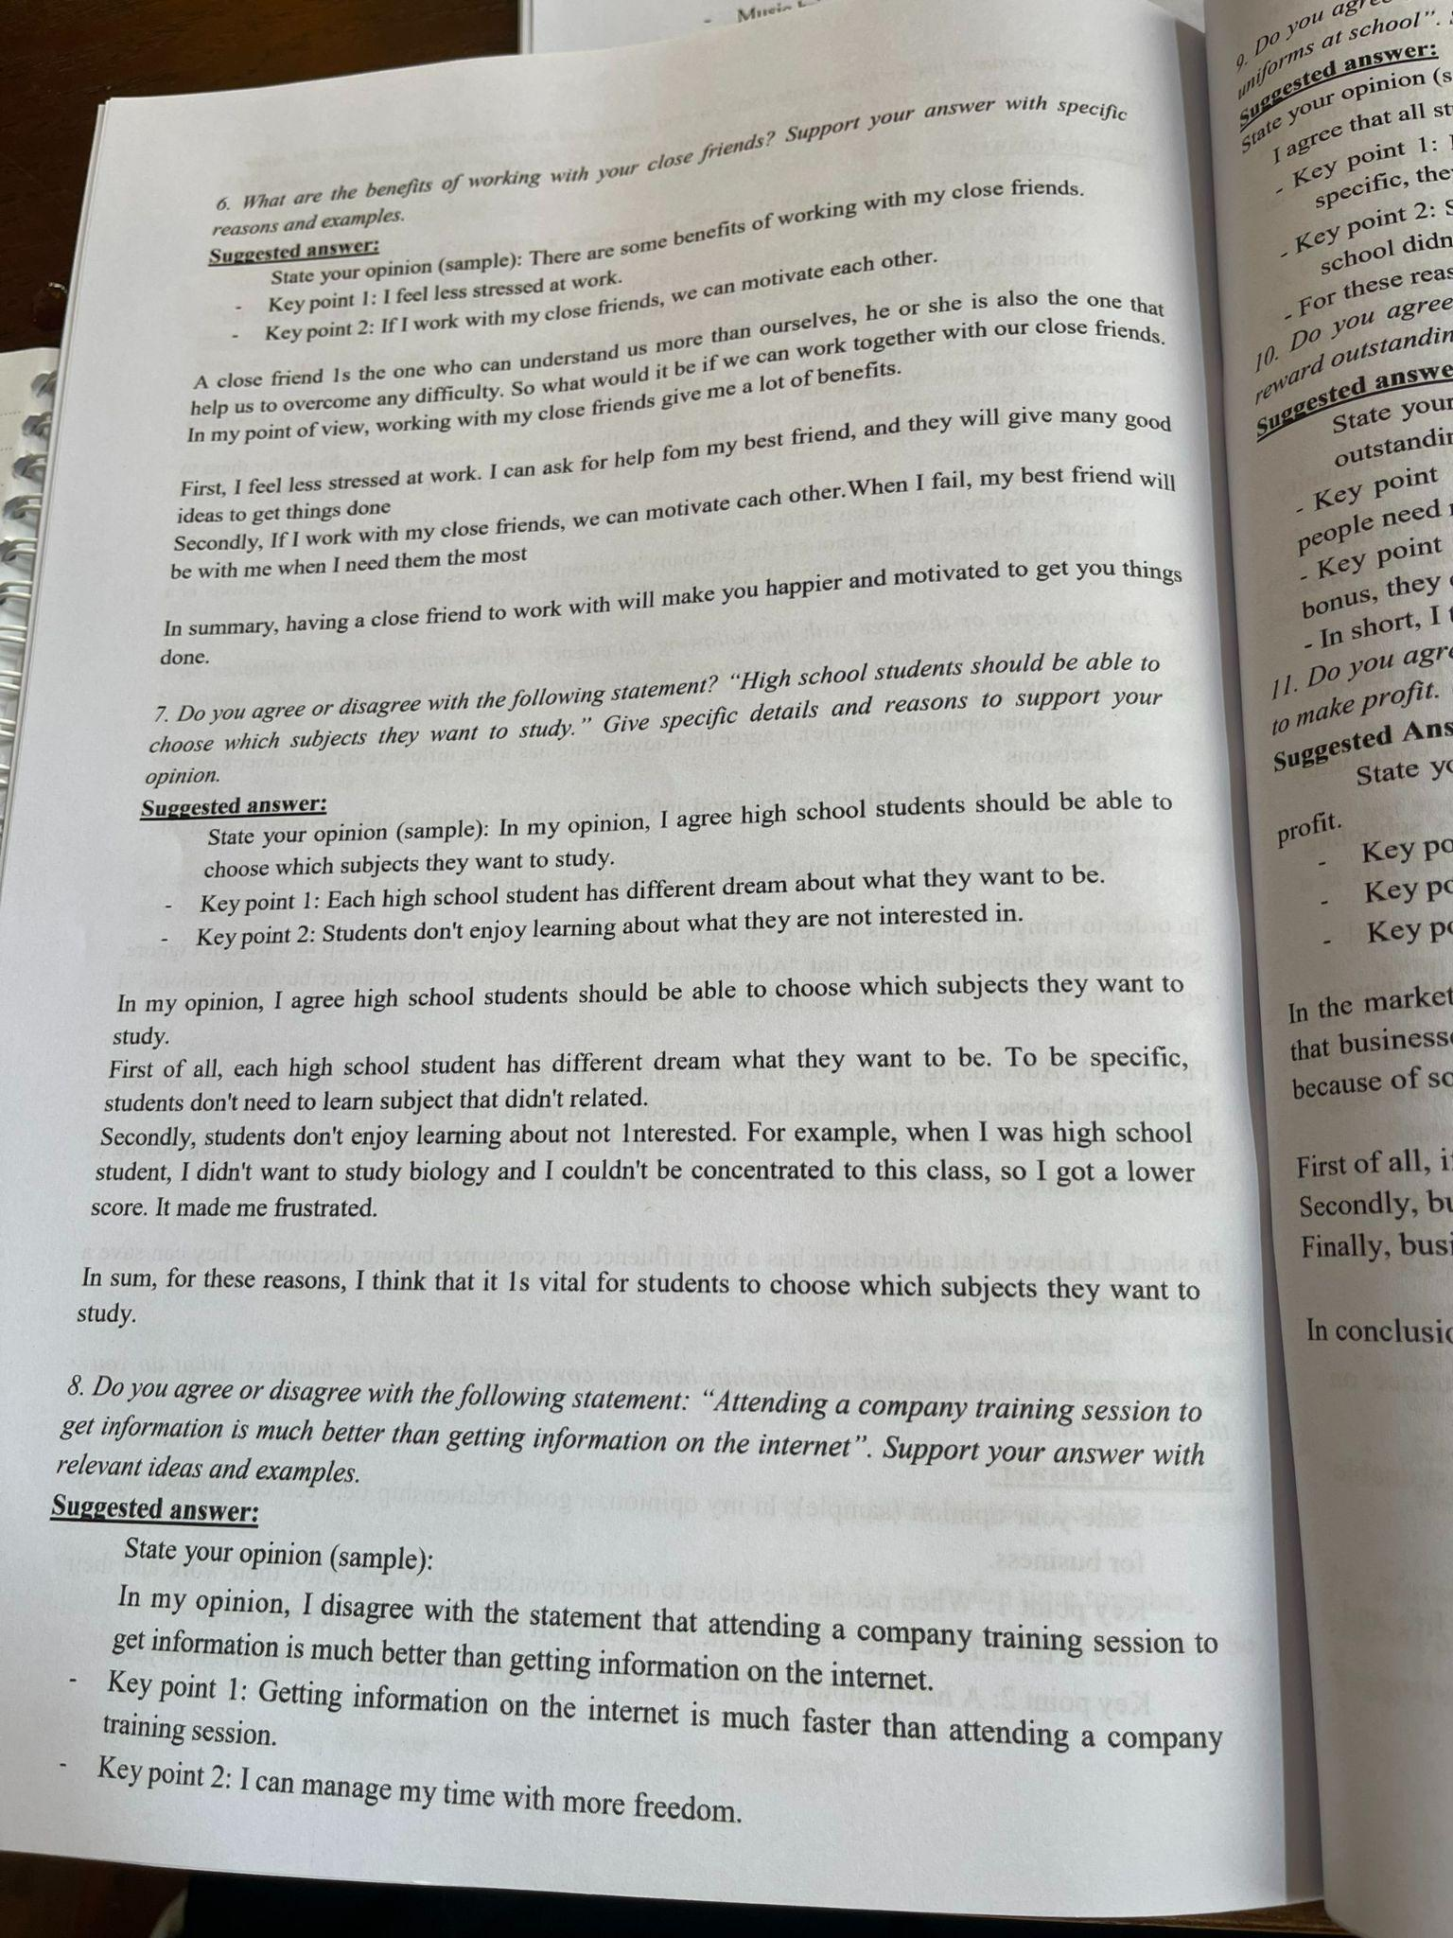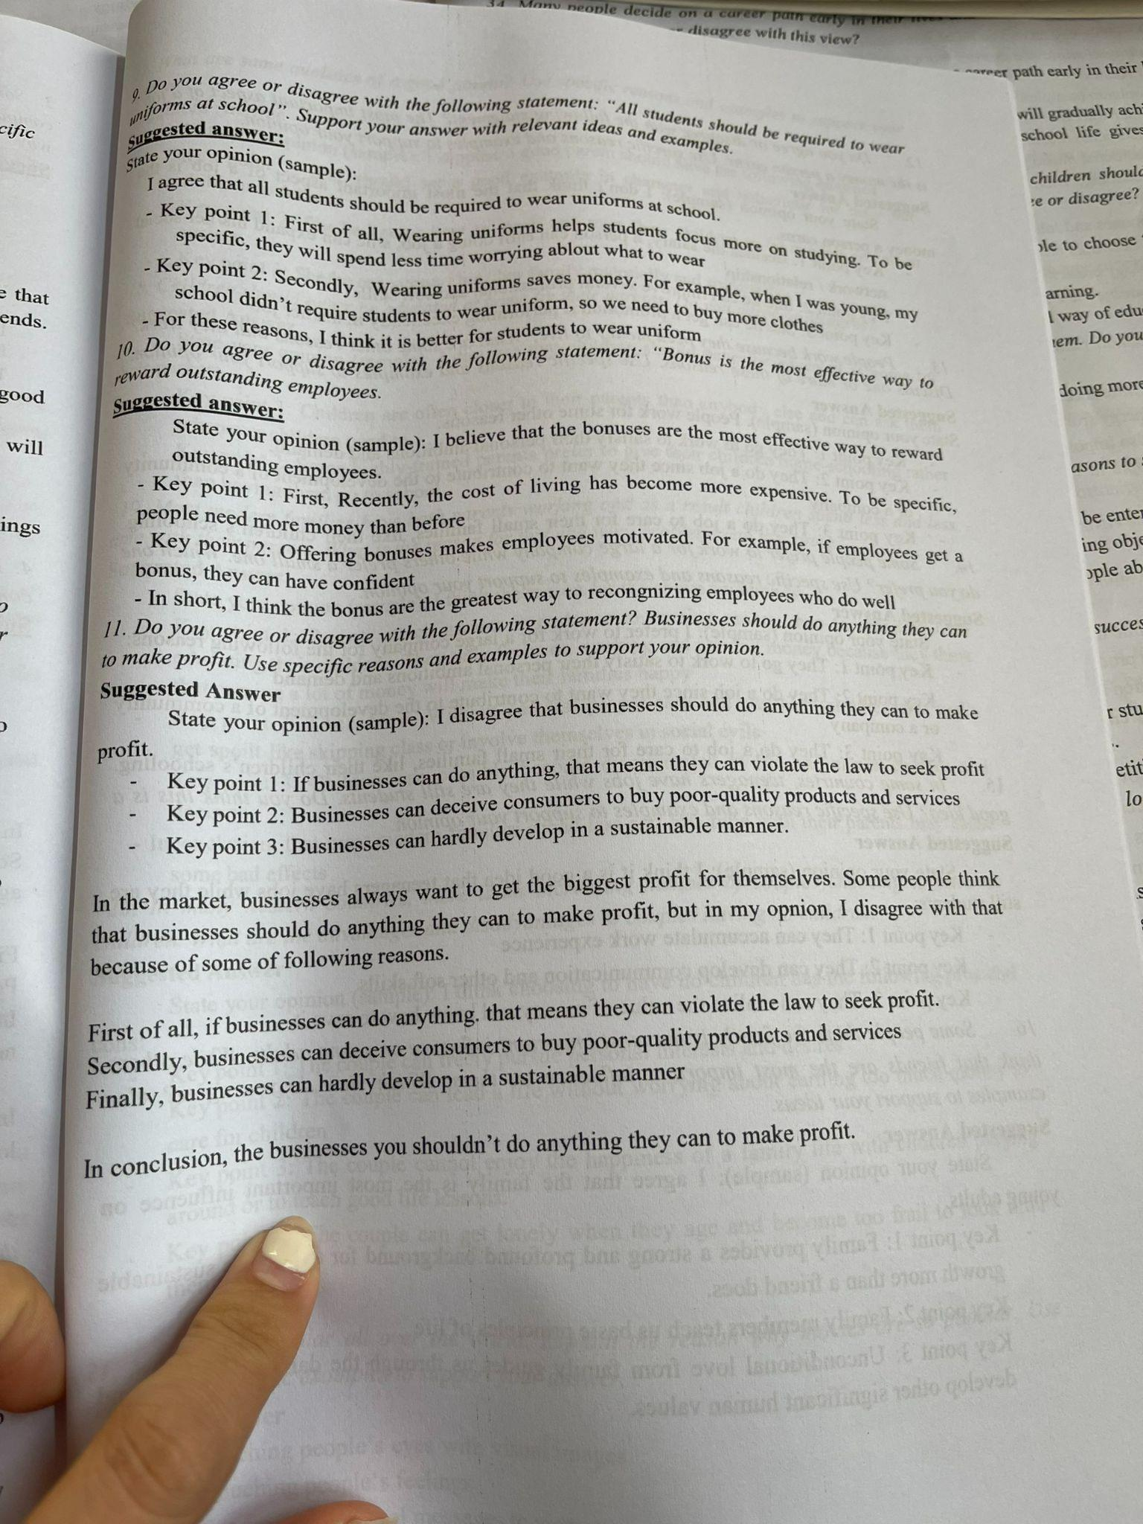

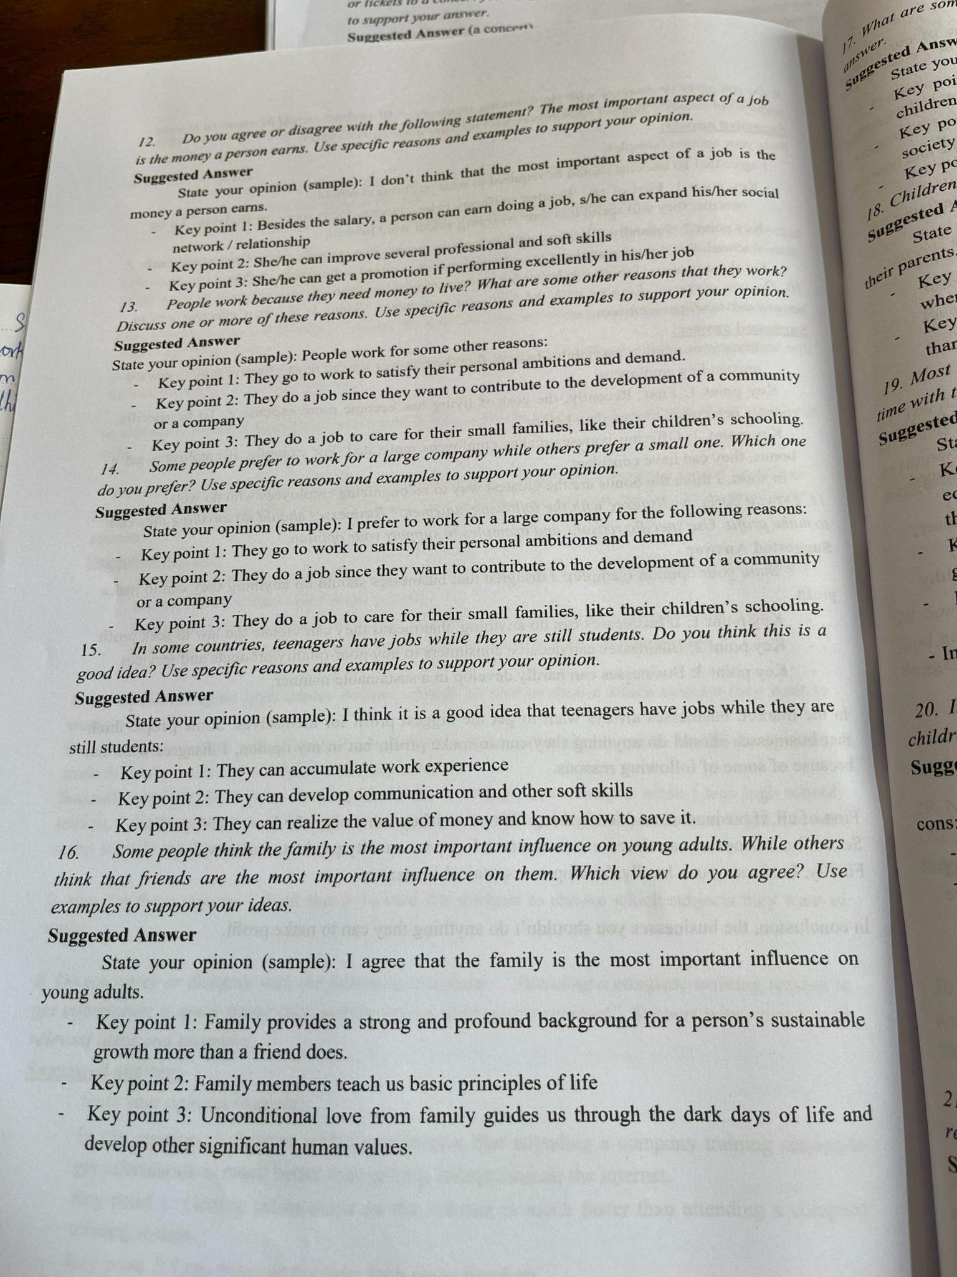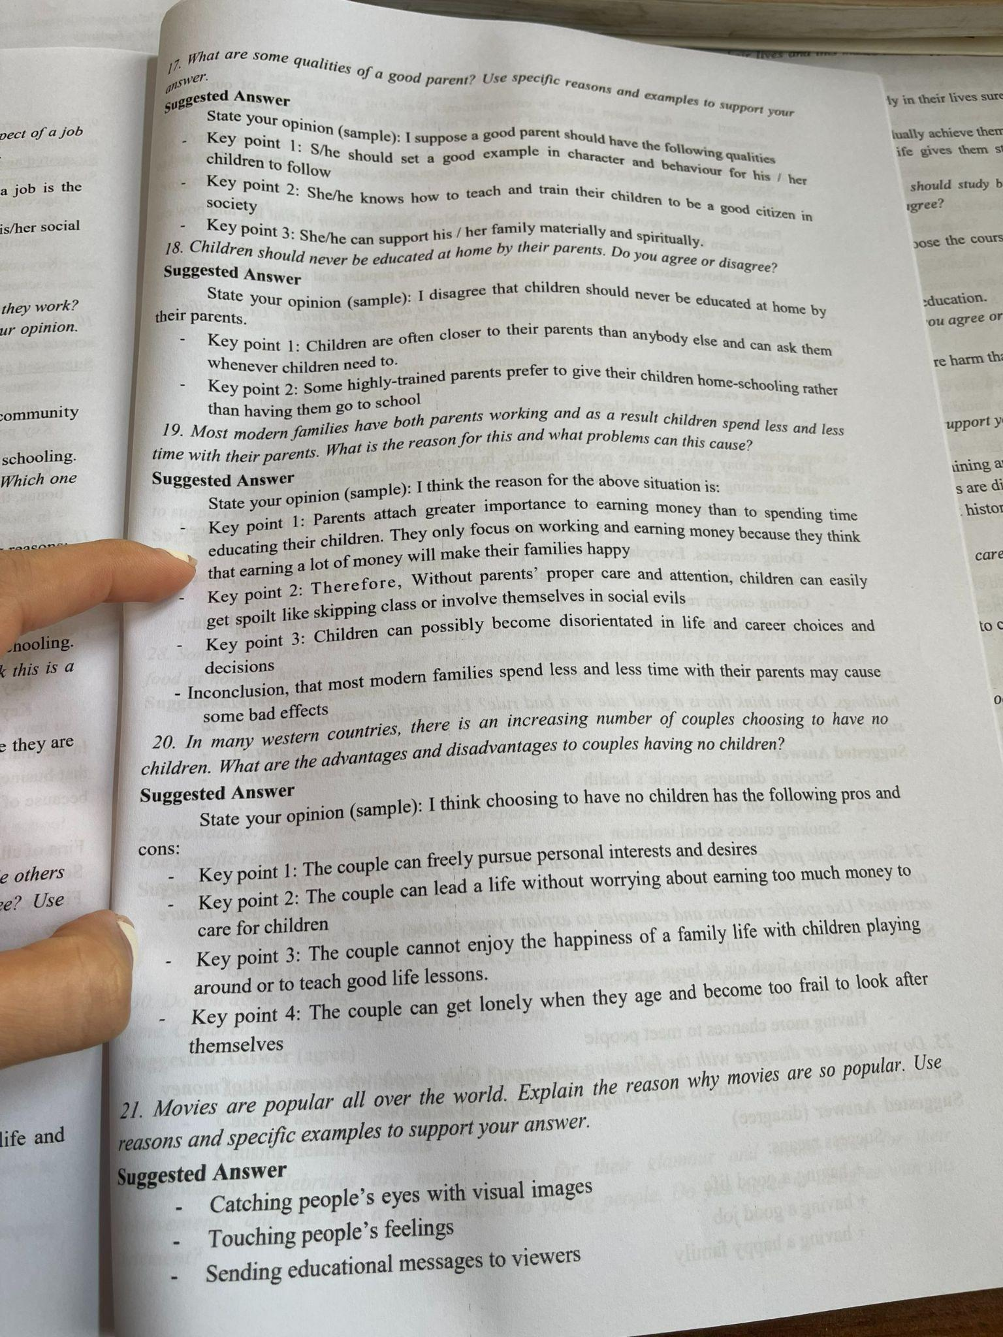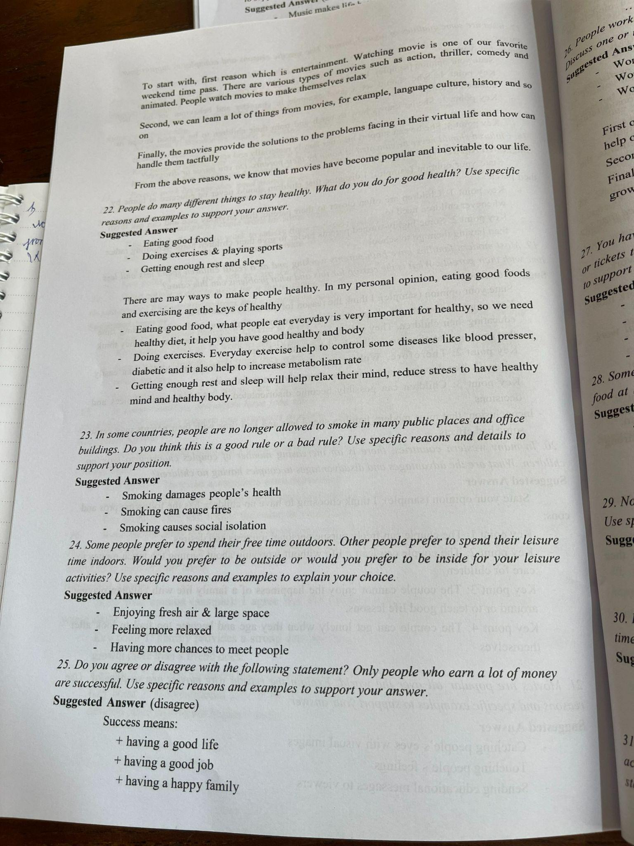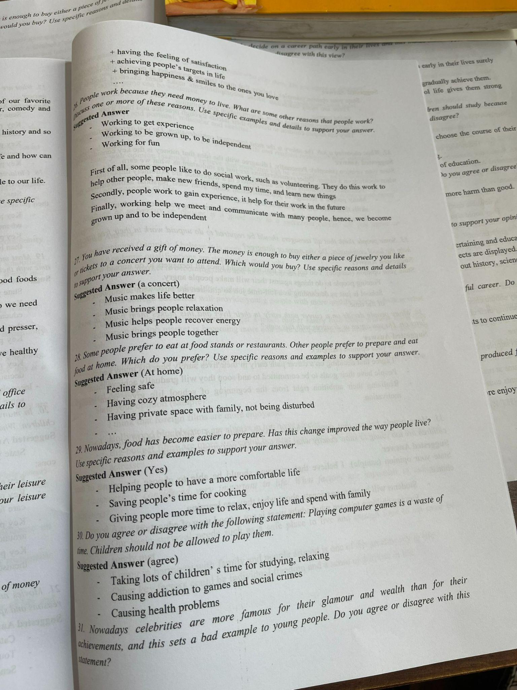

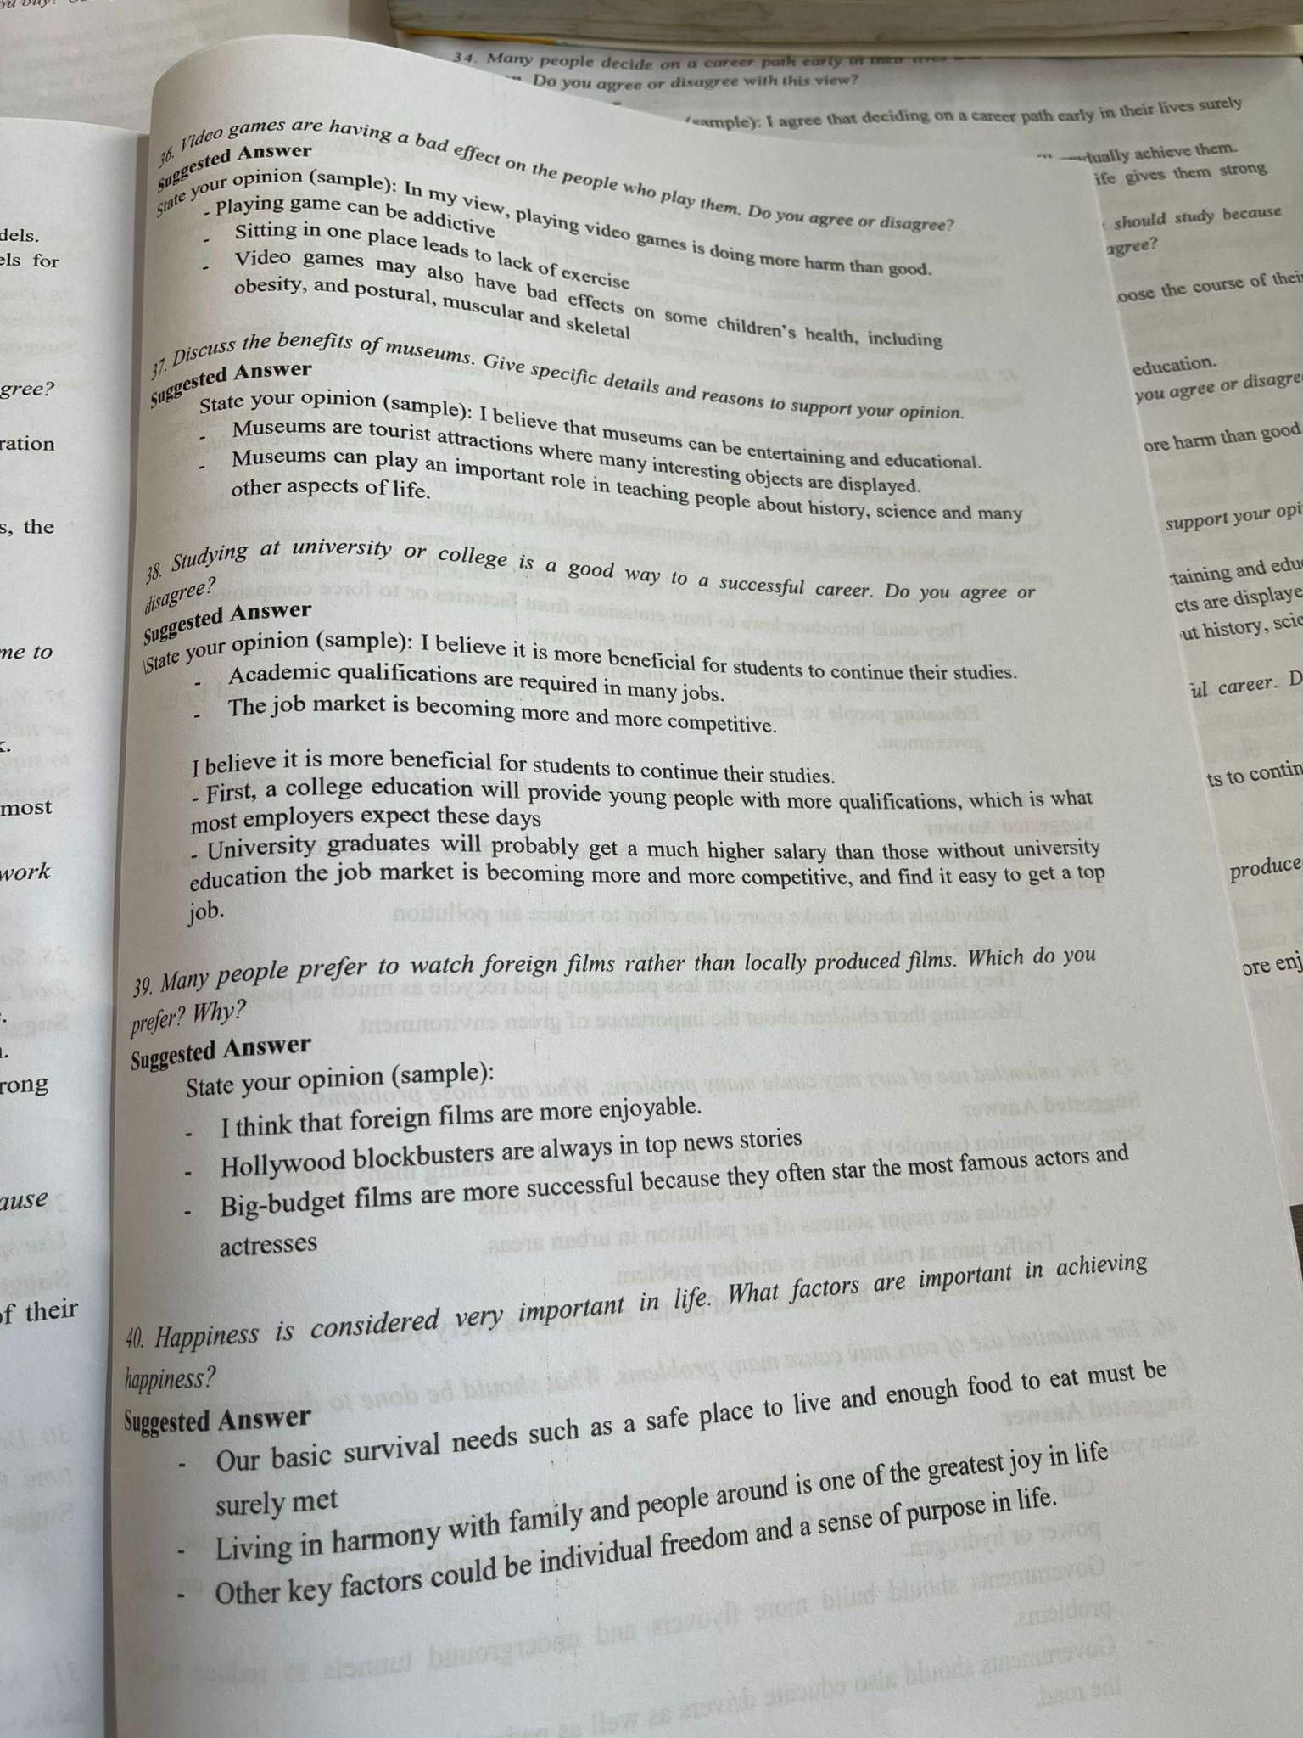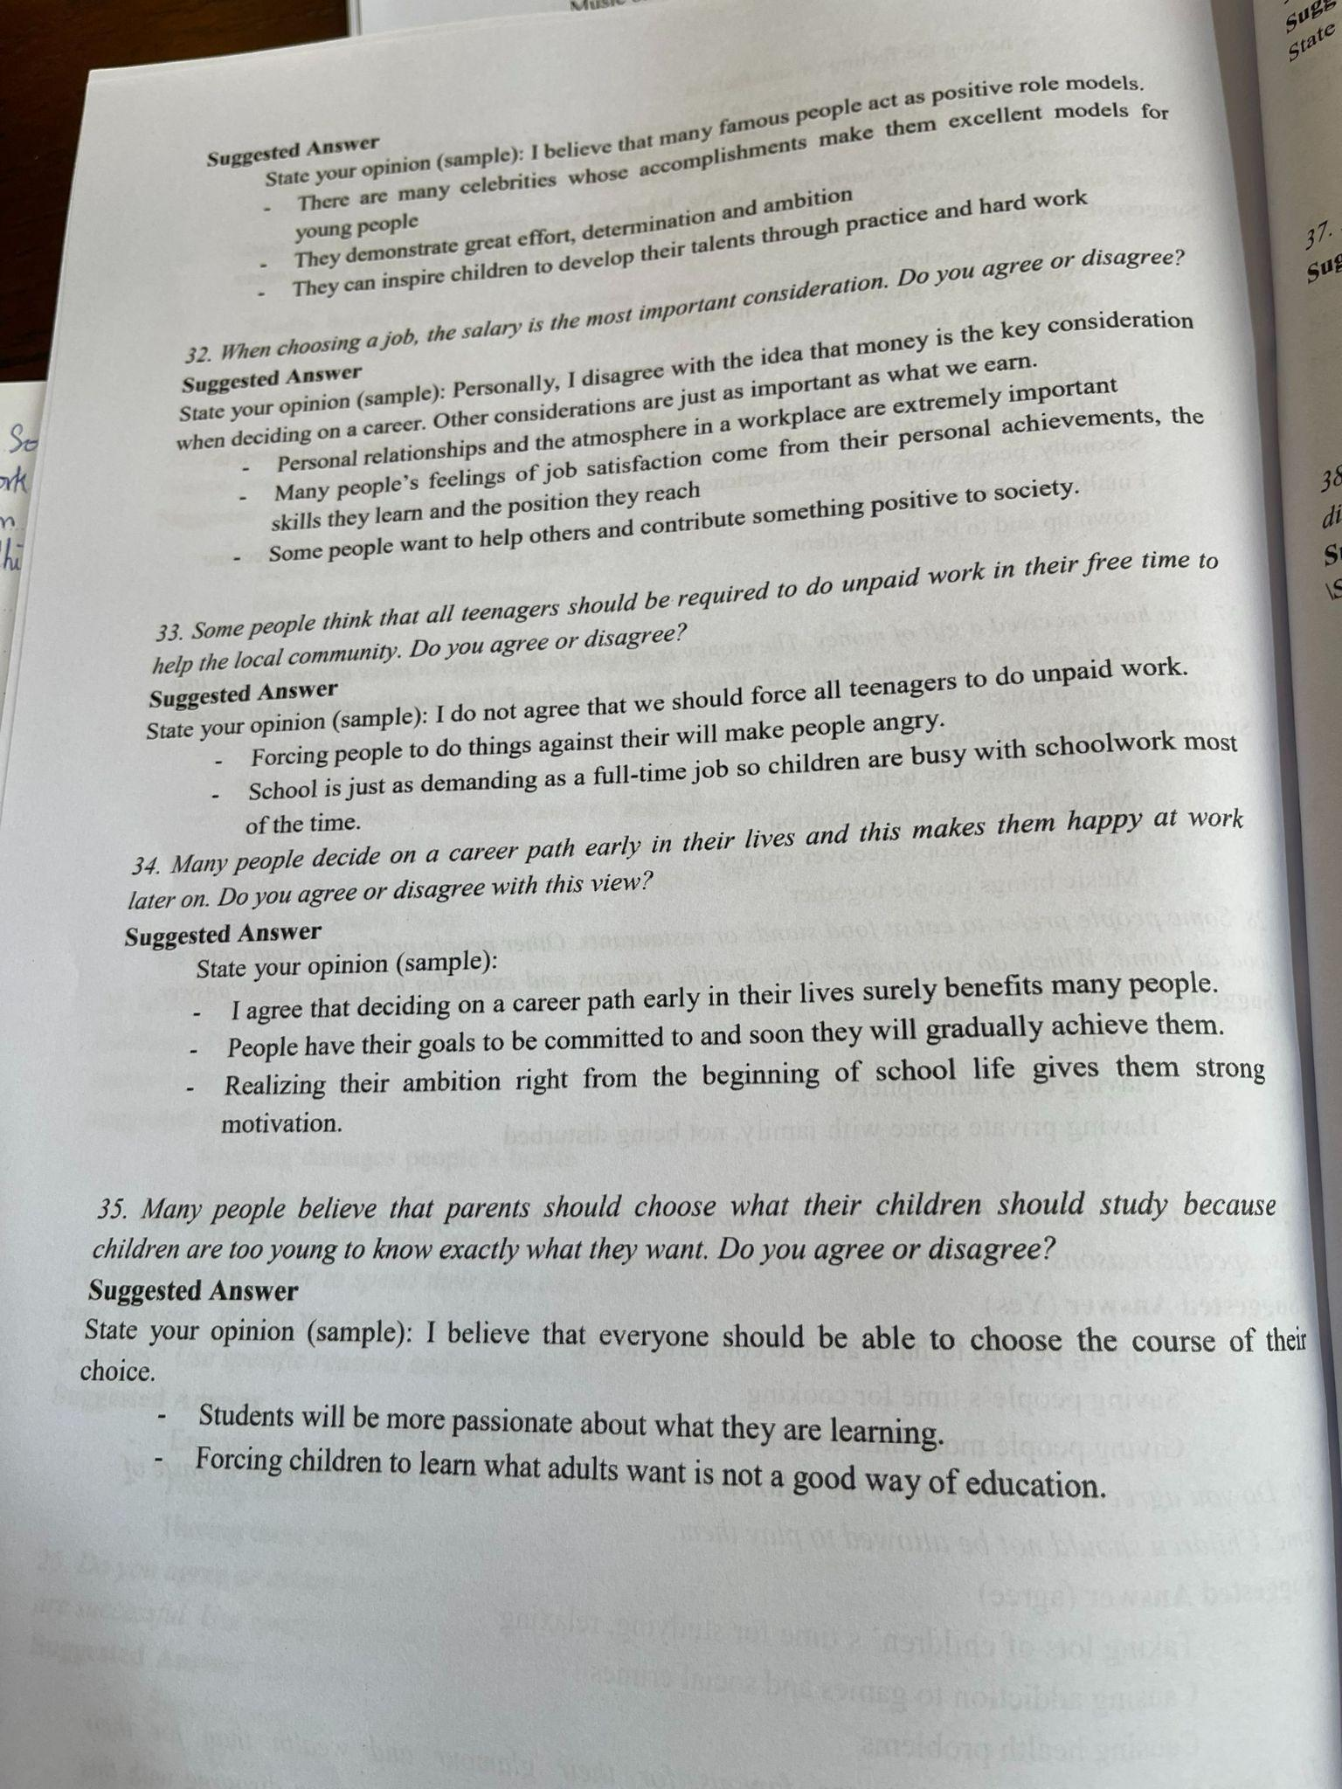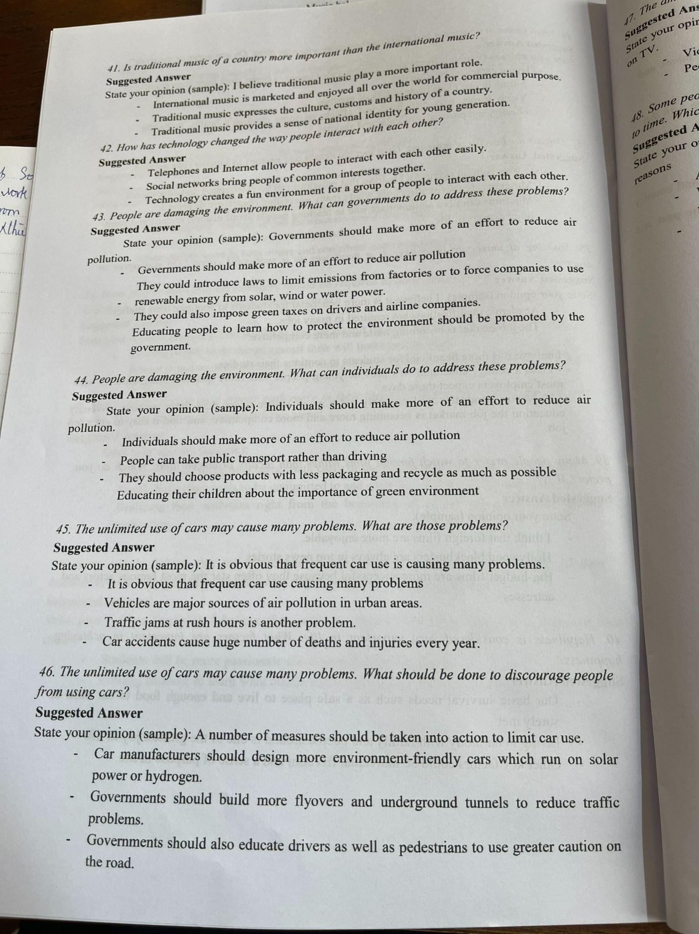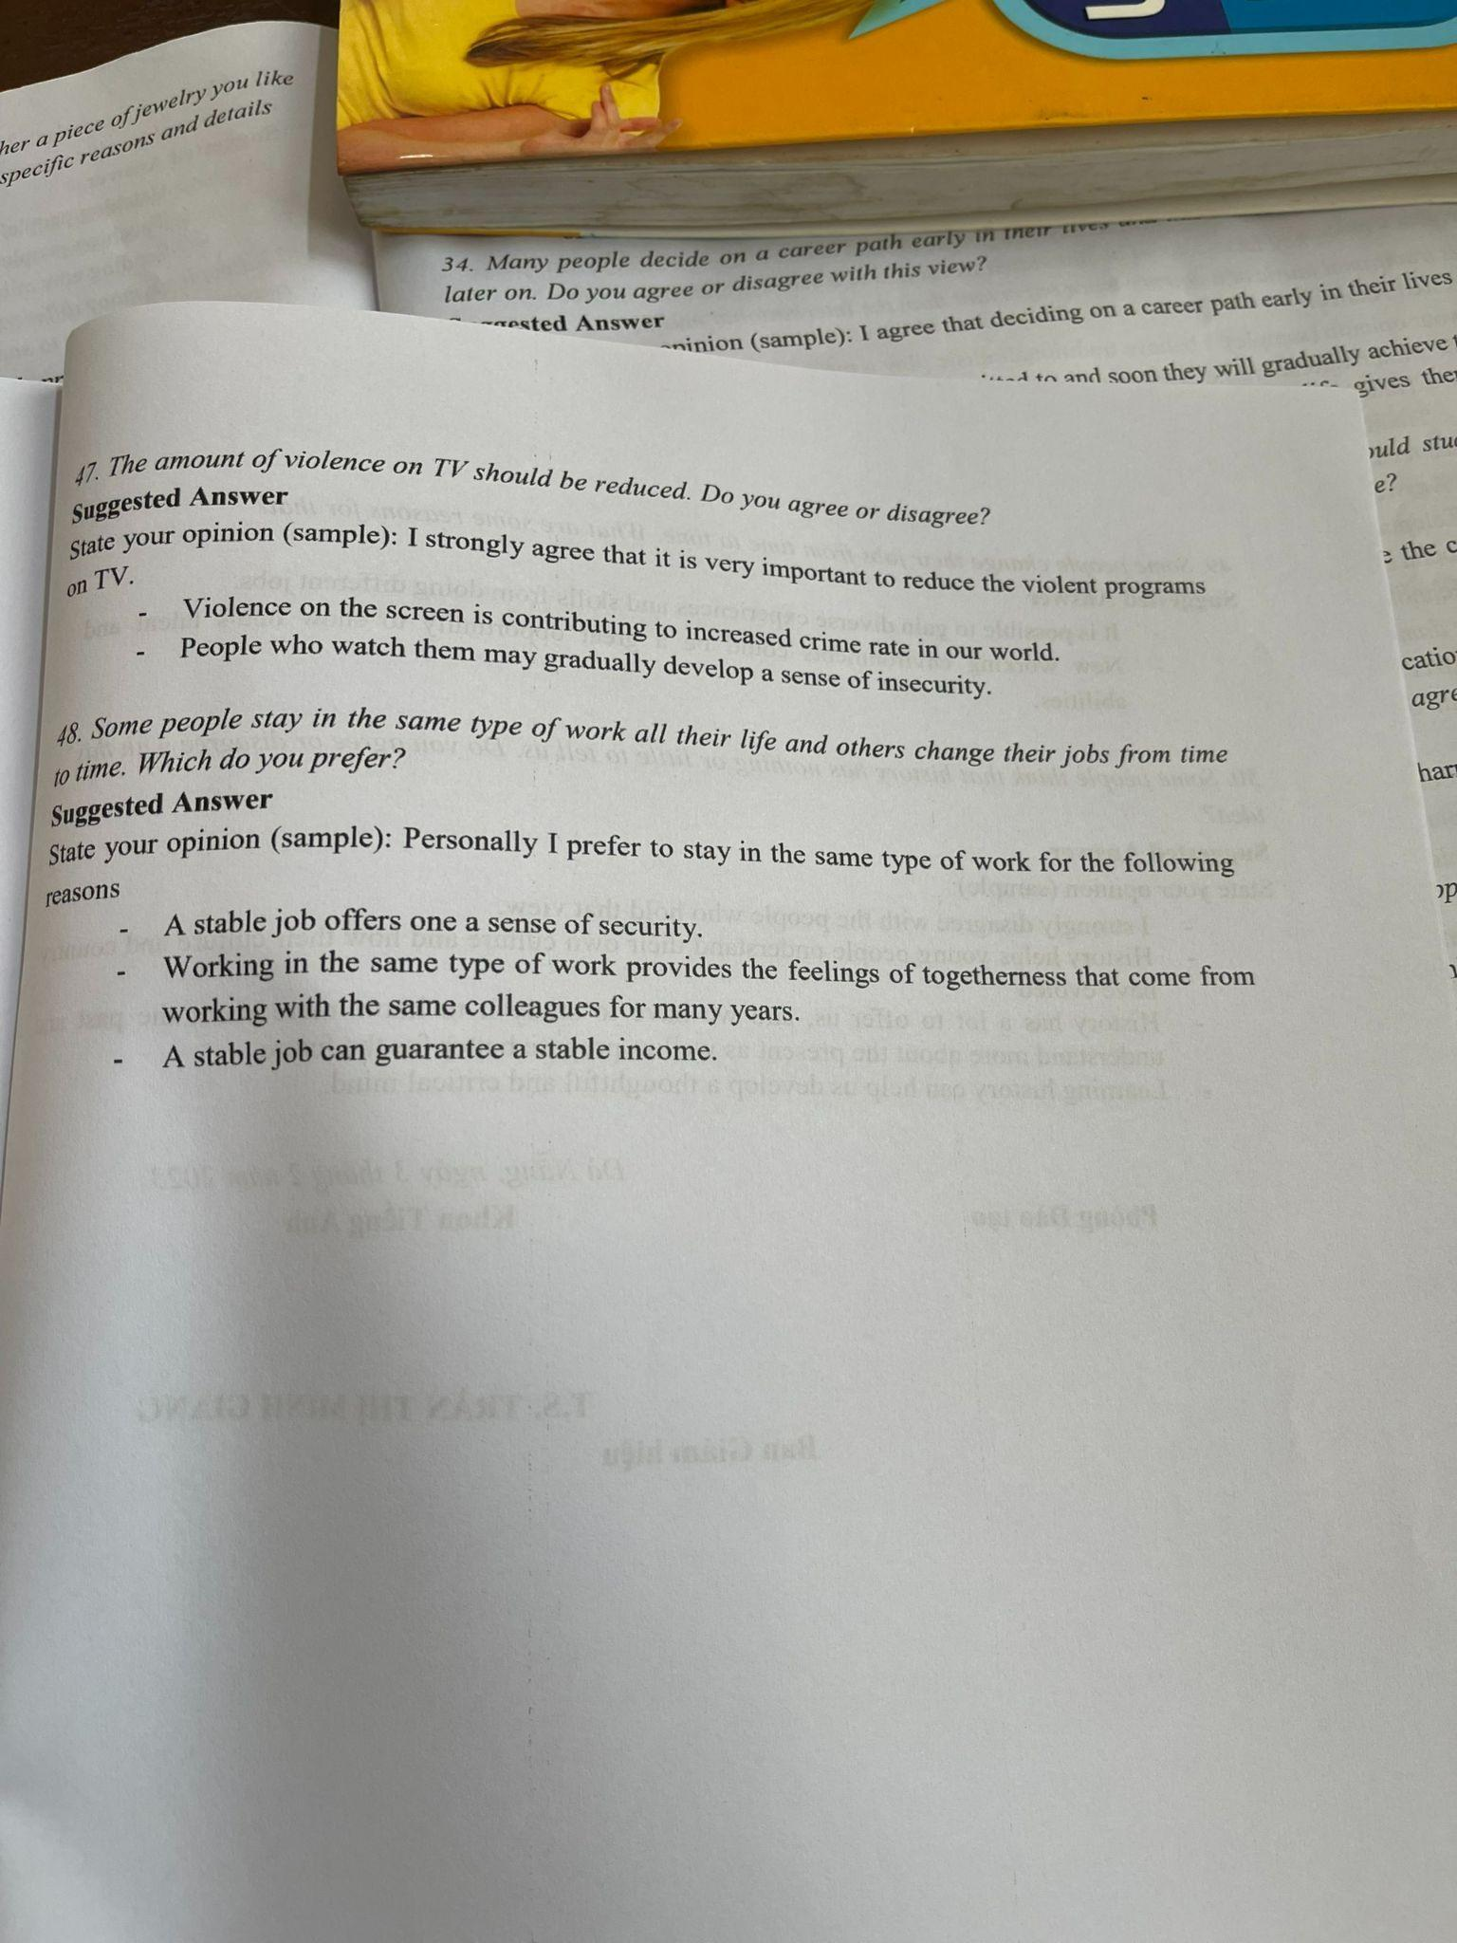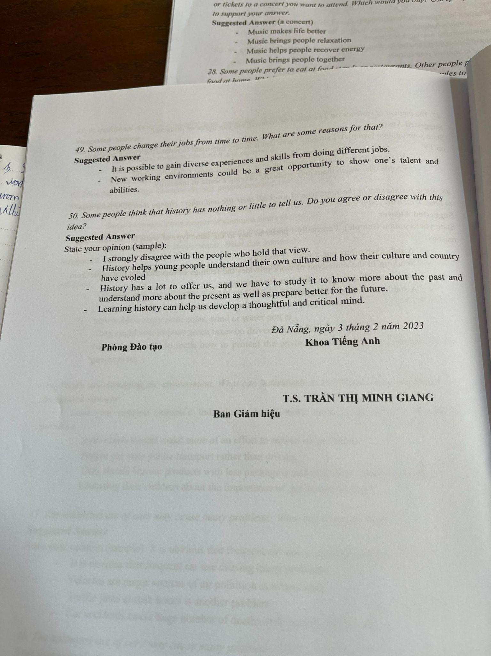

12-5-24

Phần Speak   
1 tranh  
1 topic

Topic: shoppine online với super marketing

=> tranh là thầy dạy sinh viên ở trong lớp

Topic nông thôn thành thị

Topic spend time outdoor-indoor

=> tranh nhà hàng

Topic: people do many diffrent to stay healthy ( số 22 )

=> Tranh phòng học có nhiều học sinh ngồi làm bài

topic gia đình hay bạn bè ảnh hưởng đến thanh thiếu niên nhiều nhất

=> Tranh phòng học có nhiều học sinh ngồi làm bài

topic wathching movie bad for children

=> tranh là 1 cặp ôm trái dứa, ở trong siêu thị

topic: benefit of working with your close friends

=> tranh sinh nhật , 5 đứa nhỏ đón sinh nhật

Topic 13,40, 38

tranh 41,21,15,27,3, 8  
phụ nữ với đàn ông mang mũ, đứng cạnh nhau, phụ nữ chỉ tay, đàn ông nhìn, ăn mặc đẹp, có xe đạp, có đóa hoa trước xe đạp

Speaking 2023

**KEY SPEAKING TEST**

Bài thi gồm 8 phiếu (tickets). Sinh viên thi theo hình thức bắt thăm chọn một phiếu bất kì để trả lời. Sinh viên có một cơ hội đổi phiếu. Cấu trúc mỗi phiếu (đề) gồm các phần như sau:

* Phần 1: Mô tả tranh (60 điểm). Sinh viên có 30 giây chuẩn bị và 45 giây trình bày.
* Phần 2: Thể hiện quan điểm cá nhân (140 điểm). Sinh viên có 15 giây chuẩn bị và 60 giây trình bày.

**2. Mẫu đề thi:**

**PART I: Describing a picture (**3 marks**)**

*Directions*: In this part of the test, you will describe a picture in as much detail as you can. You will then have 30 seconds to prepare your response. Then you will have 45 seconds to speak about the picture.



**PART II**: **Express an Opinion** (7 marks)

*Directions*: In this part of the test, you will give your opinion about a specific topic. Be sure to say as much as you can in the time allowed. You will have 15 seconds to prepare. Then you will have 60 seconds to speak.

***Question:***

*Some people prefer to take a job that does not pay well but does provide a lot of time off from work. What is your opinion about taking a job with a low salary that has a lot of vacation time? Give reasons for your opinion.*

**Dưới đây là một số tình huống và ngữ cảnh thường gặp trong các câu hỏi của bài thi TOEIC phần Nói**:

1.



**2.**

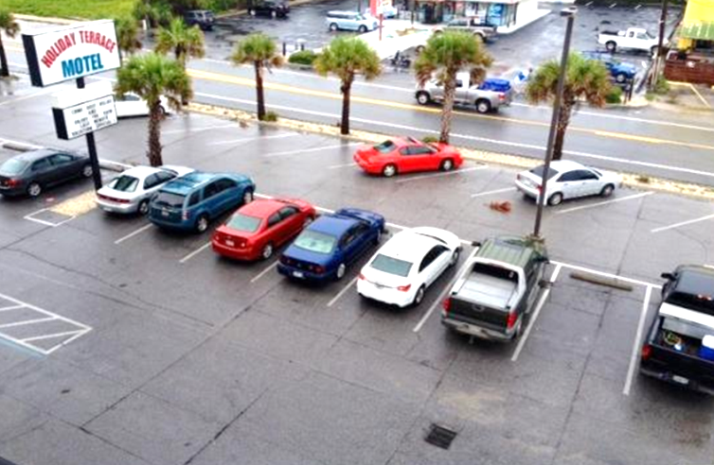

**3.**



**4.**

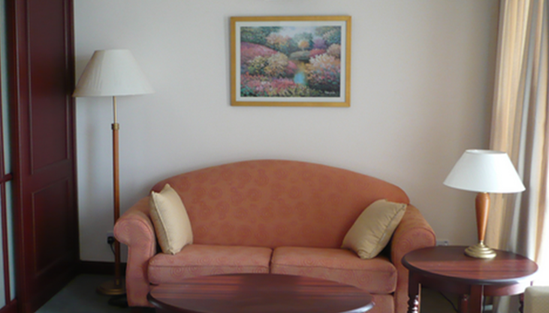

**5.**



**6.**

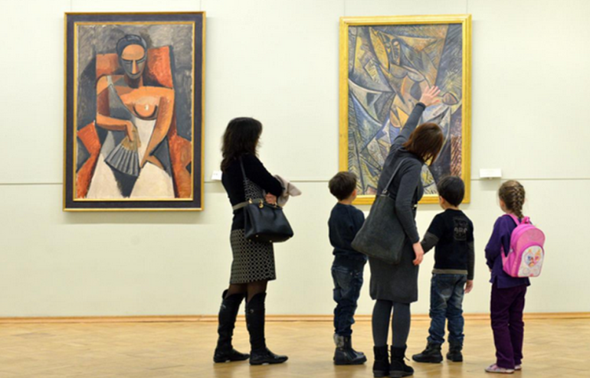

**7.**



**8.**

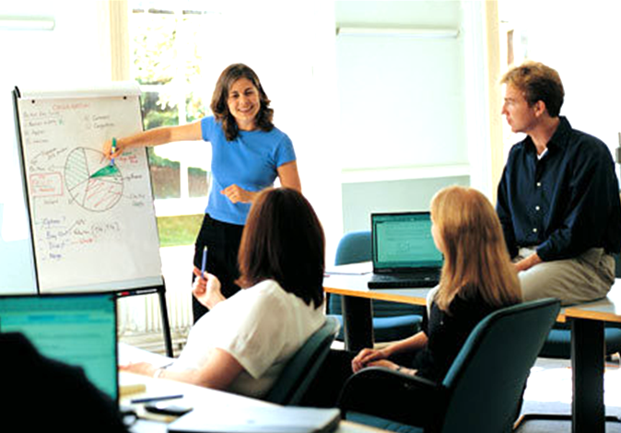

**9.**



**10.**   
 

11.

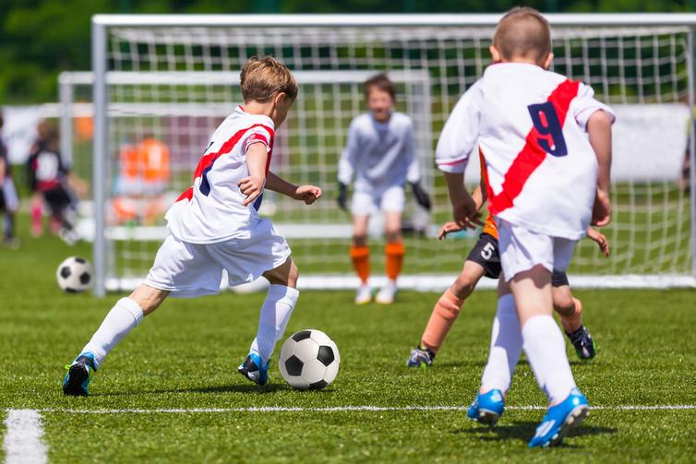

**12.**



**13.**



14.

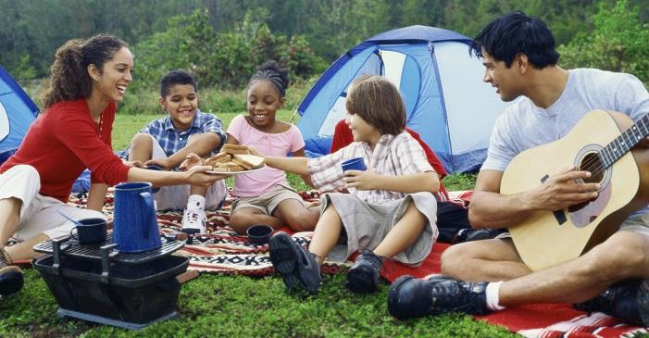

15.



16.



17.



18.

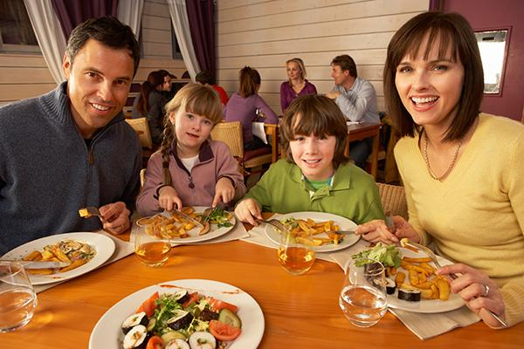

19.



20.

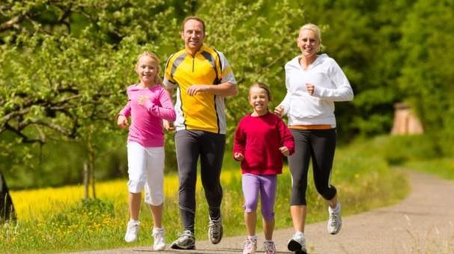In t

21.

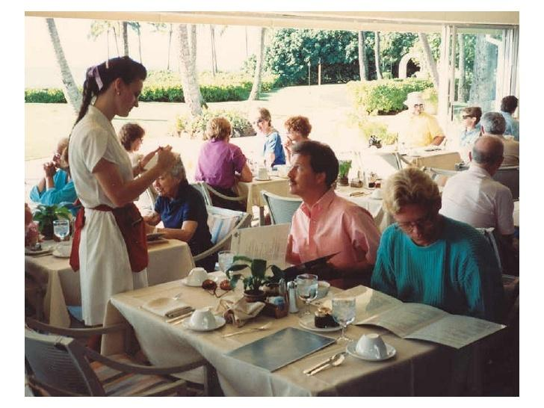

22.



23.

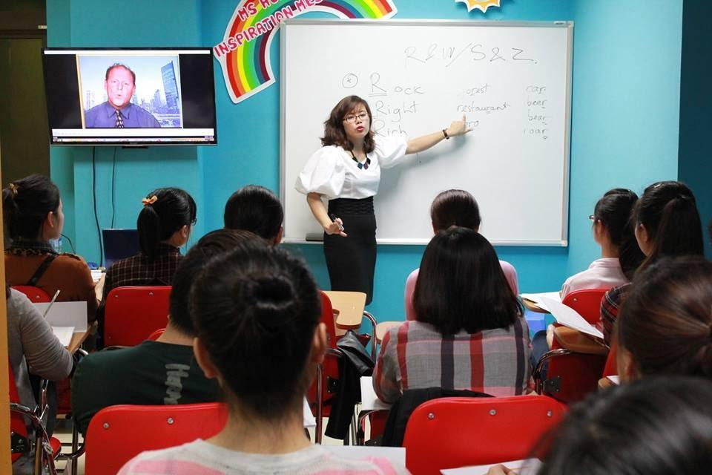

24.



18.

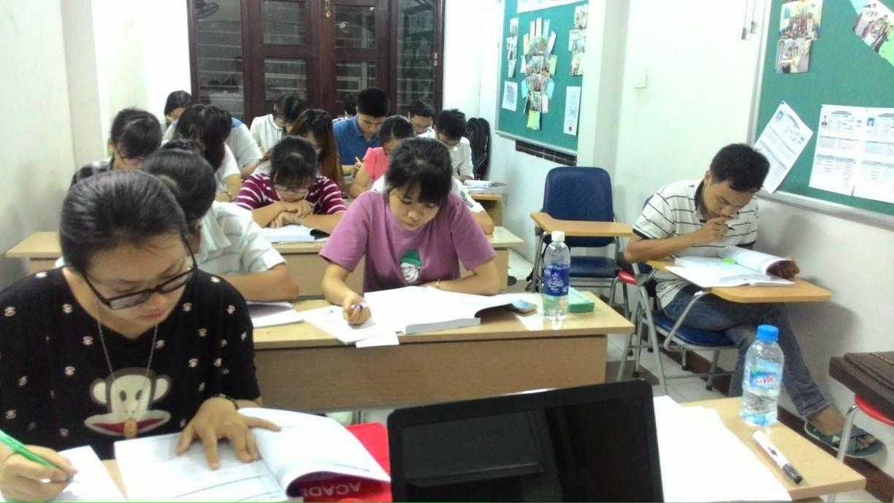

19.

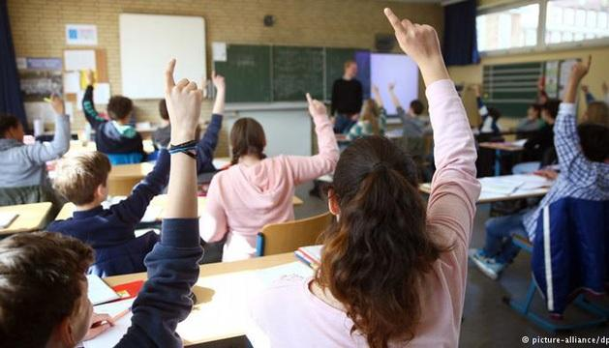

20.



28.

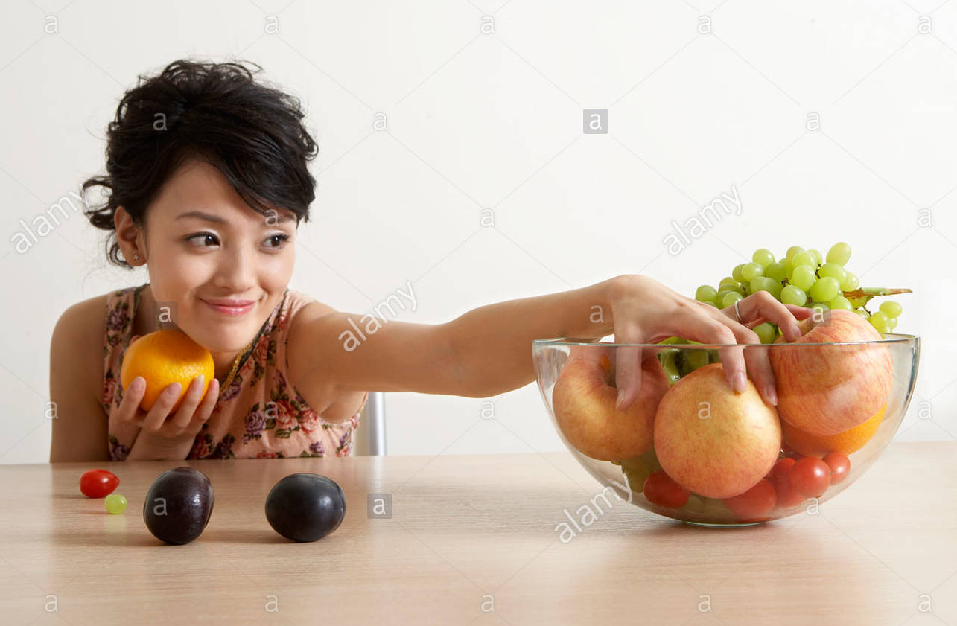

29.



30.

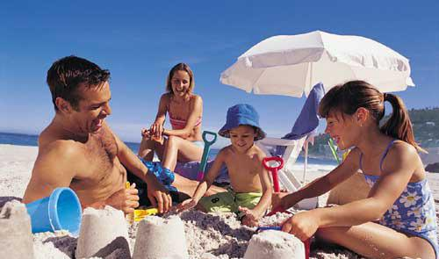

31.

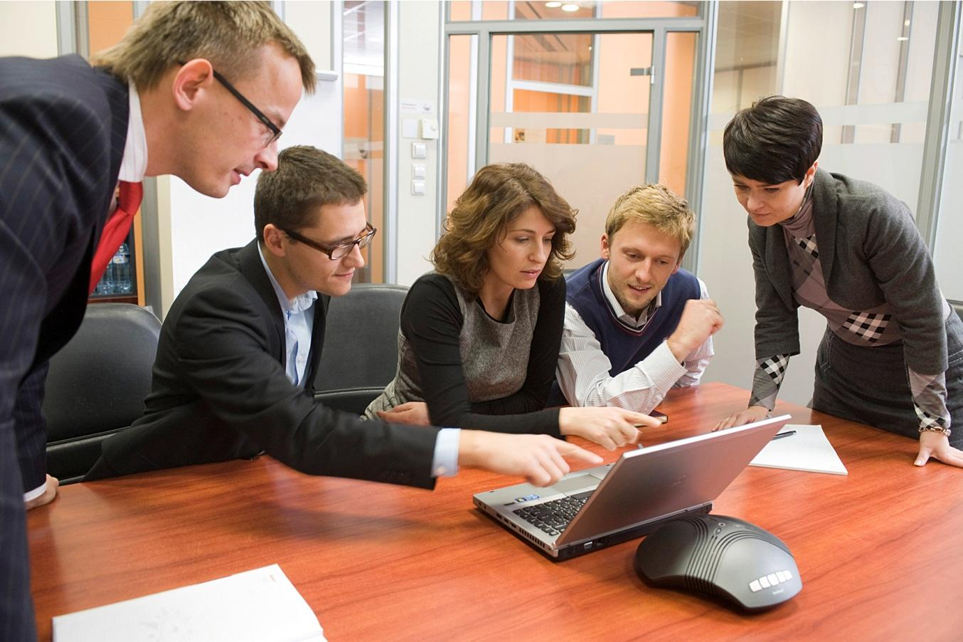

32.

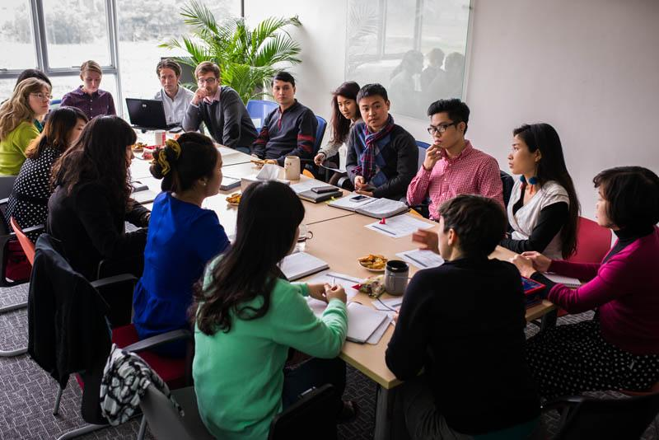

33.



34.

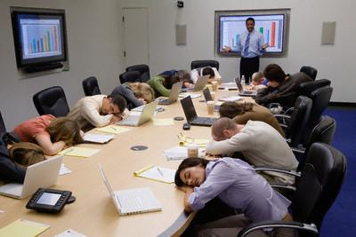

35.



36.

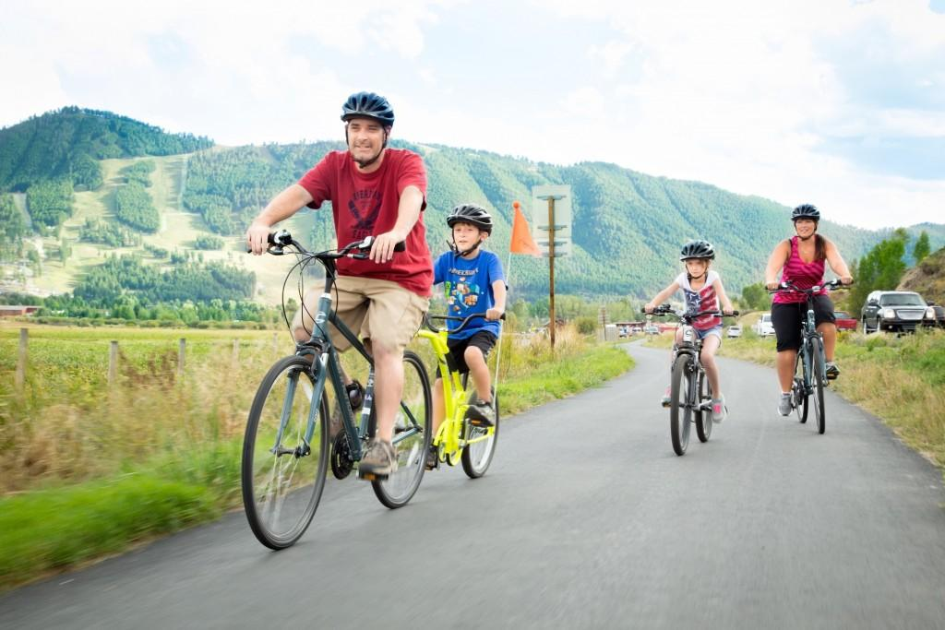

37.



38.



39.

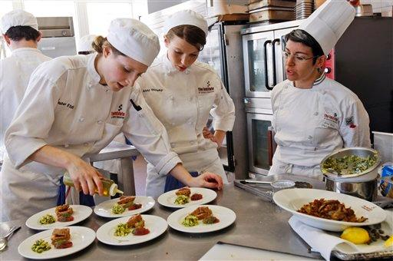

40.

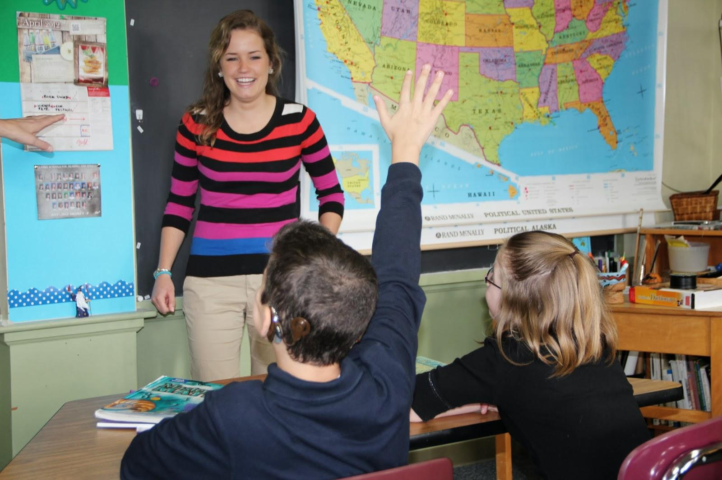

41.



42.



43.



44.



45.

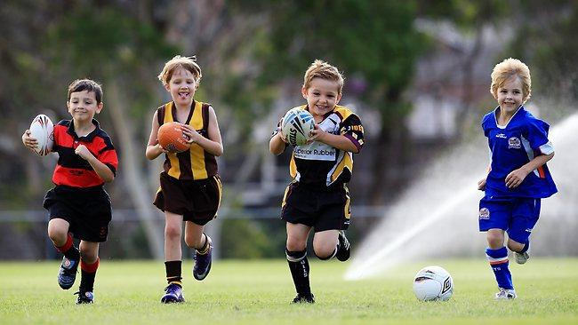

46.

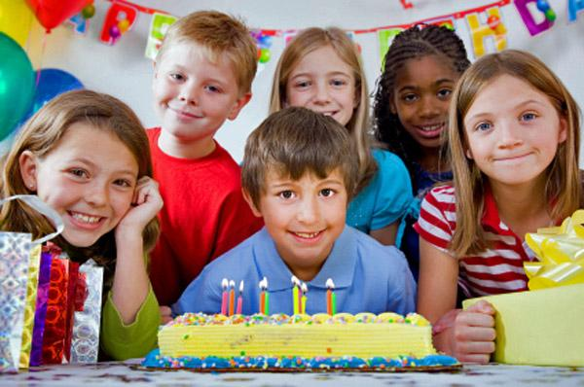

47.



48.



49.

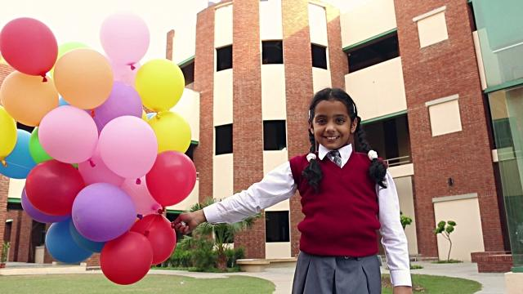

50.

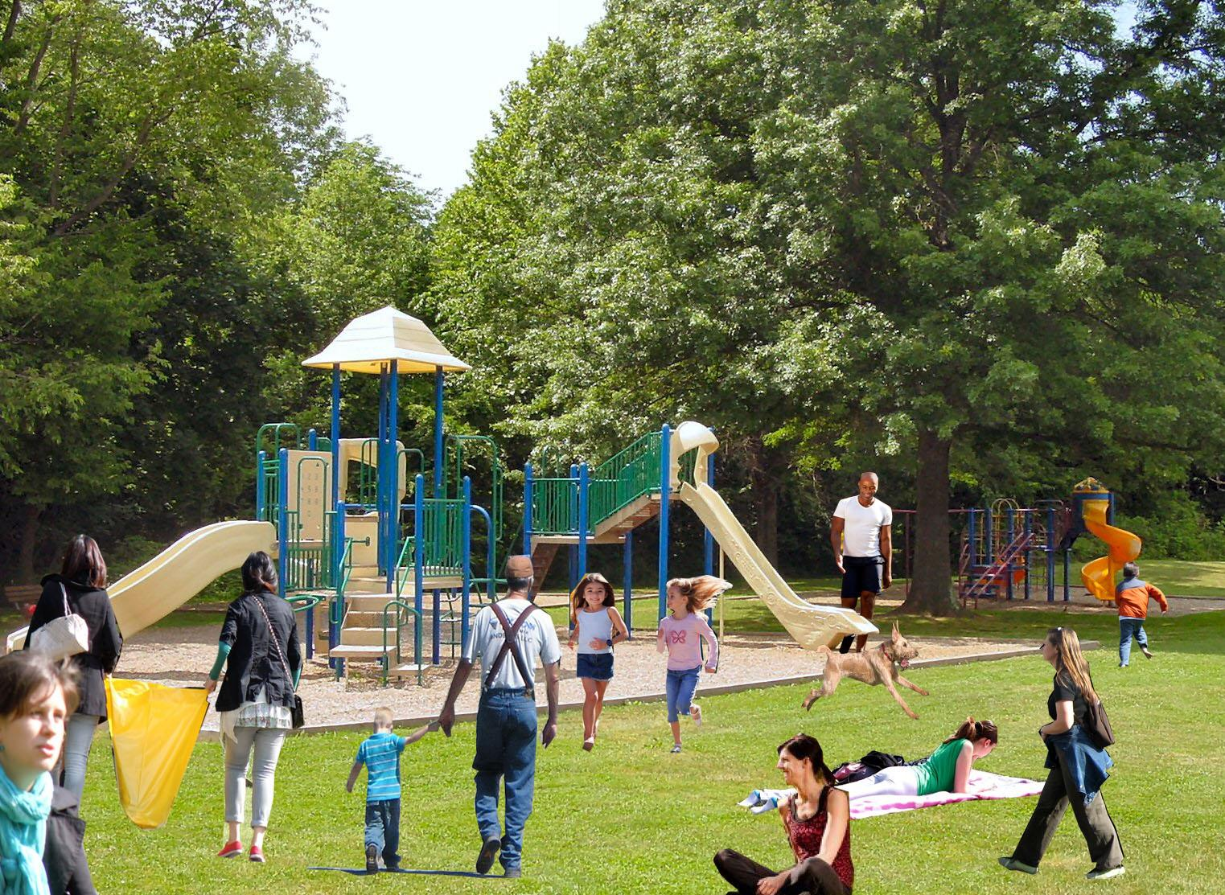

**ANSWER:**

1. Look at the picture I can see there is one woman in the picture.

It seems that she is going shopping in the supermarket.

I guess that she is buying bread.

There are two shelves at two sides of the picture and in the middle of the picture is a way.

Next, it is clear that the woman has blonde long hair.

In addition, she is wearing a T- shirt.

I think she is about 35.

I am not sure but it seems that she is holding a shopping basket.

She appears to be focusing on the products.

2. In this picture, I can see many cars.

The cars are (parked) in the parking lot.

The cars are next to the motel.

In the parking lot, I see many kinds of cars.

They are very beautiful, modern and colorful.

Along the way there are many lamp-posts.

There is some vacancy in the parking lot.

Background has some trees and in front of parking lot is the big road.

On the road there is a little traffic.

I feel the scene is quiet.

2. In the picture, I see two people.

The picture may be taken on a street.

A woman is wearing glasses and a man is hugging her.

Besides, they are wearing hats. The woman is pointing at something.

The man seems to be looking at what she shows.

I can see they are smiling together.

Maybe they are a couple.

I think they are very happy

In short, it is a nice picture

4. Look at in the picture; I can guess it is a living room

In the center of the photo, there is a sofa

On the 2 sides of the sofa has 2 pieces of pillows

There is a photo on the wall above the sofa

On the left of the picture is a high lamp

On the right of the picture, there are a table and a lamp

The table is under the lamp

Next to the table is a curtain

The room has a white color

There is a window on the right of the picture

5. In the picture, I can see a family

I think they are having dinner together because there are a lot of food and drink on the table.

They look so delicious and plentiful

The mother is cutting the pizza for her son

She has long black hair. She is wearing a sweater

The father has short hair. He is wearing a shirt

The father and his daughter are watching something and smiling

Their two children are wearing white T-shirts

I think this is a happy family.

6. Look at the picture; I guess that this is an art museum.

There are 5 people in the picture, may be they are the teachers and their students.

In the background, there are 2 pictures on the wall.

A teacher is showing a picture on the right and explaining something to her students.

In the foreground, there are 3 students; I guess that they are the elementary students.

They are looking at the picture.

Another teacher is standing behind the others, she seems to be thinking about something.

Everyone is wearing overcoats or sweaters.

I think it’s cold on that day.

Clearly, the children are having a wonderful experience.

7. Look at the picture I can see a lot of people

It seems that this is a small market.

I think it is held outdoors and it was beautiful

The people around are shopping. They seem to enjoy shopping here

The woman that has short hair and is wearing sunglasses is giving something to the man. She seems to buy an item

The woman who has white hair seems to be tasting something.

The salesman was wearing an apron and he was very happy.

There are a lot of items put in front of every counter. This market is crowed and funny.

8. Look at the picture I can see 4 people in the room.

It seems that they are having a meeting at a company

The woman who is standing in the center is having a presentation. She is smiling and so confident with her presentation.

The man who is sitting on the table is wearing a black shirt. He looks attentive to the presentation.

The woman on the right who has a yellow hair is focusing on the presentation.

The last woman on the left who is wearing white shirt, is holding a pen in her hand.

I guess there is 1 more person who is sitting on the left of the picture. Maybe this person is listening to the presentation.

There are 2 laptops on the table.

I guess all of people in this room are coworkers

It seems that they are quite serious & concentrated.

9. In this picture, I can see a man and a woman.

They are sitting in the restaurant

There are two glasses on the table

The man is looking at the cellphone

The woman is holding the glass and looking outside

The man is wearing a shirt

The woman is wearing a dress

They are not talking each other

She ignores him

I think they many have a problem

10. Look at the picture I can say this is a photo of the people

There are four people in the picture

I guess that they are colleagues

It is clear that there are two women and there are two men

I think that they are discussing work together

Next, I can see they are holding notebook

In addition, three people from right through are wearing the same suits

The woman on the left is wearing a white shirt

I am not sure but I guess that they are standing in their company

Everyone seems very happy so I think that the discussion is very successful.

11. Look at in the picture; I can see many boys are in the game

On the left, near the goal has a ball

On the center has a boy who is standing front of the goal. Maybe his mission is to keep the goal.

On the right of the photo has 2 boys, they are try to shoot the ball

The boy on the right is wearing the T-shirt number 9 and white socks

The boys in the center are running to follow the ball on the ground.

The goalkeeper is really focusing on the game

All of them look so serious with this game

I guess it is a sunny day

I think they really love to play football

12. In the picture, I can see there is a family.

They are in the park

The family has six people: grandfather, grandmother, parents and two children

The grandparents are sitting between the parents and children

They are wearing the family uniform

In the background, there are many trees

May be, they have a picnic in the park on Sunday

All of the members are talking a photo to keep memories

They are smiling and look so comfortable

It seems that this is a happy family

13. In the picture, I can see 2 people.

They are 2 the women

They are clapping their hands together.

One woman has blond hair

She has white sportswear

Another woman has black hair

She is wearing black clothing

They are holding the rackets

Maybe they are playing tennis at the stadium

They look very happy

They seem to play sports very well

14. What I can see is the picture of a family

In the background, there is a tent and many trees

There are 5 people: 3 children, woman and man

Maybe, they are going on a picnic in the park

In the middle there are many cakes, candy, fruit

The man is holding the guitar and the woman is holding the guitar and the woman is holding a dish of food.

The children are looking at the dish of food.

I guess behind them, there are huts

Clearly, they are having a good time together.

15. In the picture, I can see five people.

On the table, there are a lot of food and water

Maybe, these people are eating in the restaurant

They are talking together comfortably.

In the middle is a woman

She is smiling with her friends

She has long hair

Her friends are smiling around her

She is wearing a white dress

They look very happy.

16. In the picture, I can see, there are a woman and a little boy.

They are in the kitchen

I think they are a mother and a son.

The woman has long black hair

She is wearing a shirt

The woman is cooking the food

It looks delicious

Her son is standing beside her and watching her cooking

He looks so cute

It seems that he is eager to enjoy the food

The mother appears so happy to take care of her son.

17. Look at the picture I can see 5 people

I guess they are in an advertisement

In the center of the picture is the earth

On the left of the photo is the airplane

Around the earth and airplane are clouds

On the right of the photo has 2 men and 3 women

The first man is wearing a white hat and T-shirt

The last man is wearing a shirt

They are very happy

Maybe this is the advertisement about traveling around the world

18. Look at the picture, I guess that this is a restaurant.

There are 4 people in the picture, maybe they are a family.  
In the foreground of the picture, a family are sitting around the table with full of food.  
There are some dishes and water glasses on the table

I guess that they are eating salad.  
There are some people in the background, they are talking together.  
The restaurant is designed very simply  
It’s decorated by white walls  
The family are looking at the camera, maybe they are posing and taking a photo   
They seem happy and they are enjoying their day-off.  
I like the picture because it makes me want to meet my family.

19. Look at the picture I can see

There are two people in the picture

I guess that they are a married couple

I think that they are going shopping

It seems that, on the left has clothes shop

Besides, I can see the man is wearing a shirt and wearing jeans

And the woman is wearing a T-shirt

Next, I can see they are looking at the same direction

I am not sure but I suppose they are holding many bags

It is obvious that they are very happy with their shopping.

20. This picture shows me of family.

There are 4 people, the father, mother and 2 children.

The father and mother may be over 30 years old.

2 children are about 10 years old.

The mother is wearing a coat.

She has long hair.

They are running in the park.

They look like comfortable and fun.

I like picture, because makes me miss my family.

21.

In the picture I can see many people.

In the foreground of the photo is two men and one waitress .

The man on the right is looking at the menu and choosing the food .

The man on the left are holding the notebook and looking at the staff

They were sitting at the table.

It is clear that they are in a restaurant.

I think the waitress is writing kinds of food down.

The restaurant looks very crowded.

They may be eating lunch at the restaurant and they look very relaxed.

I can see many things on the table.

They are very beautiful.

I like the atmosphere here because it is quiet and peaceful.

22. In this picture, I can see four people.

This is a family including dad, mom and two children.

There are eating for lunch together.

The father is wearing the T-shirt and holding a knife and a fork.

The mother is wearing the shirt and has long hair.

The food put on the table looks delicious.

They are in the kitchen and behind them is the closet.

May be they are talking about the food.

It is clear that children are very lovely.

They look happy and fun together.

23. Look at the picture, I guess that this is a classroom.

There are many people in the picture, may be they are the teachers and students.

In the background of the picture, there is a board and a television.

The teacher is standing in front of the board.

She is pointing on it and explaining something to her students.

She is wearing a T-shirt, a skirt and a pair of glasses.

All the students are focusing on the lesson.

The teacher looks professional and the students are hard working

The atmosphere of the class is so calm.

I love this learning atmosphere of the picture.

24. In this picture, I can see a woman and a dog.

It is clear that they are playing together.

The woman is wearing a sportswear, a hat and shoes.

The woman is holding the ball.

The dog is seeing the woman and is standing next to her.

In the background there are many trees and mountains.

I can see they are standing on

Maybe the dog is jumping up and is trying to catch the ball.

I feel they are fun and dynamic.

25. There are several people in the picture

Maybe they are students in a class

In the background, there is a black board.

In the foreground, there is a black laptop

Maybe this is the teacher’s laptop

On the right of the picture, there are two green boards

On the green boards, I see many papers

May be the students are writing and pasting them on the boards

The students are doing a test

They look quite attentive

The atmosphere in the picture is serious

26. This is the picture of a class.

In the picture, there are many students.

Front of them has a black board.

Next to that, there is a projector.

In addition, I see they are very focusing on the lesson.

They are raising their hand up.

I'm not sure, but it seems everyone is raising one finger.

I guess they are choosing the answer for a certain question.

It appears to be a very effective lesson.

I like the atmosphere of the lesson.

27. Look at in the picture, I can see 2 people. Maybe they are in the supermarket

On the left of the photo, there is a shopping cart

On the right of the photo, there are a lot of fruits on the racks

In the center of the photo, has a woman who is wearing a cardigan

Next to the woman is a man who is wearing a shirt

They are holding a pineapple

The man and the woman are looking at together

In the center of the picture is a big green pineapple

In general, this picture has many kinds of fruit

The man and the woman in the picture may be a spouse.

28. In the picture, I can see the woman is taking the fruit.

The woman has black short hair.

She is wearing a T-shirt

She is smiling and looking at the fruits which she likes

There are 2 tomatoes on the table

The others are in the bowl

In the bowl, there is a bunch of grapes, a pear and an apple

Her left hand is reaching to get a pear and her right hand is keeping an orange.

I think she is happy and really wants to eat these fruits.

29. Look at the picture, I can see there is a Halloween festival.

In the middle of the picture, there is a pumpkin.

It’s displayed in front of the building with the words “Happy Halloween”.

In the foreground, there are many flowers and small pumpkins

In the background, there is a white castle.

There are many people in the picture.

They are taking photos together.

I think the weather is very cold because all of the people are wearing warm clothes.

There are many activities in the picture and everyone looks excited.

The picture reminds me of my Halloween festival last year.

30. In the picture, I can see a photo taken on the beach

In the foreground of the picture, there are 4 people, a man, a woman and 2 children

I think this is a family

The man is lying on the sand

The woman is wearing a bikini, she is sitting on chair

They are watching their children playing with sand on the beach

It seems that these kids are building sand castles

There is a nice umbrella next to the chair

In the background of the picture, I can see a mountain

I suppose that this family very happy.

31. - This picture is about the people  
-There are two women and two men in the meeting room  
- I guess they are discussion about some problem  
- It is clear that a laptop is on the table  
-I can see the woman who is sitting is pointing to the laptop screen  
-Three men are wearing suit , one of whom is standing  
-The man sitting next to the woman is looking at the laptop  
-The number of paper in the table is two  
-It is a true that one of three men is wearing glasses  
-I think the meeting is very uncomfortable because they look so nervous.

32: Look at the picture, i can see there are many people in an office. It is clear that they are having a meeting. The meeting room has a big window with full of sunshine and a corner has a small green plant. The meeting room seems a bit small. All people are sitting around the long table. I guess the woman is sitting a behind the window is a manager. The man is sitting in front of laptop is a secretary. There are a lot of documents on the table. I think that are discussing to set up a development plant of the meeting. Maybe the atmosphere of the meeting is very stressful. I hope the meeting will finish successfully.

33. In the picture, I can see five people. I guess they are discussion about new project. The man is standing and talking with all people. It is clear that there are four women in the room. They are wearing casual clothes. I’m sure that the meeting is very important because I can see everyone is focusing to it. I believe that they have reached an agreement.

34. In the picture I can see many people. I guess they are having a meeting. One man who is wearing T-shirt is standing talk about something. The others are sitting around a table and are sleeping. I think they feel really bored so all of them fall asleep. They are quite young about 25 to 30 years old. They are wearing formal clothes. There are many laptops and documents on the table. Finally, I want to say that I think that the man is having such a boring presentation that no one listen to him.

35: In the picture i can see two people. There are one man and one woman. It is nice weather. I guess they are a couple. The man is standing and the woman is sitting. I think they are at the top of the mountain. It is where they can see the city from above. Moreover, they are wearing T shirt, shorts and backpack. We can see he is raising his hand to the sky. They look very comfortable.

36.  This is a picture. I saw four people in the picture. They are a man, a woman, a boy and a girl. Look at the picture I think they are a family. They are riding a bike on the road. And this road is near the mountain. They are wearing a helmet. The man rides first is father, in the middle is two children, the last person maybe the mother. The weather is very beautiful. Both sides of the road are beautiful. I see them smiling. I suppose they are a happy family

37: Look at the picture, I can see there are one man and one woman.  
It seems they are attending a dance competition and they are performing their dance.  
The woman has long hair and looks very pretty.  
The man with short hair looks handsome.  
They are holding hands.   
The woman is looking at the man, the man is smiling very fresh.  
Both are wearing very sexy clothes and shoes, which look very nice.  
They dance very well and are very confident about their performance.  
In addition, in the picture I can see a lot of lights on the left.   
On the right there is a staircase and no one on it.  
Maybe they are longtime partners or are close friends with the same passion.

38: It looks like a picture taken in the kitchen. There is a person. She could be housewife. Look at the picture, i see the woman is standing in front of a big soup pot. She is wearing an apron, ponytail and tasting the soup. On the counter, there are lots of different kinds of fruits and vegetables. There look very fresh. I think she is preparing meal for her family.

39: In this picture, I can see four people. They are in the kitchen. That may be the kitchen of a certain restaurant. They are wearing white uniforms. The women on the right of picture are wearing a long white hat. Maybe they are chefs. They are standing around the table. There are 6 dishes being decorated. The women on the left of picture are holding a bottle of sauce. They are focusing on their work.

40. Look in the picture I can see there are three people in the picture. I believe that they are in the classroom. on the left of the picture, I can see the boy is raising his hand and the teacher is looking at him. Next to him, It is a girl wearing a glasses and her hair is yellow brown. In the middle of the picture, I saw the teacher smiling and she has a friendly face. Behind of the teacher, I saw the map and the board. Maybe, they are in geography class and both of them are very comfortable. The boy and the girl are both wearing uniform and glasses. In front of the boy, I can see the book, but I can't tell what book on the table. From the picture, I can see this is an interesting class and the teacher is very enthusiastic

41: Looking at the picture, I can see there is a guy and a girl.  
Both of them are talking happily together.   
They are sitting in the park.  
The sky is blue, the wind is cool.   
The guy is with short hair.   
He wears T-shirts, jeans and jeans.   
The girl has long hair and looks pretty, beautiful.   
She wears a long sleeved shirt and jeans.   
In addition, I also see in the picture, the guy sitting guitar and singing the happy girl listening to the boys.   
Both are happy to sing each other.   
Beside that, the girl was singing with her fingertips.   
I noticed, behind them a big tree.

42 Look at the picture I can see big buildings.  
There are a lot of people there.  
I see a gate.  
The buildings are built close together.  
People are walking in the yard.  
I see some people wear white.  
Some people talk to each other.  
I see the blue sky.  
And there are clouds in the sky.  
Look at the picture I think the picture was taken in the summer.

43. Looking at this picture, i can see two people. Maybe they are scientists because they are wearing laboratory coats. In addition, it is also because the picture seems to be taken in a laboratory. Behind them, there are a row of white cabinets with a lot of items in them. On the right of the picture, there is a woman using the microscope. Maybe she is analyzing samples under the microscope. Next to her is a man who is holding a document on his hand. Maybe he is helping her write down the information. They're both quite young and focusing on their work. They maybe are co-workers since they look in the same age.

44. In the picture, I can see a woman. She has a beautiful long black hair. Her face is a v-line form and has a cute nose. She wears a suit. She looks polite. Maybe, she is an office worker. And I guess she is at a coffee shop. She is sitting on armchair. She is reading newspapers and holding a cup in the hand. There is a small disk of cake and flower pot on the table. I think that she is funny and is interested in information on newspapers.

45. In this picture I can see four children. They are playing with ball together in the yard. The boy on the right the picture is running to after his ball. The boy who looks like the fastest in all is holding the ball, I guess he is soccer player. The boy that looks like the tallest in all is holding the ball, I guess he is a volley baller. The boy looks like the smallest is holding the ball maybe he is playing rugby. I hope all children will play happily.

46-This picture is about a birthday party  
-There are many children in the picture. I can see four little girls and three little boys  
-It is clear that a birthday cake is on the table  
-I guess the boy, who is sitting next to the cake is preparing blow the candles  
-There are two little girl beside the boy , one of whom is holding a gift  
-It is apparent that all of children are looking at the same side  
-I can see this room which is held the party , decorated very beautiful   
-The children are excited , all of them are smiling  
-I see the little girl who is black curly hair , is standing between two another girls  
-I think the birthday party is very happy

47- In the picture, I can see two people.   
- Maybe, they are at the hospital.   
- On the left of the picture, the woman is wearing a blouse.   
- She is holding the document in her hand.   
- I think that she has short hair.   
- The man is lying in the bed on the right of the picture.   
- He is wearing the pajamas.   
- He is talking about things with the woman.   
- They look like a doctor and a patient.   
- It is clear that the doctor is checking the man’s health.   
- I guess he feels content with her visit.

48   
- In this the picture, i can see many people.  
- I guess that they are holding a party.  
- On the left of the picture, there are two people one man and one woman.  
- They are talking with together.  
- The man on the right of the picture is decorating the dishes.  
- I am not sure but i think he is about 25.  
- On the table there are many foods and wine.  
-Besides, one woman is pouring wine into a glass.  
- They look very happy.  
- I think that they are colleagues.

49- In this picture I can see a girl.  
- That is a young girl.  
- She is wearing a uniform.  
- Maybe the girl is a student.  
- I guess she is standing on the school yard.  
- Next, her right hand is holding lots of balloons.  
- She has long black hair.  
- The girl looks very happy.  
- In addition, maybe she is taking photos at her school.

50: Look at the picture. I can see many people. They are in the picture. There are many trees around the ground. In front of the trees is a children’s area. On the left of the picture has two girls. They are holding plastic bags. Next to, there are a father and a son, Dad is holding his son's hand to the park. In the middle off the picture, there are two girls running out. I think they just finished playing the game. It seems the weather is beautiful today. Everyone looks very happy.

**PART II**: **Express an Opinion** (140 marks)

*Directions*: In this part of the test, you will give your opinion about a specific topic. Be sure to say as much as you can in the time allowed. You will have 15 seconds to prepare. Then you will have 60 seconds to speak.

*1. Some people enjoy jobs in which they do the same work every day. Others enjoy jobs that involve challenging from project to project. Which type of job would you prefer and why?*

**Suggested answer:**

State your opinion (sample): I would prefer a job that involves challenging from project to project.

* Key point 1: I don’t really like doing the same thing every day.
* Key point 2: I like to meet new people.
* Key point 3: I think doing the same thing all the time could be really boring.
* I would like to learn new things, experience many different tasks
* Key point 4: a job involves challenging from project to project helps me have opportunities to travel a lot of places.
* Key point 5: I am a type of freedom so I like challenges
* Key point 6: I will have a lot of experience related to different fields in the future
* Key point 7: I think that salary of a job that involves challenging from project to project will higher than salary of jobs which is the same every day.
* Key point 8: In my opinion, a job that involves projects will be more interesting, creative than a job at office

*2. Do you agree or disagree with the following statement? “It’s more important to eat a good diet than to exercise a lot.” Support your choice with reasons and details.*

**Suggested answer:**

State your opinion (sample): I disagree with the statement.

* Key point 1: Exercise is a very important part of a healthy lifestyle.
* Key point 2: Exercise is fun.
* Key point 3: Eating a good diet can be healthy, but if you don’t move your body, it will become weak.
* Key point 4: Exercise helps decrease diseases
* Key point 5: Exercise makes everyone active
* Key point 6: Exercise helps us reduce stress after hard work/ hard study
* Key point 7: Besides if we exercise every day, we will have a nice body/ we will have a good shape

*3. Some companies prefer to promote their current employees to management positions, but other companies prefer to recruit new managers from outside the company. Which do you prefer and why?*

**Suggested answer:**

State your opinion (sample): I prefer to promote a company’s current employees to management positions.

* Key point 1: Employees are willing to work hard for the company when there is a chance for them to be promoted to a management position.
* Key point 2: Each team wants to have a manager who knows the members very well.
* Key point 3: Company saves money, finding an outside manager can be time-consuming and expensive.
* Key point 4: The training process is shorter: They already know a lot about the job, they’re familiar with company management and systems
* Key point 5: It helps employees to be loyal to the company:  If employees understand that promoting from within is company policy, it is a strong motivation for them to work hard. Employees feel excited when knowing that their efforts will be recognized and rewarded.

*4. Do you agree or disagree with the following statement? “Advertising has a big influence on consumer buying decisions.” Give specific reasons and examples to support your opinion.*

**Suggested answer:**

* State your opinion (sample): I agree that advertising has a big influence on consumer buying decisions.
* Key point 1: (Advertising gives good information about products) and services to a lot of consumers.
* Key point 2: (Advertising makes shopping simpler).

-Key point 3: Advertising stimulates curiosity of consumers, so they want to buy that product to satisfy their feeling.

* Key point 4: (Advertising helps us easily update new products) and services that are better than the old ones.
* Key point 5: (Advertising brings consumers a lot of choices). Ads about products produced by many different companies help us have suitable choices. Without advertising, how we know that there are different products.
* Key point 6: Advertising creates competition in the market, which makes products and services cheaper
* Key point 6: (Advertising makes shopping saves time).

*5. Some people think a good relationship between coworkers is good for business. What do you think about this?*

**Suggested answer:**

* State your opinion (sample): In my opinion, a good relationship between coworkers is good for business.
* Key point 1: When people are close to their coworkers, they can enjoy their work and their time at the office more.
* Key point 2: A harmonious working environment can help managers control employees.
* Key point 3: a good relationship between coworkers makes discussions on work become easier and smoother
* Key point 4: employees in the same company that have close relationship can bring creative ideas for their work
* Key point 5: (Good relationships help to make teamwork better)
* Key point 6: (It will reduce the competition among colleagues)
* Key point 7: good relationship makes everyone feel pleasant/ comfortable
* Key point 8: people will like going to work
* Key point 9: coworkers will work better with good relationships

*6. What are the benefits of working with your close friends? Support your answer with specific reasons and examples.*

**Suggested answer:**

State your opinion (sample): There are some benefits of working with my close friends.

* Key point 1: I feel less stressed at work.
* Key point 2: If I work with my close friends, we can motivate each other.
* Key point 3: Close friends are your support, both it’s emotional and physical support
* Key point 4: You have companion, you never have to worry about being alone
* Key point 5: innovative ideas.: Two heads are better than one. As you two brainstorm, the ideas get better and better.
* Key point 6: You will have a motivation to actually go to work when you have close friends at workplace
* Key point 7: Working with my close friends makes us feel easy to communicate with each other
* Key point 8: I feel more comfortable and confident with my close friends
* Understand better
* Share more
* Discuss more easily

*7. Do you agree or disagree with the following statement? “High school students should be able to choose which subjects they want to study.” Give specific details and reasons to support your opinion.*

**Suggested answer:**

State your opinion (sample): In my opinion, I agree high school students should be able to choose which subjects they want to study.

* Key point 1: Each high school student has different dream about what they want to be.
* Key point 2: Students don't enjoy learning about what they are not interested in.
* Key point 3: in some cases students have to study several subjects that they are not related to their career in the future
* Key point 4: it gives them freedom and independence, this is an important life skill that they will need when they are older.
* Key point 5: This will make students actually think about their future and it will improve their marks
* Key point 6: I think that it takes too much time to learn many subjects
* Key point 7: In my opinion, some subjects are not really needed
* Key point 8: Students will be stressed when they learn too many subjects

*8. Do you agree or disagree with the following statement: “Attending a company training session to get information is much better than getting information on the internet”. Support your answer with relevant ideas and examples.*

**Suggested answer:**

State your opinion (sample): I disagree with the statement that attending a company training session to get information is much better than getting information on the internet.

* Key point 1: Getting information on the internet is much faster than attending a company training session.
* Key point 2: I can manage my time with more freedom.
* Key point 3: We will have comfort: you don’t have to attend classes for hours, sit in an uncomfortable chair, and suffer from back pain by the end of the day, you won’t have to get up early to get dressed for class… the list of conveniences goes on and on.
* Key point 4: It reduces traveling time, decreases traffic accident risk
* Key point 5: You will save money: you won’t have to spend money on gas for your transport, or pay for any transport
* Key point 6: The information will be more reliable

*9. Do you agree or disagree with the following statement: “All students should be required to wear uniforms at school”. Support your answer with relevant ideas and examples.*

**Suggested answer:**

State your opinion (sample): I agree that all students should be required to wear uniforms at school.

* Key point 1: Wearing uniforms helps students focus more on studying.
* Key point 2: It will save money for students.
* Key point 3: Wearing uniforms creates fairness at school, in the class
* Key point 4: If students wear uniforms, they will save more time
* Key point 5: It makes students feel proud of the school they are studying
* Key point 6: Students will not do any bad things when they are wearing uniforms
* Key point 7: the school will be more serious
* Key point 8: It helps to avoid students wearing too short compared to normal

*10. Do you agree or disagree with the following statement: “Bonus is the most effective way to reward outstanding employees.*

**Suggested answer:**

State your opinion (sample): I believe that the bonuses are the most effective way to reward outstanding employees.

* Key point 1: Recently, the cost of living has become more expensive.
* Key point 2: Offering bonuses makes employees motivated.
* It improves employee loyalty
* Key point 3: Because it is very practical.
* Key point 4: It is an important motivation for them to try to work
* Key point 5: Money is the basic goal of most employees

*11. Do you agree or disagree with the following statement? Businesses should do anything they can to make profit. Use specific reasons and examples to support your opinion.*

**Suggested Answer**

State your opinion (sample): I disagree that businesses should do anything they can to make profit.

* Key point 1: If businesses can do anything, that means they can violate the law to seek profit
* Key point 2: Businesses shouldn’t cheat consumers
* Key point 3: Businesses can hardly develop in a sustainable manner.
* Key point 4: They need to do business ethically
* Key point 5: They shouldn’t break the law
* Key point 6: They are not allowed to affect badly on the interests and health of consumers
* Key point 7: Consumers will not trust the businesses
* Key point 8: The businesses can’t develop for a long time

*12. Do you agree or disagree with the following statement? The most important aspect of a job is the money a person earns. Use specific reasons and examples to support your opinion.*

**Suggested Answer**

State your opinion (sample): I don’t think that the most important aspect of a job is the money a person earns.

* Key point 1: Besides salary a person can earn doing a job, s/he can expand his/her social network / relationship
* Key point 2: She/he can improve several professional and soft skills
* Key point 3: She/he can get a promotion if performing excellently in his/her job
* Key point 4: There are something as important as money like the passion of each person, opportunities to develop talent of each person.
* Key point 5: They want to contribute to the development of the country
* Key point 6: In fact many people choose happiness and pleasure in their job rather than money

*11. People work because they need money to live? What are some other reasons that they work? Discuss one or more of these reasons. Use specific reasons and examples to support your opinion.*

**Suggested Answer**

State your opinion (sample): People work for some other reasons:

* Key point 1: They go to work to satisfy their personal ambitions and demand
* Key point 2: They do a job since they want to contribute to the development of a community or a company
* Key point 3: They do a job to care for their small families, like their children’s schooling.
* they go to work to develop themselves more
* *People work because they need to have relationships like friends, coworkers*
* they work because they want to use knowledge/ skills that they learnt at school
* people go to work for fun
* everyone works for new skills

*12. Some people prefer to work for a large company while others prefer a small one. Which one do you prefer? Use specific reasons and examples to support your opinion.*

**Suggested Answer**

State your opinion (sample): I prefer to work for a large company for the following reasons:

- It helps me to get more relationships

 - Promotion opportunities are higher than small companies

-Large companies pay higher salaries than small companies

- The health insurance, social insurance, policy of large company are clearly better

-Working environment in large companies more professional

- We’ll learn more in large companies.

- large companies helps me develop better.

13. *In some countries, teenagers have jobs while they are still students. Do you think this is a good idea? Use specific reasons and examples to support your opinion.*

**Suggested Answer**

State your opinion (sample): I think it is a good idea that teenagers have jobs while they are still students:

* Key point 1: They can accumulate/have/get/gain work experience
* Key point 2: They can develop communication and other soft skills
* Key point 3: They can realize the value of money and know how to save it.
* They can earn/ make money to help their study
* They can have new friends
* They should go to work to learn independence in everything
* Learn to communicate in front of the crowd
* Support their family

BAD IDEA:

* Part time jobs affect study
* Part time jobs affect health of students
* Students won’t have time to improve them
* Students can be cheated
* The may be lower grades
* Students can be stressed
* They can quit their study

*16. Some people think the family is the most important influence on young adults. While others think that friends are the most important influence on them. Which view do you agree? Use examples to support your ideas.*

**Suggested Answer**

State your opinion (sample): I agree that the family is the most important influence on young adults.

* Key point 1: Family is where they were born and grow up.
* Key point 2: Family can support us whenever we encounter problems.
* Key point 3: Family will help shape their characters and viewpoints.
* Where brings warmth and love.
* Family gives us faith, motivation in life
* The family is always with us in every situation
* It is an educational place that shapes our human personality
* Parents will teach us experiences, lesson in life to help us grow
* Parents always give their children the best things
* The family is the place to protect us about material, spiritual sducation
* Family is the place that love is sincere
* The family will be at your side longer than our friends
* The family will sacrifice all for us
* The parents always support us finance, take care of us, a give us foodrather than friends

*14. What are some qualities (đức tính) of a good parent? Use specific reasons and examples to support your answer.*

**Suggested Answer**

State your opinion (sample): I suppose a good parent should have the following qualities

* Key point 1: S/he should set a good example in character and behaviour for his / her children to follow
* Key point 2: She/he knows how to teach and train their children to be a good citizen in society
* Key point 3: She/he can support his / her family materially and spiritually.
* S/he should (frequently) express love to children
* S/he should spend more time with children
* S/he can let children know how to take responsibility for their own actions
* They should reward their children with good behaviors
* They shouldn’t be angry with children when they do something wrong
* S/he does not use violence on children
* S/he should forgive the mistakes of the children
* They should teach their children how to hare sympathy and love
* A good parent should train their children how to be independent
* The parent always brings something good to their children.

*18. Children should never be educated at home by their parents. Do you agree or disagree?*

**Suggested Answer**

State your opinion (sample): I disagree that children should never be educated at home by their parents.

* Key point 1: Children are often closer to their parents than anybody else and can ask them whenever children need to.
* Key point 2: Some highly-trained parents prefer to give their children home-schooling rather than having them go to school
* Key point 3: Learning at home with your parents will save you travel time
* Key point 4: Learning at home will save money
* Key point 5: Parents will understand your child’s strengths and weaknesses
* Key point 6: Parents will follow their children’s learning process more easily
* Key point 7: Studying at home will be more comfortable than at school
* Key point 8: Children will clearly express their views with their parents
* Key point 9: In addition, when studying at home with their parents, children are not only enriched in knowledge but also educated in their characters

*19. Most modern families have both parents working and as a result children spend less and less time with their parents. What is the reason for this and what problems can this cause?*

**Suggested Answer**

State your opinion (sample): I think the reason for the above situation is:

* Key point 1: Parents attach greater importance to earning money than to spending time educating their children
* Key point 2: Without parents’ proper care and attention, children can easily get spoilt like skipping class or involve themselves in social evils
* Key point 3: Children can possibly become disorientated in life and career choices and decisions

**Reasons:**

* Parents want to make lots of money to support their children
* Parents think that making money can help families be happier
* Modern families follow the western trend and they want their children to be independent
* They bring their children to extra classes so they have time to work more
* Because of lacking of love from parents children can drop out of school and participate in social evils.
* Because their job requests are higher and higher, parents use most of their time on working.
* More and more parents don’t want to be dependent on their children so both parents try to work hard.

**Problems:**

* Children can become lonely.
* They will have distance with their parent later.
* Children won’t have happy childhood if their parents don’t spend time for them.
* This causes children to receive less love from their parents
* Because parents have little contact with children, they do not know their ability and passion.

*20. In many western countries, there is an increasing number of couples choosing to have no children. What are the advantages and disadvantages to couples having no children?*

**Suggested Answer**

State your opinion (sample): I think choosing to have no children have the following pros and cons:

**Advantages:**

* They don’t have to work hard to make money
* They don’t have to take care of children
* They have a lot of time to enjoy their life
* They can travel freely
* They can have lots of hobbies/ interests/passion

**Disadvantages:**

* They will not have real happiness when they don’t have children
* When they are old, no one takes care of them
* They can break up easily because they don’t have children
* Key point 1: The couple can freely pursue personal interests and desire
* Key point 2: The couple can lead a life without worrying about earning too much money to care for children
* Key point 3: The couple cannot enjoy the happiness of a family life with children playing around or to teach good life lessons.
* Key point 4: The couple can get lonely when they age and become too frail to look after themselves
* In my opinion, those who choose not to have children the couple can do what they like without being restricted by the kids
* The couple can travel freely together without worrying about anything
* The couple can get enjoy the happiness of a family life with children playing around to teach good life lessons
* The family will lose children’s voice, smile and marriage life boring when the couple choose not to have children
* When the couple choose not to have children their marriage can break down at anytime
* I think when a couple with no children they can comfortable make money and when they get older they can travel together in the same place they like
* The couple can adopt children to take care of instead of choose to give birth
* I think choosing to have no children influences the country later because lacking serious source of labor
* The couple may encounter objection from their parents when they choose to have no children
* Maybe they will not enjoy the happiness of the family with their children

*15. Movies are popular all over the world. Explain the reason why movies are so popular. Use reasons and specific examples to support your answer.*

**Suggested Answer**

* **movies make us relax**
* **movies have lots of pictures so they are not boring**
* **They are cheap/ not expensive**
* **Watching movies is easy to relax**
* **Watching movies help to reduce stress**
* Movies like history, biography, technology… make us know about our culture and other fields.
* Movies people’s eyes with visual images which, makes them easy for viewers to absorb the content of the movie
* Movies people‘s feeling because movie bring many emotions such as: happy, sad, happy for viewers.
* Film sends educational messages for all ages, such as environmental protection messages, some training sessions.
* Watching movies helps viewers keep up with fashion trends,…
* Watch movies help me know the daily life of idols, singers, actors that they love…
* Watch movies to spending time free.
* By watching the movies you update the daily news like the weather, sports, and even music.
* Watch the movies help you learn many languages.

*22. People do many different things to stay healthy. What do you do for good health? Use specific reasons and examples to support your answer.*

**Suggested Answer**

* I eat good food
* I do exercises often
* I often go to bed on time every day
* I don’t smoke
* Sometimes I go swimming
* Taking enough rest and sleep
* -sleeping on time and wake up early will make your emotion fresh day  
  -doing exercise in the morning will make us have strong health  
  -healthy food will help you prevent many diseases  
  -using less alcohol will reduce come risks of heart attack, cancer, cholesterol  
  -keeping optimistic spirit will help you solve the problems in your life  
  -protect yourself from the sun after a long time will prevent you from the skin cancer  
  - don’t get stressed in daily life  
  - don’t smoke . it isn’t only good for you but also affects the people around you  
  - don’t go to bed late because your body needs to rest after a tiring day

*23. In some countries, people are no longer allowed to smoke in many public places and office buildings. Do you think this is a good rule or a bad rule? Use specific reasons and details to support your position.*

**Suggested Answer**

* **Smoking damages/ affects our health**
* **Smoking can cause fires**
* **smoking is a bad habit**
* **smoking is not good for children.**
* **smoking will make us have bad smell**
* Smoking causes social isolation

In my opinion, I agree with this rule. Because

* Smoking influences everyone around
* smoking is not good for healthy
* the smoking can cause lung cancer after using long days
* the smoking can increase teeth
* smoking can cause fires
* smoking will make clothes have bad smell

*24. Some people prefer to spend their free time outdoors. Other people prefer to spend their leisure time indoors. Would you prefer to be outside or would you prefer to be inside for your leisure activities? Use specific reasons and examples to explain your choice.*

**Suggested Answer**

* **I like /enjoy fresh air**
* **I like to meet new people**
* **I love traveling**
* **My hobby is to go to events**
* **I want to go out to have lots of experience**
* **I like to have new friends**
* & large space
* Feeling more relaxed
* Having more chances to meet people

*25. Do you agree or disagree with the following statement? Only people who earn a lot of money are successful. Use specific reasons and examples to support your answer.*

**Suggested Answer** (disagree)

**Success means:**

**+ having a good life**

**+ having a good job**

**+ having a happy family**

**+ having freedom**

**+ having lots of good friends**

+ having the feeling of satisfaction

+ achieving people’s targets in life

+ bringing happiness & smiles to the ones you love

….

*26. People work because they need money to live. What are some other reasons that people work? Discuss one or more of these reasons. Use specific examples and details to support your answer.*

**Suggested Answer**

In my opinion, I think there are a lot of reasons that people work   
And the reasons can be:

* **People work to get experience**
* **People work for fun**
* **Working helps us have friends**

**Working brings us skills**

**Working helps people have relationships**

* Different jobs will bring us different knowledge
* Work also makes people feel happy.
* Work will help us grow up and become more independent of everything.
* Work makes us have freedom about money, from that we can do anything we want

*27. You have received a gift of money. The money is enough to buy either a piece of jewelry you like or tickets to a concert you want to attend. Which would you buy? Use specific reasons and details to support your answer.*

**Suggested Answer** (a concert)

* **Music makes life better**
* **Music helps us relax**
* **Music brings people together**
* **Music makes everyone reduce stress**
* Music brings people the feeling of relaxation
* Music helps people recover energy
* When I receive a gift of money, I will buy tickets to go to a concert I want because:   
  Firstly, jewelry that I like whenever I can buy it, but the connection to participate is only one.  
  If you do not go now, there will not be many opportunities.  
  Secondly, that connection has a lot of things I love like my favorite songs. The music there  
  will help me recover energy after a hard day's work.  
  And besides, there are many other things that make me choose to attend.

*28. Some people prefer to eat at food stands or restaurants. Other people prefer to prepare and eat food at home. Which do you prefer? Use specific reasons and examples to support your answer.*

**Suggested Answer:** (At home)

In my opinion I prefer to prepare and eat food at home.

* **Eating at home is safe**
* **Eating at home makes people happy**
* **I like cooking for my family**
* **Eating at home save money**
* **It is good for our health**
* I will have feeling of safety
* Eating at home has cozy atmosphere
* We will have private space with family, not being disturbed
* It creates a warm and close atmosphere  
  - Eating at home help to save money and ensure health  
  -Some people like cooking and prepare for themselves and for your family
* …

*29. Nowadays, food has become easier to prepare. Has this change improved the way people live? Use specific reasons and examples to support your answer.*

**Suggested Answer** (Yes)

In my opinion, this change improved the way people live because:

-It helps us/people save time

- We can spend more time with family

-It makes people relax

-We have lots of time to do other things

* Helping people to have a more comfortable life
* Saving people’s time for cooking
* Giving people more time to relax, enjoy life and spend with family
* -For busy people, it's a great way to save time to work  
  -It's another way to spend more time with their family  
  -It is comfortable when cooking

*30. Do you agree or disagree with the following statement: Playing computer games is a waste of time. Children should not be allowed to play them.*

**Suggested Answer** (agree)

* Children play computer games and often quit studying
* Playing computer game is not good for health
* Children can have aggressive behavior
* Children will become passive
* Taking lots of children’ s time for studying, relaxing
* Causing addiction to games and social crimes

**Disagree:**

* - I think that is not exactly because games can help people relax   
  - It does not waste of time if you know how to play it properly.  
  - Games will help connect people together  
  - It will stimulate the intelligence of children   
  - I am sure that children will be able to learn at better games at school   
  - Not only that, It will help children access and use computer more fluently  
  - It increases the reflexes of people  
  - However, in addition to the positive side on the games if not used properly can be addictive for both adults and children.

*31. Nowadays celebrities are more famous for their glamour and wealth than for their achievements, and this sets a bad example to young people. Do you agree or disagree with this statement?*

**Suggested Answer**

***Disagree***

State your opinion (sample): I believe that many famous people act as positive role models.

* There are many celebrities whose accomplishments make them excellent models for young people
* They demonstrate great efforts, determination and ambition
* They can inspire children to develop their talents through practice and hard work

***Agree:***

* There are several reasons why I completely agree with this statement that this would affect the young badly.  
  - These young people may skip school or college to follow their patterns to gain money or popularity, while they may not be gifted in these majors  
  - Celebrities also glamorize bad behaviors such drinking alcohol, engaging in drug use and promiscuous behaviors

*32. When choosing a job, the salary is the most important consideration. Do you agree or disagree?*

**Suggested Answer**

State your opinion (sample): Personally, I disagree with the idea that money is the key consideration when deciding on a career. Other considerations are just as important as what we earn.

* Personal relationships and the atmosphere in a workplace are extremely important
* Many people’s feelings of job satisfaction come from their personal achievements, the skills they learn and the position they reach
* Some people want to help others and contribute something positive to society.
* I disagree with the idea that salary is the most important when choosing a job  
  - People choose their job which is relevant to their abilities or advantages that they have  
  - The atmosphere in a workplace has a positive impact on workers, which is extremely crucial when choosing a job  
  - Some people decide career based on the passion despite the lack of money for some situations

*33. Some people think that all teenagers should be required to do unpaid work in their free time to help the local community. Do you agree or disagree?*

**Suggested Answer**

State your opinion (sample): I do not agree that we should force all teenagers to do unpaid work.

* Forcing people to do things against their will make people angry.
* School is just as demanding as a full-time job so children are busy with schoolwork most of the time.
* - Schools require children to spend most of their time studying under high pressure.   
  - When young people do have some free time, we should encourage them to enjoy it with their friends or to spend it doing sports and other leisure activities  
  - I do not believe that society has anything to gain from obliging young people to do unpaid work.

*34. Many people decide on a career path early in their lives and this makes them happy at work later on. Do you agree or disagree with this view?*

**Suggested Answer**

State your opinion (sample): I agree that deciding on a career path early in their lives surely benefits many people.

* People have their goals to be committed to and soon they will gradually achieve them.
* Realizing their ambition right from the beginning of school life gives them strong motivation.
* Many people decide on a career path early in their lives and this makes them happy at work later on .   
  In my opinion , I agree with this view beacause   
  - people have their goals to be committed to and soon they will gradually achieve them   
  - realizing their ambition right from the beginning of school life gives them strong motivation   
  - people will have a lot of experience more   
  - people will have a lot of time to work   
  - we will have a multiple relationship   
  - if we fail, we have a lot of time make it again   
  - we will have a lot of more opportunity   
  - we will know how to invest effectively

*35. Many people believe that parents should choose what their children should study because children are too young to know exactly what they want. Do you agree or disagree?*

**Suggested Answer**

State your opinion (sample): I believe that everyone should be able to choose the course of their choice.

* Students will be more passionate about what they are learning.
* Forcing children to learn what adults want is not a good way of education.

I believe that everyone should be able to choose the course of their choice :  
- Forcing children to learn what adults want will make them boring and stressful.   
- Children can not develop their full potential.   
- Children do not control their life.

*36. Video games are having a bad effect on the people who play them. Do you agree or disagree?*

**Suggested Answer**

State your opinion (sample): In my view, playing video games is doing more harm than good.

* Playing game can be addictive
* Sitting in one place leads to lack of exercise
* Playing video games also costs a lot of time and money.
* Many schoolchildren and students quit school because of game
* playing video games for a long time can make your eyes weak, dry and easily short sighted.
* Some video games also cause the soul to be affected by violence, killing

*37. Discuss the benefits of museums. Give specific details and reasons to support your opinion.*

**Suggested Answer**

State your opinion (sample): I believe that museums can be entertaining and educational.

* Museums are tourist attractions where many interesting objects are displayed.
* Museums can play an important role in teaching people about history, science and many other aspects of life.
* The museum educates us,
* it preserves our history,
* it show us how we have developed.
* It is a place that preserves values of the past, of culture, and wider than that of humanity.

*38. Studying at university or college is a good way to a successful career. Do you agree or disagree?*

**Suggested Answer**

State your opinion (sample): I believe it is more beneficial for students to continue their studies.

* Academic qualifications are required in many jobs.
* The job market is becoming more and more competitive.
* I think it is the shortest path to success
* You will have more opportunities to study, gain experience, and expand relationships than those who have never attend college.
* You will easily get a better job. With your knowledge, you can work in many areas and easily increase your income.
* easily gain more knowledge and more skills
* people around and society will respect you
* you will feel more confident in anything than others don’t study at university or college

*39. Many people prefer to watch foreign films rather than locally produced films. Which do you prefer? Why?*

**Suggested Answer**

State your opinion (sample):  I would prefer to watch foreign films rather than locally produced films because:

* I think that foreign films are more enjoyable and interesting.
* we can know the culture of many countries
* when we watch foreign films , we can see our abroad idol
* we have many selections to see more.
* *foreign films are more modern than domestic films*
* contents of foreign film are often new and deep
* Investing in techniques is better than *domestic movies*

- Professional quality, professional performance are what we can easily get from foreign movies

*28. Happiness is considered very important in life. What factors are important in achieving happiness?*

**Suggested Answer:**

*Happiness is considered very important in life.* In my opinion, *factors are important in achieving happiness are*

*Firstly, we have good health*

*Secondly, we have good friends*

*Thirdly, we have happy family*

*Fourthly, many people love me*

* Our basic survival needs such as a safe place to live and enough food to eat must be surely met
* Living in harmony with family and people around is one of the greatest joy in life
* Other key factors could be individual freedom and a sense of purpose in life.
* - Traveling many places can be happiness.  
  - Happiness is success in work   
  - Helping people to have a more comfortable life   
  - working well for the society  
  -happiness does not make parents sad  
  - Important factor in chaieving happiness is shopping free clothing  
  -Happiness means having a good health.  
  -living in harmony with family and people around is one of the greatest joy in life

*41. Is traditional music of a country more important than the international music?*

**Suggested Answer**

State your opinion (sample): I believe traditional music play a more important role.

* International music is marketed and enjoyed all over the world for commercial purpose.
* Traditional music expresses the culture, customs and history of a country.
* Traditional music provides a sense of national identity for young generation.
* Each genre is different in its own way
* I believe traditional music play a more important role because of   
  1. international music is marked and enjoyed all over the world for commercial pose  
  2. traditional music expresses the culture, custom and history of a country   
  3. traditional music provides a sense of national identity for young generation   
  4. traditional music is a foundation for young souls and humans  
  5. traditional music is the background step to reach the international  
  6. Traditional music has a place and an important role in the lives of people  
  7. Traditional music make us have responsibility of developing it  
  8. International music increasingly noisy , is changing  
  9. Traditional music connects people in one country together  
  10. Traditional music helps to enhance the cultural value of the nation

*29. How has technology changed the way people interact with each other?*

**Suggested Answer:**

*In my opinion, technology has changed the way people interact with each other*

*Firstly, Fb helps update activities of people around/ our friends*

*Secondly, technology saves time*

*Thirdly, Fb helps people interact free*

*Fourthly, technology saves money*

* Telephones and Internet allow people to interact with each other easily.
* Social networks bring people of common interests together.
* Technology creates a fun environment for a group of people to interact with each other.
* Ease Of Access To Information
* Saves Time
* Ease Of Mobility
* Better Communication Means
* Cost Efficiency
* Innovation In Many Fields

*43. People are damaging the environment. What can governments do to address these problems?*

**Suggested Answer**

State your opinion (sample): Governments should make more effort to reduce air pollution.

* They could introduce laws to limit emissions from factories or to force companies to use renewable energy from solar, wind or water power.
* They could also impose green taxes on drivers and airline companies.
* Educating people about how to protect the environment should be promoted by the government.
* People are damaging the environment. What can governments do to address these problems?  
  - Government should make more effort to reduce air pollutions:  
  + They could introduce laws to limit emissions from factories or to force companies to use renewable energy from solar, wind or water power  
  + They could also impose freen taxes on drivers and airline companies  
  + Educating people about how to protect the environment should be promoted by the government  
  + Develop environmentally friendly fuel  
  + Encourage people to use public transportation by improving service qualityt  
  + Limited personal car in city area   
  + Banning vehicles used over 10 years of operation  
  + Plant more trees

*44. People are damaging the environment. What can individuals do to address these problems?*

**Suggested Answer**

State your opinion (sample): Individual should make more effort to reduce air pollution.

* People can take public transport rather driving
* They should choose products with less packaging and recycle as much as possible
* Educating their children about the importance of green environment
* People can take public transport rather driving.  
  - They should choose product with less packaging and recycle as much as possible.  
  - Educating their children about the importance of green environment.  
  - We should plant a lot of trees.  
  - Prohibition of illegal logging.  
  - We should save paper.  
  - We should turn off the engine when waiting the traffic lights.  
  - We don’t throw garbage indiscriminately, put waste in the right places and speak up if you see the unconscious actions of others.  
  - Propagating to people the necessity of environmental protection.  
  - Put plastic bottles on recycling places.  
  - Organize volunteer activities to collect waste.  
  - To punish individuals and organizations that have acted as waste dumping, waste water not properly treated in the environment.

*45. The unlimited use of car may cause many problems. What are those problems?*

**Suggested Answer**

State your opinion (sample): It is obvious that frequent car use is causing many problems.

* Vehicles are major sources of air pollution in urban areas.
* Heavy traffic jam at rush hours is another problem.
* Car accidents cause huge number of death and injuries every year.
* It can lead to global warming and energy crisis.
* It affects on people’s health due to the lack of physical movements when human are too dependent on transporting by cars.
* - smoke from car has made dangerous to human’s health like lung cancer or heart disease.
* -Vehicles are major sources of air pollution in urban areas  
  -Heave traffic jam at rush hours is another problem.  
  -Car accidents cause huge number of death and injuries every year.  
  - Using the car is limited age as over 18 years of age.  
  -Driving the car is dangerous when you drunk drive and you using telephone.  
  - The lack of physical movements, using the car effects on people's health.  
  -The cost people have to pay for warranty and repair each year.  
  - Serious problem is human's dependence on transporting by cars.  
  -The fuel consumption of motorcycles is higher than that of buses.  
  - The unlimited use of car may increase the likelihood of accidents.

*46. The unlimited use of car may cause many problems. What should be done to discourage people to use cars?*

**Suggested Answer**

State your opinion (sample): A number of measures should be taken into action to limit car use.

* Car manufacturers should design more environment-friendly cars which run on solar power or hydrogen.
* Governments should build more flyovers and underground tunnels to reduce traffic problems.
* Governments should also educate drivers as well as pedestrians to take greater precaution on the road.
* encourage habits using public transport instead of private vehicle.
* - government should raise people’s awareness of environment pollution caused by car smoke.
* Government can ask car driver to pay high tax when they buy car
* People having car will
* - government should enact a strict law to restrict use of cars on the rush hours.  
  - government should build more flyovers and underground tunnels to reduce traffic problems.

47. The amount of violence on TV should be reduced. Do you agree or disagree?

**Suggested Answer**

State your opinion (sample): I strongly agree that it is very important to reduce the violent programs on TV.

* Violence on the screen is contributing to increased crime rate in our world.
* People who see them may gradually develop a sense of insecurity.

- Violence on the screen is a shock to children  
- People who see them will feel eager to win   
- Violence on TV affects the heat and blood presure on the elderly  
- People who are addicted to violent program will become unpleasant  
- Children who see program will make their characters more violent  
- Violent TV program have bad effects teh live of actor’s   
- The viewers ò violences are easy to imitate the actor’s action in real life.

48. Some people stay in the same type of work all their life and others change their jobs from time to time. Which do you prefer?

**Suggested Answer**

State your opinion (sample): Personally I prefer to stay in the same type of work for the following reasons

* A stable job offers one a sense of security.
* Working in the same type of work provides the feelings of togetherness that come from working with the same colleagues for many years.
* A stable job can guarantee a stable income.
* You know the processes and systems so well that things become extremely easy for you. You know where you cut corners and where you simply mustn't.
* You know whom to approach for any issue so new hires gravitate to you for anything they are facing.
* If you are good at what you do, you form relationships with people who are growing. This really helps if you want to move to another division or need that reference for something.
* Life becomes comfortable and manageable with little effort.
* People are a lot more easy on your "work from homes" and "sick leaves"

30. Some people change their jobs from time to time. What are some reasons for that?

**Suggested Answer:**

Some people change their jobs from time to time. In my opinion, some reasons are for that

Firstly, they are/feel stressed/bored

Secondly, they change living place

Thirdly, they want high salary

Fourthly, they are not suitable with them

Fifthly, they like challenge

* It is possible to gain diverse experiences and skills from doing different jobs.
* New working environments could be a great opportunity or show one’s talent and abilities.
* 1. It is possible to gain diverse experiences and skills from doing different jobs.  
  2. New working environment could be a great opportunity or show one's talent and abilities.  
  3. They see opportunities to advance themselves and their careers.  
  4. When they change your jobs, they will have a chance to work with new co workers, and gain new experiences.  
  5. They will have this chance to find a job with better salary in new places.  
  6. Skills and abilities didn't fit the job.  
  7. Their boss have bad characters.  
  8. More interesting work and better work schedule.  
  9. Choosing a less stressful job.  
  10. Company moves to a new location.

*50. Some people think that history has nothing or little to tell us. Do you agree or disagree with this idea?*

**Suggested Answer**

State your opinion (sample): I strongly disagree with the people who hold that view.

* History has a lot to offer us, and we have to study it to know more about the past and understand more about present as well as prepare better for the future.
* Learning history can help us develop a thoughtful and critical mind.
* 1. History has a lot to offer us, and we have to study it to know more about the past and understand more about the present as well as prepare better for the future.  
  2. Learning history can help us develop a thoughtful and critical mind.  
  3. We can learn more experience from history such as success, failure,..  
  4. History helps young people understand their own culture and how their culture and country have developed.  
  5. History gives identify and helps us know about a sense of roots and belongings.  
  6. It shows patterns of behavious or events in the past and their bad things which can help us avoid in the future.  
  7. The past can give us a example of the future such as idea, development, times,…  
  8. History helps us understand changes. It is helpful for science, technology,…  
  9. Valuable information can often be found in history: traditional medicines, lifestyles, techniques,…  
  10. History teaches us never forget such events in order to honour the memories of those lost and to ensure them never happen again (war, violence, outbreak,…).

1. Some people enjoy jobs in which they do the same work every day. Others enjoy jobs that involve challenges from project to project. Which type of job would you prefer and why?

* I don’t really like doing the same thing every day.
* I like to meet new people.
* I think doing the same thing all the time could be really boring

2. Do you agree or disagree with the following statement? “It’s more important to eat a good diet than to exercise a lot.” Support your choice with reasons and details.

* Exercise is a very important part of a healthy lifestyle.
* Exercise is fun.
* We need to combine both diet and exercises to have a beautiful body

3. Some companies prefer to promote their current employees to management positions, but other companies prefer to recruit new managers from outside the company. Which do you prefer and why?

* If employees have the opportunity for promotion, they will work harder.
* Each team prefers a manager who knows the team members well.

4. Do you agree or disagree with the following statement? “Advertising has a big influence on consumer buying decisions.” Give specific reasons and examples to support your opinion.

* Advertising gives good information about products and services to a lot of consumers.
* Advertising makes shopping simpler and more save time

5. Some people think a good relationship between coworkers is good for business. What do you think about this?

* A good relationship between coworkers enhances work quality.
* A friendly work environment can help a business control employees.

6. What are the benefits of working with your close friends? Support your answer with specific reasons and examples.

* I feel less stressed at work.
* If I work with my close friends, we can motivate each other.

7. Do you agree or disagree with the following statement? “High school students should be able to choose which subjects they want to study.” Give specific details and reasons to support your opinion.

I disagree

* Each high school student has a different dream about what they want to be.
* Students don’t like to study subjects that they are not interested in.

8. Do you agree or disagree with the following statement: “Attending a company training session to get information is much better than getting information on the internet”. Support your answer with relevant ideas and examples.

I disagree with the statement

* Getting information on the internet is much faster
* I can manage my time more freely.

9. Do you agree or disagree with the following statement: “All students should be required to wear uniforms at school”. Support your answer with relevant ideas and examples.

I agree that all students should be required to wear uniforms at school.

* Wearing uniforms helps students focus more on studying.
* Wearing uniforms saves money

10. Do you agree or disagree with the following statement: “Bonus is the most effective way to reward outstanding employees.

* Recently, the cost of living has become more expensive.
* provide bonuses makes employees motivated

11. Do you agree or disagree with the following statement? Businesses should do anything they can to make profit. Use specific reasons and examples to support your opinion

* a company do anything to make profit is an unethical company
* They can deceive customer to sell low-quality product.
* they can violate the law

12. Do you agree or disagree with the following statement? The most important aspect of a job is the money a person earns. Use specific reasons and examples to support your opinion.

I disagree

* Besides salary, the job will help us develop qualifications and soft skills.
* The job will help us build many relationships.
* We can get a promotion if we work hard

13. People work because they need money to live? What are some other reasons that they work? Discuss one or more of these reasons. Use specific reasons and examples to support your opinion.

People work for some other reasons:

* They work to pursue their passions.
* They work to gain more experiences.
* They work to take care of their families.

14. Some people prefer to work for a large company while others prefer a small one. Which one do you prefer? Use specific reasons and examples to support your opinion.

* Working for a large company provides more opportunities for connecting.
* Large companies often offer higher salaries.
* There are more conditions for development

15. In some countries, teenagers have jobs while they are still students. Do you think this is a good idea? Use specific reasons and examples to support your opinion

I think it is a good idea:

* They can collect work experience.
* They can enhance their communication skills.
* They can realize the value of money

16. Some people think the family is the most important influence on young adults. While others think that friends are the most important influence on them. Which view do you agree? Use examples to support your ideas.

* Unconditional love and support from family help us overcome difficulties.
* Family provides a place to recharge.
* Parents are considered the first teachers.

17. What are some qualities of a good parent? Use specific reasons and examples to support your answer.

* they don't love blind children blindly
* Good parent will love their children responsibly
* the unconditional trust of parent

18. Children should never be educated at home by their parents. Do you agree or disagree?

I disagree with….

* Parents are considered the first teachers.
* Parents understand their children best because they know what their children need.

19. Most modern families have both parents working and as a result children spend less and less time with their parents. What is the reason for this and what problems can this cause?

* The cost of living has became more expensive.
* They prioritize their careers over spending time with their children.
* This affects the connection between parents and children.

20. In many western countries, there is an increasing number of couples choosing to have no children. What are the advantages and disadvantages to couples having no children?

Advantage:

* They can feel freedom
* They can do anything go anywhere
* They can’t feel pressure

Disadvantages:

* They maybe face difficulties later year
* They might it difficult when they need someone to take care for their health

21. Movies are popular all over the world. Explain the reason why movies are so popular. Use reasons and specific examples to support your answer.

* Touching people’s feelings
* Movies can spread energy.
* Movies are a way to relax.

22. People do many different things to stay healthy. What do you do for good health? Use specific reasons and examples to support your answer.

* Eating good food
* Doing exercises & playing sports
* Getting enough sleep

23. In some countries, people are no longer allowed to smoke in many public places and office buildings. Do you think this is a good rule or a bad rule? Use specific reasons and details to support your position.

* Smoking is bad for your health
* Smoking can cause lung cancer
* Smoking contaminates the air

24. Some people prefer to spend their free time outdoors. Other people prefer to spend their leisure time indoors. Would you prefer to be outside or would you prefer to be inside for your leisure activities? Use specific reasons and examples to explain your choice.

* I like to play sports especially basketball
* Feeling more relaxed
* Having more chances to meet people
* I like to take part in the social activities

25. Do you agree or disagree with the following statement? Only people who earn a lot of money are successful. Use specific reasons and examples to

I disagree

* Success is when you fulfill your dream and goals
* Earn little money but you have good health and have time to spend with your family is still much better.

27. You have received a gift of money. The money is enough to buy either a piece of jewelry you like or tickets to a concert you want to attend. Which would you buy? Use specific reasons and details to support your answer.

* Music makes life better
* Music brings people relaxation
* Music helps people recover energy
* Music brings people together

28. Some people prefer to eat at food stands or restaurants. Other people prefer to prepare and eat food at home. Which do you prefer? Use specific reasons and examples to support your answer.

* Eating at home is a way to save money.
* I can protect health because i can choose safe food
* I will have a happy mood

29. Nowadays, food has become easier to prepare. Has this change improved the way people live? Use specific reasons and examples to support your answer.

* Helping people to have a more comfortable life
* Saving people’s time for cooking
* Giving people more time to relax

30. Do you agree or disagree with the following statement: Playing computer games is a waste of time. Children should not be allowed to play them.

* Playing computer game are addictive
* playing computer game affect the health of children
* Many children develop autism

31. Nowadays celebrities are more famous for their glamour and wealth than for their achievements, and this sets a bad example to young people. Do you agree or disagree with this statement?

* They are an example of trying to pursue passion
* They can inspire children to develop their talents
* Their achievements become excellent models for young people.

32. When choosing a job, the salary is the most important consideration. Do you agree or disagree?

* The salary evaluates a person’s ability.
* it will keep you motivated to you devote yourself to the business
* a good salary helps us to have a better life

33. Some people think that all teenagers should be required to do unpaid work in their free time to help the local community. Do you agree or disagree?

* I still think it should be a choice rather than an obligation/ responsibility.
* Instead of being required to do unpaid work in their free time to help the local community, we should encourage spreading the meaning of volunteer participation.

34. Many people decide on a career path early in their lives and this makes them happy at work later on. Do you agree or disagree with this view?

* They will soon achieve their dreams.
* People decide on a career path early in their lives will motivate them to strive

35. Many people believe that parents should choose what their children should study because children are too young to know exactly what they want. Do you agree or disagree?

* Students have their dream and what they want to be.
* Parents choose what their children should study is not a good way of education

36. Video games are having a bad effect on the people who play them. Do you agree or disagree?

* Playing game can be addictive
* Playing games affects the health of the people.
* Cause Many people develop autism

37. Discuss the benefits of museums. Give specific details and reasons to support your opinion.

* Museum is an attraction for tourists.
* Museums help people gain more knowledge about history.

38. Studying at university or college is a good way to a successful career. Do you agree or disagree?

Many jobs require educational qualifications.

Having a higher professional qualification opens up more opportunities.

39. Many people prefer to watch foreign films rather than locally produced films. Which do you prefer? Why?

* I think that foreign films are more enjoyable.
* Foreign films to have higher production quality’

40 Happiness is considered very important in life. What factors are important in achieving happiness?

* A happy family is the most important thing.
* Having a good job is essential
* Having many good friends is important for happiness

41. Is traditional music of a country more important than the international music?

* Traditional music spread the customs and history of a country.
* Traditional music often connect communities together

42. How has technology changed the way people interact with each other?

* Telephones and the Internet allow people to connect with each other easily.
* Social networks bring people of common favorite together.
* Technology creates a fun environment.

43. People are damaging the environment. What can governments do to address these problems?

* Motivate education and enhance acknowledgments.
* Offer environmental protection laws
* Encourage green industry and technology

44. People are damaging the environment. What can individuals do to address these problems?

* Motivate education and enhance acknowledgments.
* Participating tree planting campaigns
* People can choose public transport

45. The unlimited use of cars may cause many problems. What are those problems?

* Vehicles majorly contaminate the air.
* Cause traffic jams
* Result in people die a lot of every year

46. The unlimited use of cars may cause many problems. What should be done to discourage people from using cars?

* Motivate education and enhance acknowledgments.
* Offer traffic safety regulations
* Individuals participating in traffic have responsibilities

47. The amount of violence on TV should be reduced. Do you agree or disagree?

* Violence on the TV will increase the crime rate.
* It will make people feel unsafe.

48. Some people stay in the same type of work all their life and others change their jobs from time to time. Which do you prefer?

* I like to meet new coworkers.
* It gives me more experience.
* It make me have more opportunities
* it helps me change the working environment

49. Some people change their jobs from time to time. What are some reasons for that?

* They like to meet new coworkers.
* It gives them more experience.
* It make their have more opportunities
* They want to change the working environment

50. Some people think that history has nothing or little to tell us. Do you agree or disagree with this idea?

* History helps us understand more about the past and prepares well for the future.
* Learning history can help us develop thinking.

1. Một số người thích công việc mà họ làm những công việc giống nhau hàng ngày. Những người khác thích công việc có nhiều thách thức từ dự án này đến dự án khác. Bạn thích loại công việc nào hơn và tại sao?

* Tôi thực sự không thích làm điều tương tự mỗi ngày.
* Tôi thích gặp những người mới.
* Tôi nghĩ làm cùng một việc mọi lúc có thể thực sự nhàm chán

2. Bạn đồng ý hay không đồng ý với nhận định sau? “Điều quan trọng hơn là ăn một chế độ ăn uống tốt hơn là tập thể dục nhiều.” Hỗ trợ sự lựa chọn của bạn với lý do và chi tiết.

* Tập thể dục là một phần rất quan trọng của lối sống lành mạnh.
* Tập thể dục là niềm vui.
* Chúng ta cần kết hợp cả chế độ ăn uống và tập luyện để có thân hình đẹp

3. Một số công ty thích thăng chức cho nhân viên hiện tại của mình lên các vị trí quản lý, nhưng các công ty khác lại thích tuyển dụng những người quản lý mới từ bên ngoài công ty. Mà bạn thích và tại sao?

* Nếu nhân viên có cơ hội thăng tiến, họ sẽ làm việc chăm chỉ hơn.
* Mỗi đội thích một người quản lý biết rõ các thành viên trong nhóm.

4. Bạn đồng ý hay không đồng ý với nhận định sau? “Quảng cáo có ảnh hưởng lớn đến quyết định mua hàng của người tiêu dùng.” Đưa ra lý do cụ thể và ví dụ để hỗ trợ ý kiến của bạn.

* Quảng cáo cung cấp thông tin tốt về sản phẩm và dịch vụ cho nhiều người tiêu dùng.
* Quảng cáo giúp việc mua sắm trở nên đơn giản và tiết kiệm thời gian hơn

5. Một số người cho rằng mối quan hệ tốt đẹp giữa các đồng nghiệp là điều tốt cho công việc kinh doanh. Bạn nghĩ gì về điều này?

* Mối quan hệ tốt đẹp giữa các đồng nghiệp sẽ nâng cao chất lượng công việc.
* Một môi trường làm việc thân thiện có thể giúp doanh nghiệp kiểm soát được nhân viên.

6. Lợi ích của việc làm việc với những người bạn thân là gì? Hỗ trợ câu trả lời của bạn với lý do và ví dụ cụ thể.

* Tôi cảm thấy bớt căng thẳng hơn trong công việc.
* Nếu tôi làm việc với những người bạn thân của mình, chúng tôi có thể động viên lẫn nhau.

7. Bạn đồng ý hay không đồng ý với nhận định sau? “Học sinh trung học phải được quyền chọn môn học mình muốn học.” Cung cấp chi tiết cụ thể và lý do để hỗ trợ ý kiến của bạn.

tôi không đồng ý

* Mỗi học sinh trung học có một ước mơ khác nhau về những gì các em muốn trở thành.
* Học sinh không thích học những môn học mà mình không hứng thú.

8. Bạn đồng ý hay không đồng ý với nhận định sau: “Tham gia một buổi đào tạo của công ty để lấy thông tin tốt hơn nhiều so với việc lấy thông tin trên internet”. Hỗ trợ câu trả lời của bạn bằng những ý tưởng và ví dụ có liên quan.

Tôi không đồng ý với tuyên bố

* Truy cập thông tin trên internet nhanh hơn nhiều
* Tôi có thể quản lý thời gian của mình một cách tự do hơn.

9. Bạn đồng ý hay không đồng ý với nhận định sau: “Tất cả học sinh phải mặc đồng phục ở trường”. Hỗ trợ câu trả lời của bạn bằng những ý tưởng và ví dụ có liên quan.

Tôi đồng ý rằng tất cả học sinh nên được yêu cầu mặc đồng phục ở trường.

* Mặc đồng phục giúp học sinh tập trung hơn vào việc học.
* Mặc đồng phục giúp tiết kiệm tiền

10. Bạn đồng ý hay không đồng ý với nhận định sau: “Tiền thưởng là cách hiệu quả nhất để khen thưởng những nhân viên xuất sắc.

* Gần đây, chi phí sinh hoạt đã trở nên đắt đỏ hơn.
* cung cấp tiền thưởng làm cho nhân viên có động lực

11. Bạn đồng ý hay không đồng ý với nhận định sau? Các doanh nghiệp nên làm bất cứ điều gì có thể để kiếm lợi nhuận. Sử dụng lý do và các ví dụ cụ thể để hỗ trợ ý kiến của bạn

* một công ty làm bất cứ điều gì để kiếm lợi nhuận là một công ty phi đạo đức
* Họ có thể lừa dối khách hàng để bán sản phẩm chất lượng thấp.
* họ có thể vi phạm pháp luật

12. Bạn đồng ý hay không đồng ý với nhận định sau? Khía cạnh quan trọng nhất của công việc là số tiền mà một người kiếm được. Sử dụng lý do và các ví dụ cụ thể để hỗ trợ ý kiến của bạn.

tôi không đồng ý

* Bên cạnh mức lương, công việc sẽ giúp chúng ta phát triển trình độ chuyên môn và kỹ năng mềm.
* Công việc sẽ giúp chúng ta xây dựng được nhiều mối quan hệ.
* Chúng ta có thể được thăng chức nếu chúng ta làm việc chăm chỉ

13. Người ta làm việc vì cần tiền để sống? Một số lý do khác mà họ làm việc là gì? Thảo luận về một hoặc nhiều lý do trong số này. Sử dụng lý do và các ví dụ cụ thể để hỗ trợ ý kiến của bạn.

Mọi người làm việc vì một số lý do khác:

* Họ làm việc để theo đuổi đam mê của mình.
* Họ làm việc để có thêm kinh nghiệm.
* Họ làm việc để chăm sóc gia đình.

14. Một số người thích làm việc cho công ty lớn trong khi những người khác lại thích làm việc cho công ty nhỏ. Bạn thích cái nào hơn? Sử dụng lý do và các ví dụ cụ thể để hỗ trợ ý kiến của bạn.

* Làm việc cho một công ty lớn mang lại nhiều cơ hội kết nối hơn.
* Các công ty lớn thường đưa ra mức lương cao hơn.
* Có nhiều điều kiện để phát triển

15. Ở một số nước, thanh thiếu niên có việc làm khi còn là sinh viên. Bạn có nghĩ đây là ý kiến hay? Sử dụng lý do và các ví dụ cụ thể để hỗ trợ ý kiến của bạn

Tôi nghĩ nó là một ý tưởng hay:

* Họ có thể thu thập kinh nghiệm làm việc.
* Họ có thể nâng cao kỹ năng giao tiếp của mình.
* Họ có thể nhận ra giá trị của đồng tiền

16. Một số người cho rằng gia đình là nơi có ảnh hưởng quan trọng nhất đối với thanh niên. Trong khi những người khác lại cho rằng bạn bè là người có ảnh hưởng quan trọng nhất đối với họ. Bạn đồng ý với quan điểm nào? Sử dụng các ví dụ để hỗ trợ ý tưởng của bạn.

* Tình yêu thương và sự hỗ trợ vô điều kiện từ gia đình giúp chúng ta vượt qua khó khăn.
* Gia đình cung cấp một nơi để nạp lại năng lượng.
* Cha mẹ được coi là những người thầy đầu tiên.

17. Một số đức tính của cha mẹ tốt là gì? Sử dụng lý do cụ thể và ví dụ để hỗ trợ câu trả lời của bạn.

* họ không yêu trẻ mù một cách mù quáng
* Cha mẹ tốt sẽ yêu thương con cái một cách có trách nhiệm
* sự tin tưởng vô điều kiện của cha mẹ

18. Cha mẹ không bao giờ nên dạy con ở nhà. Bạn đồng ý hay không đồng ý?

Tôi không đồng ý với….

* Cha mẹ được coi là những người thầy đầu tiên.
* Cha mẹ hiểu con mình nhất vì họ biết con mình cần gì.

19. Hầu hết các gia đình hiện đại đều có cả cha lẫn mẹ đều đi làm và kết quả là con cái ngày càng dành ít thời gian hơn cho cha mẹ. Lý do cho điều này là gì và điều này có thể gây ra những vấn đề gì?

* Chi phí sinh hoạt đã trở nên đắt đỏ hơn.
* Họ ưu tiên sự nghiệp hơn là dành thời gian cho con cái.
* Điều này ảnh hưởng đến sự kết nối giữa cha mẹ và con cái.

20. Ở nhiều nước phương Tây, ngày càng có nhiều cặp vợ chồng lựa chọn không có con. Những thuận lợi và bất lợi của các cặp vợ chồng không có con là gì?

Lợi thế:

* Họ có thể cảm thấy tự do
* Họ có thể làm bất cứ điều gì, đi bất cứ đâu
* Họ không thể cảm thấy áp lực

Nhược điểm:

* Họ có thể gặp khó khăn vào cuối năm
* Họ có thể gặp khó khăn khi cần ai đó chăm sóc sức khỏe của mình

21. Phim được yêu thích trên toàn thế giới. Giải thích lý do tại sao phim lại được yêu thích đến vậy. Sử dụng lý do và ví dụ cụ thể để hỗ trợ câu trả lời của bạn.

* Chạm đến cảm xúc của mọi người
* Phim có thể lan tỏa năng lượng.
* Phim là một cách để thư giãn.

22. Mọi người làm nhiều việc khác nhau để giữ sức khỏe. Bạn làm gì để có sức khỏe tốt? Sử dụng lý do cụ thể và ví dụ để hỗ trợ câu trả lời của bạn.

* Ăn đồ ăn ngon
* Tập thể dục và chơi thể thao
* Ngủ đủ giấc

23. Ở một số nước, người dân không còn được phép hút thuốc ở nhiều nơi công cộng và tòa nhà văn phòng. Bạn nghĩ đây là quy tắc tốt hay quy tắc xấu? Sử dụng lý do và chi tiết cụ thể để hỗ trợ quan điểm của bạn.

* Hút thuốc lá có hại cho sức khỏe của bạn
* Hút thuốc lá có thể gây ung thư phổi
* Hút thuốc làm ô nhiễm không khí

24. Một số người thích dành thời gian rảnh ở ngoài trời. Những người khác thích dành thời gian giải trí trong nhà. Bạn muốn ở bên ngoài hay bạn thích ở bên trong để tham gia các hoạt động giải trí của mình? Sử dụng lý do và ví dụ cụ thể để giải thích sự lựa chọn của bạn.

* Tôi thích chơi thể thao đặc biệt là bóng rổ
* Cảm thấy thư thái hơn
* Có nhiều cơ hội gặp gỡ mọi người hơn
* Tôi thích tham gia các hoạt động xã hội

25. Bạn đồng ý hay không đồng ý với nhận định sau? Chỉ những người kiếm được nhiều tiền mới thành công. Sử dụng lý do và ví dụ cụ thể để

tôi không đồng ý

* Thành công là khi bạn thực hiện được ước mơ và mục tiêu của mình
* Kiếm được ít tiền nhưng có sức khỏe tốt và có thời gian dành cho gia đình vẫn tốt hơn rất nhiều.

27. Bạn đã nhận được một món quà bằng tiền. Số tiền đủ để mua một món đồ trang sức bạn thích hoặc vé tham dự buổi hòa nhạc mà bạn muốn tham dự. Bạn sẽ mua cái nào? Sử dụng lý do cụ thể và chi tiết để hỗ trợ câu trả lời của bạn.

* Âm nhạc làm cuộc sống tốt đẹp hơn
* Âm nhạc mang đến cho con người sự thư giãn
* Âm nhạc giúp con người phục hồi năng lượng
* Âm nhạc mang mọi người lại gần nhau

28. Một số người thích ăn ở các quầy bán đồ ăn hoặc nhà hàng. Những người khác thích chuẩn bị và ăn thức ăn ở nhà hơn. Bạn thích cái nào hơn? Sử dụng lý do cụ thể và ví dụ để hỗ trợ câu trả lời của bạn.

* Ăn ở nhà là một cách để tiết kiệm tiền.
* Tôi có thể bảo vệ sức khỏe vì tôi có thể lựa chọn thực phẩm an toàn
* Tôi sẽ có tâm trạng vui vẻ

29. Ngày nay, việc chuẩn bị thức ăn đã trở nên dễ dàng hơn. Sự thay đổi này có cải thiện cách sống của mọi người không? Sử dụng lý do cụ thể và ví dụ để hỗ trợ câu trả lời của bạn.

* Giúp con người có cuộc sống thoải mái hơn
* Tiết kiệm thời gian nấu nướng của mọi người
* Để mọi người có thêm thời gian thư giãn

30. Bạn đồng ý hay không đồng ý với nhận định sau: Chơi game trên máy tính là lãng phí thời gian. Trẻ em không nên được phép chơi chúng.

* Chơi game trên máy tính gây nghiện
* chơi game trên máy tính ảnh hưởng tới sức khỏe trẻ em
* Nhiều trẻ mắc chứng tự kỷ

31. Ngày nay những người nổi tiếng nổi tiếng vì sự quyến rũ và giàu có hơn là vì thành tích của họ, và điều này tạo ra một tấm gương xấu cho giới trẻ. Bạn có đồng ý hay không đồng ý với tuyên bố này?

* Họ là tấm gương về việc cố gắng theo đuổi đam mê
* Họ có thể truyền cảm hứng cho trẻ em phát triển tài năng của mình
* Thành tích của họ trở thành hình mẫu xuất sắc cho giới trẻ.

32. Khi lựa chọn công việc, mức lương là yếu tố quan trọng nhất. Bạn đồng ý hay không đồng ý?

* Mức lương đánh giá năng lực của một người.
* nó sẽ giúp bạn có động lực để cống hiến hết mình cho công việc kinh doanh
* một mức lương tốt giúp chúng ta có một cuộc sống tốt hơn

33. Một số người nghĩ rằng tất cả thanh thiếu niên nên được yêu cầu làm công việc không công trong thời gian rảnh rỗi để giúp đỡ cộng đồng địa phương. Bạn đồng ý hay không đồng ý?

* Tôi vẫn nghĩ đó nên là một sự lựa chọn hơn là một nghĩa vụ/trách nhiệm.
* Thay vì bắt buộc phải làm những công việc không công vào thời gian rảnh để giúp đỡ cộng đồng địa phương, chúng ta nên khuyến khích lan tỏa ý nghĩa của việc tham gia tình nguyện.

34. Nhiều người quyết định theo đuổi con đường sự nghiệp từ rất sớm và điều này khiến họ hạnh phúc trong công việc sau này. Bạn đồng ý hay không đồng ý với quan điểm này?

* Họ sẽ sớm đạt được ước mơ của mình.
* Mọi người quyết định con đường sự nghiệp sớm trong đời sẽ thúc đẩy họ phấn đấu

35. Nhiều người cho rằng cha mẹ nên chọn ngành cho con học vì trẻ còn quá nhỏ để biết chính xác mình muốn gì. Bạn đồng ý hay không đồng ý?

* Học sinh có ước mơ và điều họ muốn trở thành.
* Cha mẹ chọn ngành cho con học không phải là cách giáo dục tốt

36. Trò chơi điện tử đang có ảnh hưởng xấu đến những người chơi chúng. Bạn đồng ý hay không đồng ý?

* Chơi game có thể gây nghiện
* Chơi game ảnh hưởng tới sức khỏe con người.
* Nguyên nhân Nhiều người mắc bệnh tự kỷ

37. Thảo luận về lợi ích của bảo tàng. Cung cấp chi tiết cụ thể và lý do để hỗ trợ ý kiến của bạn.

* Bảo tàng là điểm thu hút khách du lịch.
* Bảo tàng giúp mọi người có thêm kiến thức về lịch sử.

38. Học đại học hoặc cao đẳng là con đường tốt để thành công trong sự nghiệp. Bạn đồng ý hay không đồng ý?

Nhiều công việc đòi hỏi trình độ học vấn.

Có trình độ chuyên môn cao hơn sẽ mở ra nhiều cơ hội hơn.

39. Nhiều người thích xem phim nước ngoài hơn phim sản xuất trong nước. Bạn thích cái nào hơn? Tại sao?

* Tôi nghĩ rằng phim nước ngoài thú vị hơn.
* Phim nước ngoài có chất lượng sản xuất cao hơn'

40 Hạnh phúc được coi là rất quan trọng trong cuộc sống. Những yếu tố nào là quan trọng để đạt được hạnh phúc?

* Gia đình hạnh phúc là điều quan trọng nhất.
* Có một công việc tốt là điều cần thiết
* Có nhiều bạn tốt là điều quan trọng để hạnh phúc

41. Âm nhạc truyền thống của một quốc gia có quan trọng hơn âm nhạc quốc tế không?

* Âm nhạc truyền thống lan truyền phong tục và lịch sử của một đất nước.
* Âm nhạc truyền thống thường kết nối cộng đồng với nhau

42. Công nghệ đã thay đổi cách mọi người tương tác với nhau như thế nào?

* Điện thoại và Internet cho phép mọi người kết nối với nhau một cách dễ dàng.
* Mạng xã hội mang những người có cùng sở thích lại với nhau.
* Công nghệ tạo ra một môi trường vui vẻ.

43. Con người đang hủy hoại môi trường. Chính phủ có thể làm gì để giải quyết những vấn đề này?

* Khuyến khích giáo dục và nâng cao sự ghi nhận.
* Đưa ra luật bảo vệ môi trường
* Khuyến khích công nghiệp và công nghệ xanh

44. Con người đang hủy hoại môi trường. Các cá nhân có thể làm gì để giải quyết những vấn đề này?

* Khuyến khích giáo dục và nâng cao sự ghi nhận.
* Tham gia phong trào trồng cây
* Người dân có thể lựa chọn phương tiện công cộng

45. Việc sử dụng ô tô không giới hạn có thể gây ra nhiều vấn đề. Những vấn đề đó là gì?

* Xe cộ chủ yếu làm ô nhiễm không khí.
* Gây ùn tắc giao thông
* Kết quả là có rất nhiều người chết mỗi năm

46. Việc sử dụng ô tô không giới hạn có thể gây ra nhiều vấn đề. Cần làm gì để ngăn cản người dân sử dụng ô tô?

* Khuyến khích giáo dục và nâng cao sự ghi nhận.
* Đưa ra các quy định về an toàn giao thông
* Cá nhân tham gia giao thông có trách nhiệm

47. Nên giảm bớt lượng bạo lực trên TV. Bạn đồng ý hay không đồng ý?

* Bạo lực trên TV sẽ làm tăng tỷ lệ tội phạm.
* Nó sẽ khiến mọi người cảm thấy không an toàn.

48. Một số người làm cùng một loại công việc cả đời và những người khác thỉnh thoảng thay đổi công việc. Bạn thích cái nào hơn?

* Tôi thích gặp gỡ đồng nghiệp mới.
* Nó mang lại cho tôi nhiều kinh nghiệm hơn.
* Nó giúp tôi có nhiều cơ hội hơn
* nó giúp tôi thay đổi môi trường làm việc

49. Một số người thỉnh thoảng thay đổi công việc. Một số lý do cho điều đó là gì?

* Họ thích gặp gỡ đồng nghiệp mới.
* Nó mang lại cho họ nhiều kinh nghiệm hơn.
* Nó làm cho họ có nhiều cơ hội hơn
* Họ muốn thay đổi môi trường làm việc

50. Một số người nghĩ rằng lịch sử không có gì hoặc có rất ít điều để cho chúng ta biết. Bạn đồng ý hay không đồng ý với ý tưởng này?

* Lịch sử giúp chúng ta hiểu thêm về quá khứ và chuẩn bị tốt cho tương lai.
* Học lịch sử có thể giúp chúng ta phát triển tư duy.